

**CT127-3-2-PFDA**

**PROGRAMMING FOR DATA ANALYSIS**

***Degree Students Academic Performance Dataset***

NAME : JUSTIN ONG CHIN IT

TP NUMBER : TP063682

INTAKE CODE : APU2F2202SE

LECTURER : AMARDEEP SINGH A/L UTTAM SINGH

HAND OUT DATE : 11 APRIL 2022 (WEEK 7)

HAND IN DATE : 23 MAY 2021 (WEEK 12)

WEIGHTAGE : 50 %

Table of Contents

Introduction 14

Assumptions 15

Data Import 16

Installing and Loading Packages 17

Data Exploration 18

Data Processing 21

Examine Occurrence of Missing Values 21

Creating New Data Frame For Data Manipulation 22

Creating AVG_G column 23

Creating AVG_ALC column 24

Creating Pedu column 25

Outcome From Data Processing 26

Questions and Analysis 28

Question 1: Why do some students have high rates of absenteeism ? 29

Data Manipulation For Question 1's Analyses 29

Analysis 1.1: Investigating the relationship of students' age of those that have high absences 32

Data Visualization 1.1 33

Findings 1.1 34

Justification 1.1 35

Recommendation 1.1 36

Analysis 1.2: Investigating the relationship of students' social interaction frequency of those that have high absences 37

Data Visualization 1.2 (Part 1) 38

Additional Data Manipulation for Analysis 1.2 42

Data Visualization 1.2 (Part 2) 46

Findings 1.2 49

Justification 1.2 50

Recommendation 1.2 51

Analysis 1.3: Investigating the relationship of students' past class failures of those that have high absences 52

Data Visualization 1.3 53

Findings 1.3 54

Justification 1.3 55

Recommendation 1.3 56

Question 2: What are the reasons that influence heavy alcohol consumption among students ? 57

Data Manipulation For Question 2's Analyses 57

Analysis 2.1: Investigating if students' sex determine their heavy alcohol consumption 58

Data Visualization 2.1 59

Findings 2.1 61

Justification 2.1 62

Recommendation 2.1 63

Analysis 2.2: Investigating the relationship of students' social interaction frequency of those that have heavy alcohol consumption 64

Data Visualization 2.2 65

Findings 2.2 66

Justification 2.2 67

Recommendation 2.2 68

Analysis 2.3: Investigating the relationship of students' age with those that have heavy alcohol consumption 69

Data Visualization 2.3 70

Findings 2.3 72

Justification 2.3 73

Recommendation 2.3 74

Question 3: Why do some students consistently improve their Math marks for each degree level ? 75

Data Manipulation For Question 3's Analyses 75

Analysis 3.1: Investigating if students' relationship status contribute towards them improving or maintaining their Math scores 76

Data Visualization 3.1 77

Findings 3.1 80

Justification 3.1 81

Recommendation 3.1: 82

Analysis 3.2: Investigating if students' average alcohol consumption contribute towards them improving or maintaining their Math scores 83

Data Visualization 3.2 84

Findings 3.2 86

Justification 3.2 87

Recommendation 3.2 88

Analysis 3.3: Investigating if students' desire for higher education contribute towards them improving or maintaining their Math scores 89

Data Visualization 3.3 90

Findings 3.3 92

Justification 3.3 93

Recommendation 3.3 94

Question 4: Why do some students' Math marks decline over each degree level ? 95

Data Manipulation For Question 4's Analyses 95

Analysis 4.1: Investigating if the educational level of students' parents contribute towards their declining Math scores 96

Data Visualization 4.1 97

Findings 4.1 99

Justification 4.1 100

Recommendation 4.1 101

Analysis 4.2: Investigating if the study time of students contribute towards their declining Math scores 102

Data Visualization 4.2 103

Findings 4.2 105

Justification 4.2 106

Recommendation 4.2 107

Analysis 4.3: Investigating if the students' number of absences contribute towards their declining Math scores 108

Data Visualization 4.3 109

Findings 4.3 111

Justification 4.3 112

Recommendation 4.3 113

Question 5: What are the factors that influence students' average Math marks ? 114

Data Manipulation For Question 5's Analyses 114

Analysis 5.1: Investigating if the students' travel time to school has an impact on their average Math scores 115

Data Visualization 5.1 117

Findings 5.1 118

Justification 5.1 119

Recommendation 5.1 120

Analysis 5.2: Investigating if students' legal guardian has an impact on their average Math scores 121

Data Visualization 5.2 122

Findings 5.2 123

Justification 5.2 124

Recommendation 5.2 125

Analysis 5.3: Investigating if students' past class failures has an impact on their average Math scores 126

Data Visualization 5.3 127

Findings 5.3 129

Justification 5.3 130

Recommendation 5.3 132

Additional Features 134

Annotations 134

annotation_custom() 134

annotate() 136

Plotly 138

Bee Swarm Plot 142

Conclusion 144

References 145

Table of Figures

Introduction 14

Assumptions 15

Data Import 16

Figure 1: Souce Code for importing student.csv dataset to RStudio and viewing it 16

Installing and Loading Packages 17

Figure 2: Source Code for installing and loading necessary packages 17

Data Exploration 18

Figure 3: Source Code for displaying the first 6 rows of the student.csv dataset 18

Figure 4: Source Code for displaying the last 6 rows of the student.csv dataset 18

Figure 5: Source Code for displaying the dimensions of the student.csv dataset and the class for each attribute 19

Figure 6: Source Code for displaying the compact structure for each attribute in the student.csv dataset 19

Figure 7: Source code for displaying the summary information for each attribute in the student.csv dataset 20

Data Processing 21

Examine Occurrence of Missing Values 21

Figure 8: Source Code for examining empty values for each attribute in the student.csv dataset 21

Creating New Data Frame For Data Manipulation 22

Figure 9: Source Code for copying the student.csv dataset to a new variable, df 22

Creating AVG_G column 23

Figure 10: Source Code for creating AVG_G column and appending it to the data frame, df 23

Creating AVG_ALC column 24

Figure 11: Source Code for creating and inserting AVG_ALC column to the data frame, df, and removing Dalc column and Walc column from the data frame, df 24

Creating Pedu column 25

Figure 12: Source Code for creating and inserting Pedu column to the data frame, df, and removing Medu column and Fedu column from the data frame, df 25

Outcome From Data Processing 26

Figure 13: Source Code for comparing the number of columns between original data frame, stud_data, and new data frame, df, and displaying the compact structure of new data frame, df 26

Figure 14: The 3 column additions to the data frame, df 27

Questions and Analysis 28

Question 1: Why do some students have high rates of absenteeism ? 29

Figure 15: Source Code for drawing Plotly Box Plot to investigate outliers 29

Figure 16: Source Code for finding out the number of students and proportions of extreme outliers 30

Figure 17: Source Code for removing extreme outliers 31

Figure 18: Source Code for calculating mean of the absences column (after removing extreme outliers) 31

Analysis 1.1: Investigating the relationship of students' age of those that have high absences 32

Figure 19: Source Code for filtering high absences students, grouping them by age column and summing observations for each age grouping 32

Figure 20: Source Code for producing Bar Chart (Analysis 1.1) 33

Figure 21: Bar Chart (Analysis 1.1) 34

Analysis 1.2: Investigating the relationship of students' social interaction frequency of those that have high absences 37

Figure 22: Source Code for filtering high absences students, grouping them by goout column and summing observations for each goout grouping 37

Figure 23: Source Code for producing Lollipop Chart (Analysis 1.2) 38

[Figure 24: Lollipop Chart (Analysis 1.2) 40](https://cloudmails-my.sharepoint.com/personal/tp063682_mail_apu_edu_my/Documents/Documents/APU/Y2%20Sem1/PFDA/PFDA%20Assg/PFDA%20Individual%20Assignment%20(JUSTIN%20ONG%20CHIN%20IT%20(TP063682)).docx#_Toc104226187)

Figure 25: Explanation of why another plot (pie chart) is necessary 41

Figure 26: Source Code for calculating students with "Very Low" or "Low" socialization frequency 42

Figure 27: Source Code for calculating students with "Very High" or "High" socialization frequency 43

Figure 28: Source Code for checking the proportions are correct 44

Figure 29: Source Code for creating new data frame for pie chart 45

Figure 30: Source Code for producing Pie Chart (Analysis 1.2) 46

[Figure 31: Pie Chart (Analysis 1.2) 47](https://cloudmails-my.sharepoint.com/personal/tp063682_mail_apu_edu_my/Documents/Documents/APU/Y2%20Sem1/PFDA/PFDA%20Assg/PFDA%20Individual%20Assignment%20(JUSTIN%20ONG%20CHIN%20IT%20(TP063682)).docx#_Toc104226194)

Figure 32: Source Code for arranging Lollipop Chart and Pie Chart together on one page 48

Figure 33: Lollipop Chart and Pie Chart (Analysis 1.2) 48

Analysis 1.3: Investigating the relationship of students' past class failures of those that have high absences 52

Figure 34: Source Code for filtering high absences students, grouping them by failures column and summing observations for each failures grouping 52

Figure 35: Source Code for producing Bar Chart (Analysis 1.3) 53

Figure 36: Bar Chart (Analysis 1.3) 54

Question 2: What are the reasons that influence heavy alcohol consumption among students ? 57

Figure 37: Source Code for filtering records whose AVG_ALC column equals to 4 or 5 57

Analysis 2.1: Investigating if students' sex determine their heavy alcohol consumption 58

Figure 38: Source Code for grouping heavy alcohol consumption students by sex column and summing observations for each sex grouping 58

Figure 39: Source Code for creating textual table for data frame, df2.1 59

Figure 40: Source Code for producing Waffle Chart (Analysis 2.1) 60

Figure 41: Waffle Chart (Analysis 2.1) 61

Analysis 2.2: Investigating the relationship of students' social interaction frequency of those that have heavy alcohol consumption 64

Figure 42: Source Code for grouping heavy alcohol consumption students by goout column and summing observations for each goout grouping 64

Figure 43: Source Code for producing Tree Map (Analysis 2.2) 65

Figure 44: Tree Map (Analysis 2.2) 66

Analysis 2.3: Investigating the relationship of students' age with those that have heavy alcohol consumption 69

Figure 45: Using data frame, alc_df, from Data Manipulation For Question 2's Analyses 69

Figure 46: Source Code for grouping heavy alcohol consumption students by age column, summing observations and calculating student proportions for each age grouping, then creating textual table for the data frame 70

Figure 47: Source Code for producing Bar Chart (Analysis 2.3) 71

Figure 48 Bar Chart (Analysis 2.3) 72

Question 3: Why do some students consistently improve their Math marks for each degree level ? 75

Figure 49: Source Code for filtering records whose G2 column is greater than or equal to G1 column and G3 column is greater than or equal to G2 column 75

Analysis 3.1: Investigating if students' relationship status contribute towards them improving or maintaining their Math scores 76

Figure 50: Source Code for grouping improving mathematics marks students by romantic column, summing observations and calculating student proportions for each romantic grouping 76

Figure 51: Source Code for creating labels for donut chart 77

Figure 52: Source Code for producing Donut Chart (Analysis 3.1) 78

Figure 53: Donut Chart (Analysis 3.1) 80

Analysis 3.2: Investigating if students' average alcohol consumption contribute towards them improving or maintaining their Math scores 83

Figure 54: Source Code for grouping improving mathematics marks students by AVG_ALC column and summing observations for each AVG_ALC grouping 83

Figure 55: Source Code for creating textual table for data frame, df3.2 84

Figure 56: Source Code for producing Line Chart (Analysis 3.2) 85

Figure 57: Line Chart (Analysis 3.2) 86

Analysis 3.3: Investigating if students' desire for higher education contribute towards them improving or maintaining their Math scores 89

Figure 58: Source Code for grouping improving mathematics marks students by higher column, summing observations and calculating student proportions for each higher grouping 89

Figure 59: Source Code for producing Pie Chart (Analysis 3.3) 90

Figure 60: Pie Chart (Analysis 3.3) 92

Question 4: Why do some students' Math marks decline over each degree level ? 95

Figure 61: Source Code for filtering records whose G2 column is less than G1 column and G3 column is less than G2 column 95

Analysis 4.1: Investigating if the educational level of students' parents contribute towards their declining Math scores 96

Figure 62: Source Code for determining the minimum and maximum value from the AVG_G column and factor levels from Pedu column 96

Figure 63: Source Code for producing Bee Swarm Plot (Analysis 4.1) 97

Figure 64: Bee Swarm Plot (Analysis 4.1) 99

Analysis 4.2: Investigating if the study time of students contribute towards their declining Math scores 102

Figure 65: Using data frame, bad_stud_df, from Data Manipulation For Question 4's Analyses 102

Figure 66: Source Code for producing Histogram (Analysis 4.2) 103

Figure 67: Histogram (Analysis 4.2) 105

Analysis 4.3: Investigating if the students' number of absences contribute towards their declining Math scores 108

Figure 68: Source Code for grouping declining mathematics marks students by absences column, summing observations for each absences grouping, and factoring the absences column 108

Figure 69: Source Code for producing Lollipop Chart (Analysis 4.3) 109

Figure 70: Lollipop Chart (Analysis 4.3) 111

Question 5: What are the factors that influence students' average Math marks ? 114

Figure 71: Explanation of how the data manipulation is carried out for Question 5's Analyses 114

Analysis 5.1: Investigating if the students' travel time to school has an impact on their average Math scores 115

Figure 72: Souce Code for copying original data frame, df, to new data frame, df5.1, and then factoring the traveltime column of the new data frame, df5.1 115

Figure 73: Souce Code for replacing factor levels in traveltime column from the data frame, df5.1 116

Figure 74: Source Code for grouping all students by traveltime column and calculating the mean average mathematics score (AVG_G) for each traveltime grouping 116

Figure 75: Source Code for producing Density Ridgeline Plot (Analysis 5.1) 117

Figure 76: Density Ridgeline Plot (Analysis 5.1) 118

Analysis 5.2: Investigating if students' legal guardian has an impact on their average Math scores 121

Figure 77: Using original data frame, df 121

Figure 78: Source Code for creating hline() function to insert a horizontal line on box plot 121

Figure 79: Source Code for producing Plotly Box Plot (Analysis 5.2) 122

Figure 80: Plotly Box Plot (Analysis 5.2) 123

Analysis 5.3: Investigating if students' past class failures has an impact on their average Math scores 126

Figure 81: Source Code for grouping all students by failures column and calculating the mean average mathematics score (AVG_G) for each failures grouping 126

Figure 82: Source Code for producing Density Plot (Analysis 5.3) 127

Figure 83: Density Plot (Analysis 5.3) 129

Additional Features 134

Annotations 134

Figure 84: Source Code for the annotation() custom function used in Line Chart (Analysis 3.2) 134

Figure 85: Source Code for the annotate() function used in Lollipop Chart (Analysis 4.3) 136

Plotly 138

Figure 86: Source Code for the Plotly implementation used in Plotly Box Plot (Data Manipulation For Question 1's Analyses) 138

Figure 87: Source Code for the Plotly implementation used in Plotly Box Plot (Analysis 5.2) 138

Figure 88: Individual Box Plot showing summary information of students' average mathematics scores if they have their fathers as legal guardians. 139

Figure 89: Individual Box Plot showing summary information of students' average mathematics scores if they have their mothers as legal guardians. 140

Figure 90: Individual Box Plot showing summary information of students' average mathematics scores if they have others as legal guardians (foster or adoptive parents). 140

Bee Swarm Plot 142

Figure 91: Source Code for the geom_beeswarm() function used in Bee Swarm Plot (Analysis 4.1) 142

Conclusion 144

References 145

# Introduction

The data from the *student.csv* dataset is elicited from 2 Portuguese schools, Gabriel Pereira University and Mousinho da Silveira University. It contains their students' final year mathematics marks at each degree level at the conclusion of their three-year undergraduate studies. Likewise, it also included various non-academic attributes that may or may not have influenced the results of their mathematics score. For instance, the Dalc column (students' weekday alcohol consumption rate), Walc column (students' weekend alcohol consumption rate), Medu column (education level of students' mothers), Fedu column (education level of students' fathers), goout column (students' tendency to socialize), romantic column (students' relationship status), etc. In total, there are 34 attributes in the *student.csv* dataset. Data analysis techniques such as data processing, data exploration, data manipulation, data transformation, and data visualization will be executed for this dataset. Its purpose is to investigate the relationship between those attributes to comprehend if there exist correlations between them, which may lead to significant findings explaining students' academic performance. Subsequently, justifications for those findings can be rationalized with additional research into the subject area. Similarly, practical recommendations for improving those findings can be accordingly provided. Therefore, the remainder of this report will incorporate all of the above activities to conduct a thorough analysis of the *student.csv* dataset.

# Assumptions

1. Gabriel Pereira University and Mousinho da Silveira University have on-campus and off-campus student accommodations.
2. Gabriel Pereira University and Mousinho da Silveira University has fraternities and sororities.
3. Gabriel Pereira University and Mousinho da Silveira University have an AlcoholEdu programme that promotes students' understanding of drinking and alcohol abuse. However, its syllabus and implementation are the same across all age groups.
4. Gabriel Pereira University and Mousinho da Silveira University has international students.
5. Since the average age to enter university is 19, students between 15 and 18 are assumed to be gifted students (Dunn, 2019).
6. Gabriel Pereira University and Mousinho da Silveira University do not provide counselling services to students.
7. The "other" in the guardian column is presumed to be solely foster or adoptive parents, not relatives.
8. The failures column exclusively pertains to the number of past class failures for the mathematics module.
9. Gabriel Pereira University and Mousinho da Silveira University provide the option of enabling students to take fewer credit hours every semester, so long as they are aware of the consequences.
10. Gabriel Pereira University and Mousinho da Silveira University students can work part-time while studying (Lungu, 2022).
11. The higher column is interpreted as students' desire for postgraduate studies like Master's or Doctorate degrees.

# Data Import

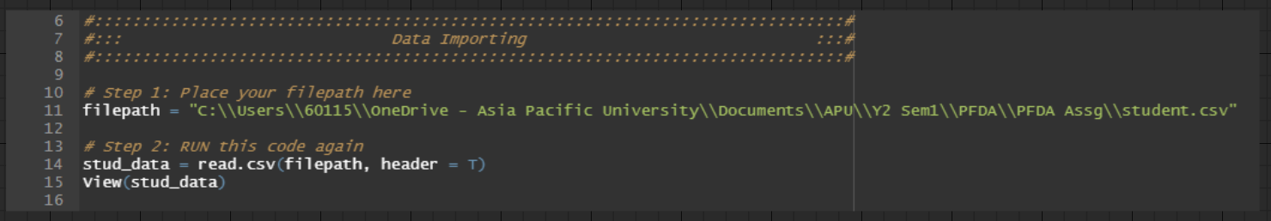

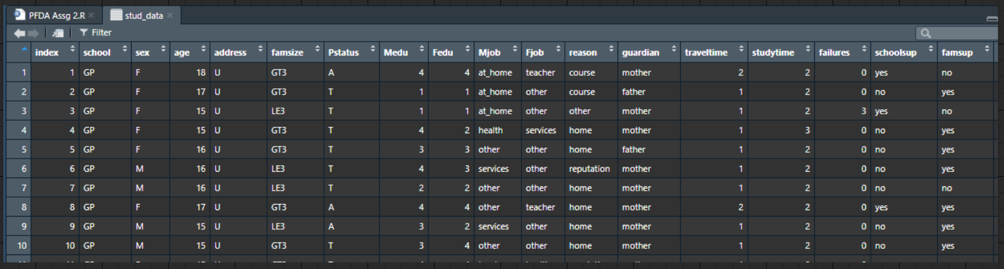

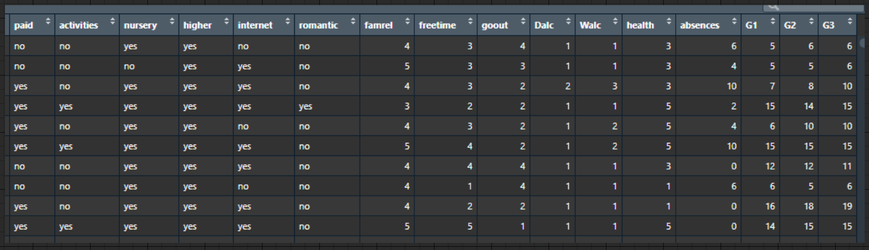

Figure 1: Souce Code for importing student.csv dataset to RStudio and viewing it

The file path of *student.csv* from the local machine is stored in the character variable, *filepath*. Afterwards, the *read.csv()* function will import *student.csv* to RStudio and store it in the data frame object, *stud_data*. The header is set to TRUE to utilize the original column headers from *student.csv*. The csv file can be observed in RStudio using the *View()* function.

# Installing and Loading Packages

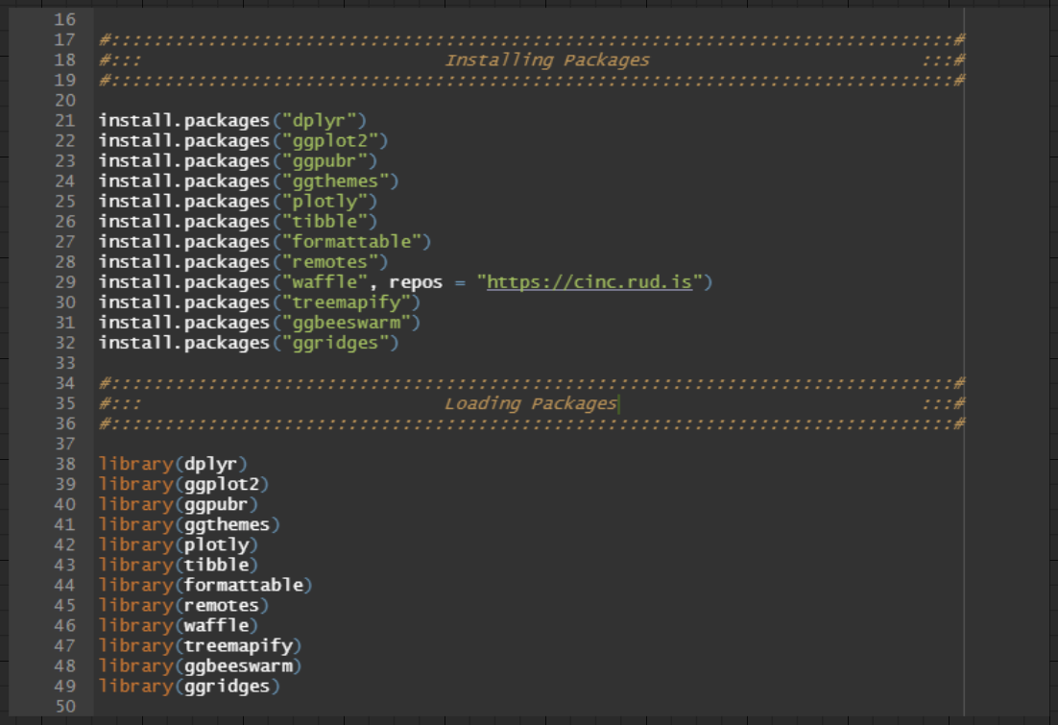

Figure 2: Source Code for installing and loading necessary packages

The above steps of installing and loading the packages are critical for allowing tasks such as data exploration, data manipulation, data transformation and data visualization to be performed in RStudio.

# Data Exploration

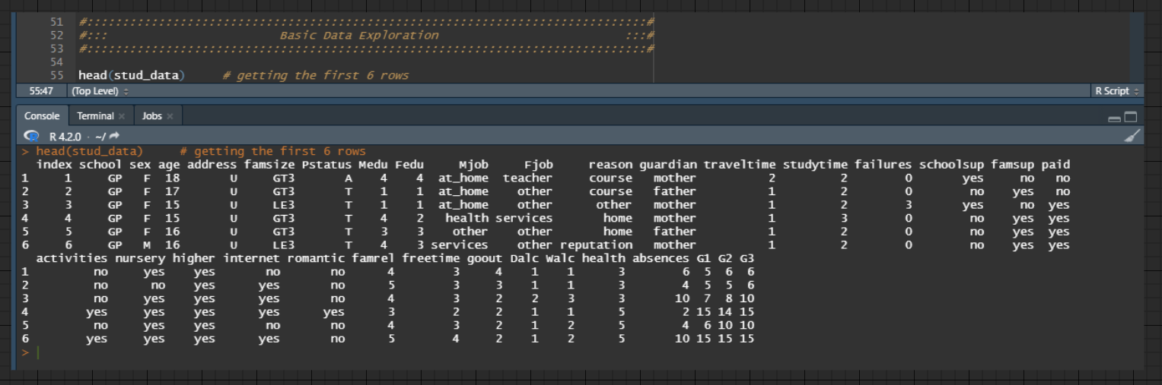

Figure 3: Source Code for displaying the first 6 rows of the student.csv dataset

The first 6 rows of the *student.csv* data set are displayed by supplying *stud_data* to the *head()* function.

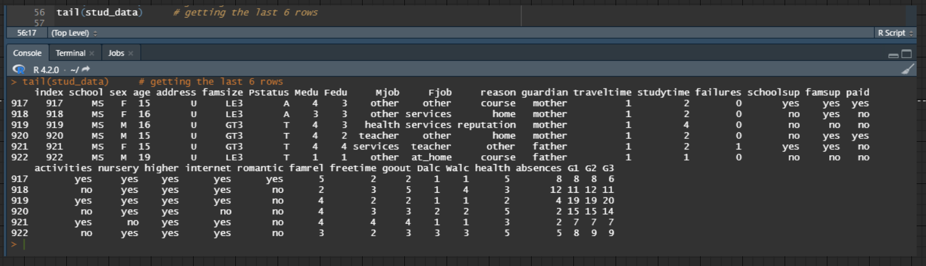

Figure 4: Source Code for displaying the last 6 rows of the student.csv dataset

The last 6 rows of the *student.csv* data set are displayed by supplying *stud_data* to the *tail()* function.

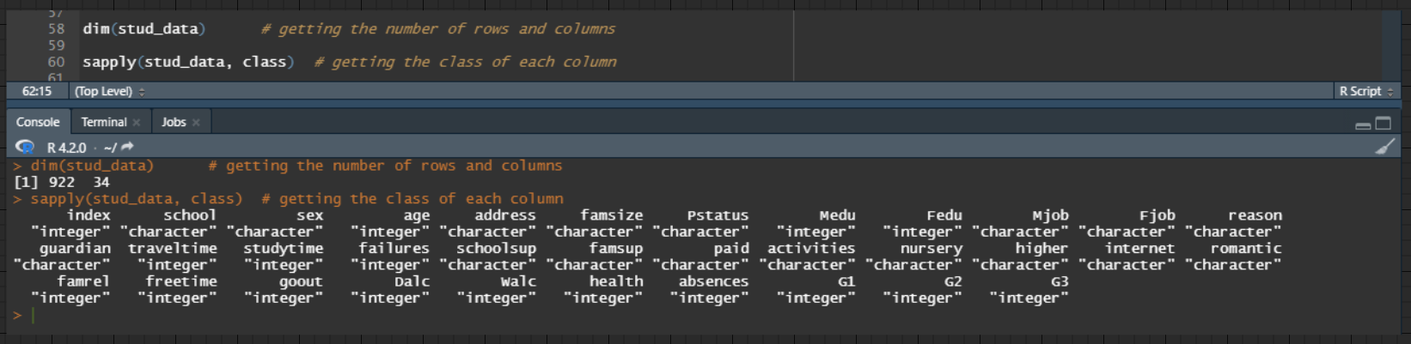

Figure 5: Source Code for displaying the dimensions of the student.csv dataset and the class for each attribute

The number of rows and columns of the *student.csv* data set is displayed by supplying *stud_data* to the *dim()* function. The result is 922 rows and 34 columns.

The class of each attribute in the *student.csv* data set is displayed by supplying *stud_data* and the *class* argument to the *sapply()* function.

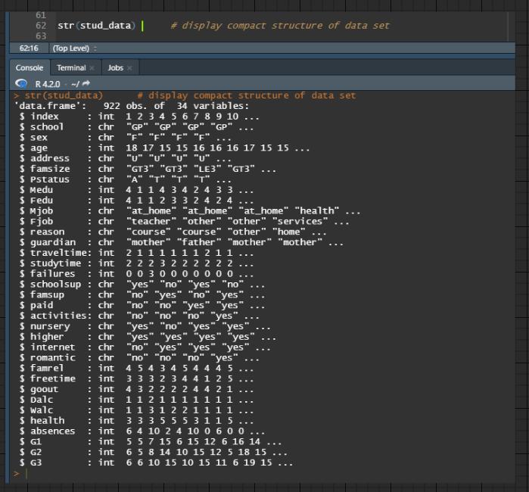

Figure 6: Source Code for displaying the compact structure for each attribute in the student.csv dataset

The compact structure of the *student.csv* data set is displayed by supplying *stud_data* to the *str()* function. It lists the class for each column, along with several observations.

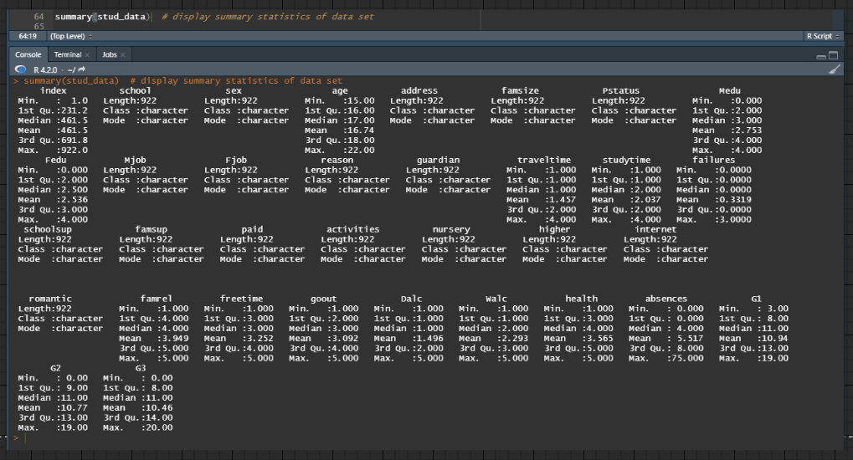

Figure 7: Source code for displaying the summary information for each attribute in the student.csv dataset

The summary information of the *student.csv* data set is displayed by supplying *stud_data* to the *summary()* function. It provides a comprehensive overview of all observations for each class.

# Data Processing

## Examine Occurrence of Missing Values

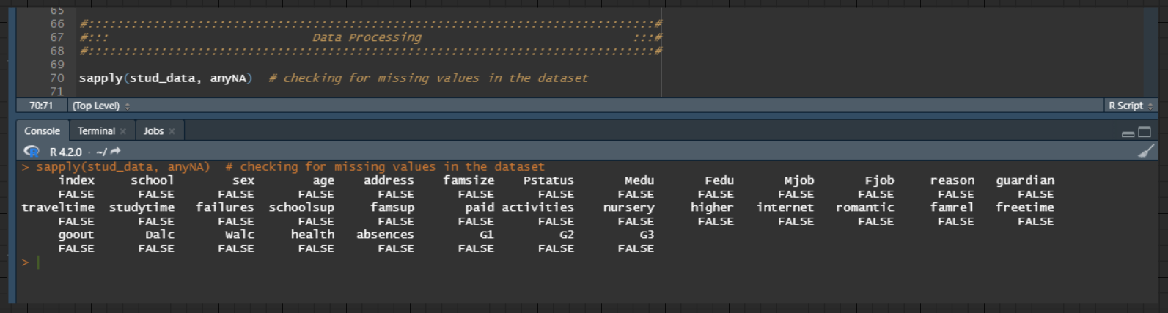

Figure 8: Source Code for examining empty values for each attribute in the student.csv dataset

The *sapply()* function is used to examine if there are any missing values for each column in the data frame, *stud_data*, which holds the *student.csv* data set. By passing the data frame, *stud_data*,and anyNA function into the sapply() function, columns with missing values will show TRUE, while columns free from missing values will show *FALSE*. The result is the *student.csv* data set is a clean data set as all columns are free from missing values.

## Creating New Data Frame For Data Manipulation

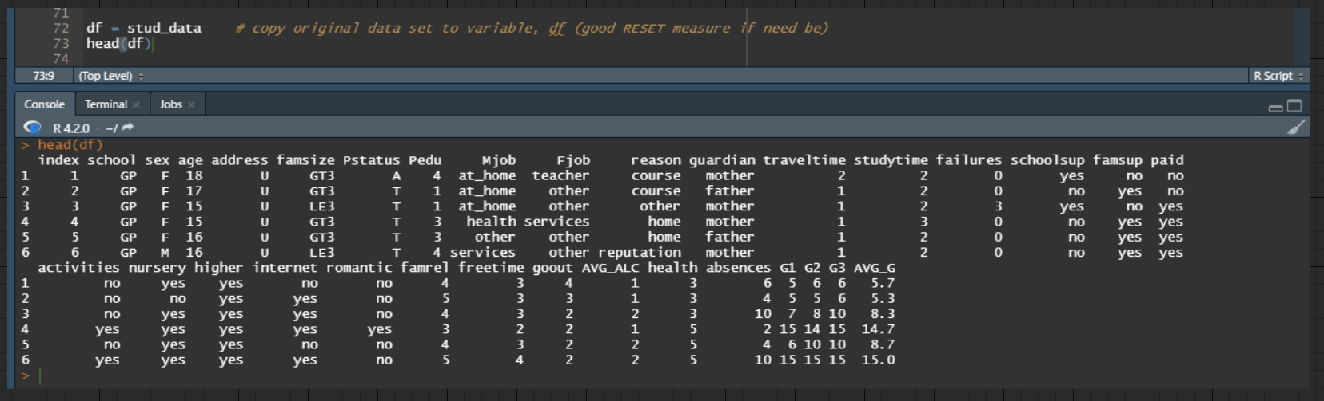

Figure 9: Source Code for copying the student.csv dataset to a new variable, df

A new data frame, *df*, is constructed as a carbon copy of the data frame, *stud_data*. The latter is evident in the console output in Figure 9. This step allows data manipulation to be conducted on the data frame, *df*, when analysing its *student.csv* data set. Hence, the data frame, *stud_data,* can always be referred back to as it contains the unadulterated *student.csv* data set.

## Creating AVG_G column

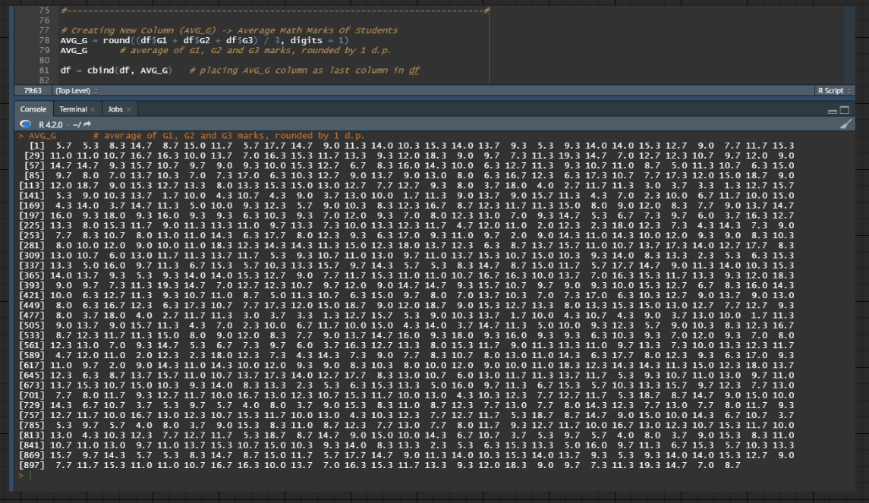

Figure 10: Source Code for creating AVG_G column and appending it to the data frame, df

A new vector, AVG_G, is constructed by averaging students' G1, G2 and G3 scores with one decimal place. Its purpose is to provide students' mean mathematic marks upon the completion of their three-year degree. It is appended to the data frame, *df*, as the last column.

## Creating AVG_ALC column

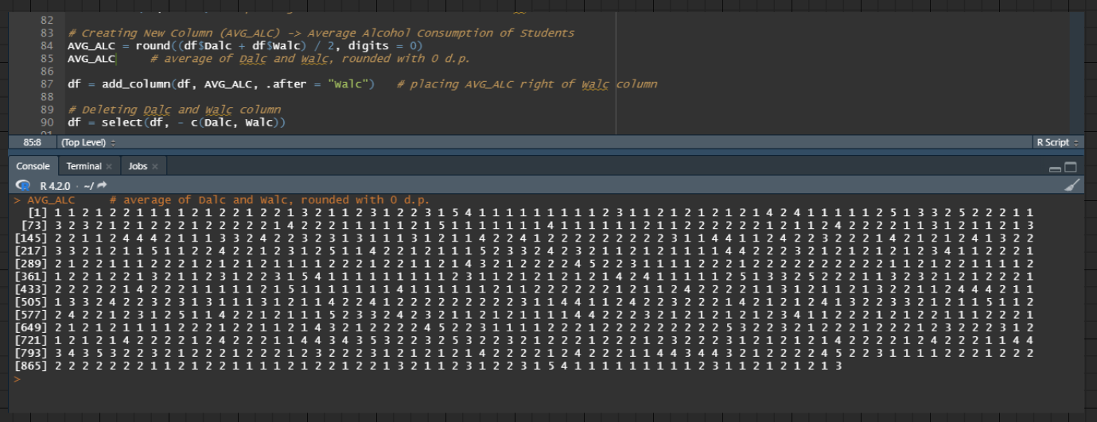

Figure 11: Source Code for creating and inserting AVG_ALC column to the data frame, df, and removing Dalc column and Walc column from the data frame, df

A new vector, AVG_ALC, is constructed by averaging students' weekday alcohol consumption rate (Dalc column) and their weekend alcohol consumption rate (Walc column) with zero decimal places. Its purpose is to provide students' weekly alcohol consumption rate. It is inserted into the data frame, *df*, at the right side of the Walc column. Afterwards, the Dalc column and Walc column are removed from the data frame, *df*, as only the AVG_ALC column will be used during data analysis when investigating students' alcohol consumption rate.

## Creating Pedu column

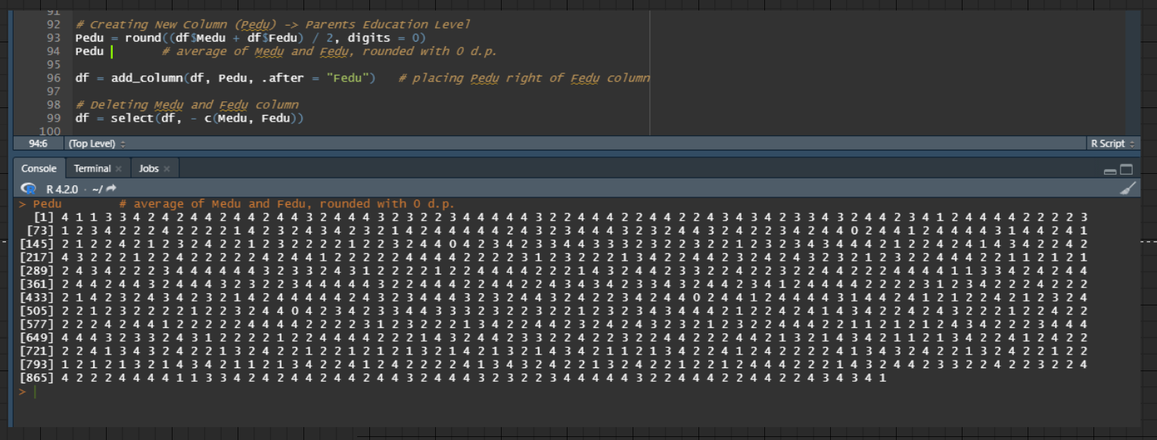

Figure 12: Source Code for creating and inserting Pedu column to the data frame, df, and removing Medu column and Fedu column from the data frame, df

A new vector, Pedu, is constructed by averaging the education level of students' mothers (Medu column) and the education level of students' fathers (Fedu column) with zero decimal places. Its purpose is to provide the average education level of students' parents. It is inserted into the data frame, *df*, at the right side of the Fedu column. Afterwards, the Medu column and Fedu column are removed from the data frame, *df*, as only the Pedu column will be used during data analysis when investigating the average education level of students' parents.

## Outcome From Data Processing

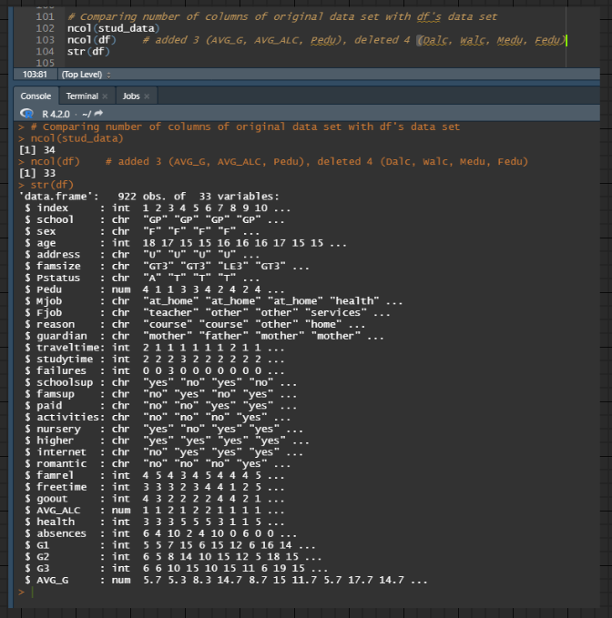

Figure 13: Source Code for comparing the number of columns between original data frame, stud_data, and new data frame, df, and displaying the compact structure of new data frame, df

In summary, 3 new columns were inserted into the data frame, *df*, which are the AVG_G column, AVG_ALC column and Pedu column. Additionally, 4 columns were removed from the data frame, *df*, which are the Dalc column, Walc column, Medu column and Fedu column. Therefore, the new data frame, *df*, has 33 columns, while the original data frame, *stud_data*, has 34 columns.

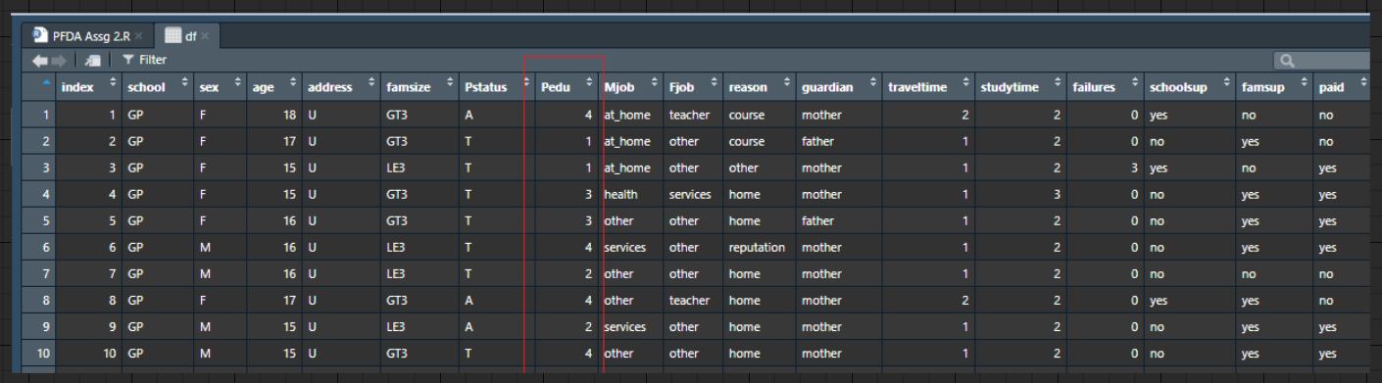

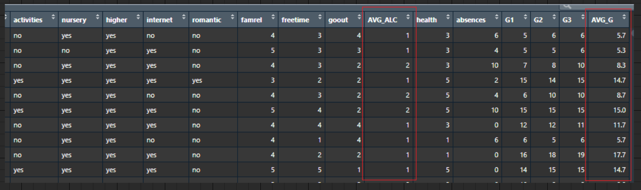

Figure 14: The 3 column additions to the data frame, df

The columns highlighted in red are the new columns inserted into the data frame, *df*, which are the AVG_G column, AVG_ALC column and Pedu column.

# Questions and Analysis

The following **KEYWORDS** will be heavily adopted in the source code explanation to minimize regurgitating the same explanation.

1. **COSMETIC REASONS**: inserting or modifying plot title, plot subtitle, x-axis label, y-axis label, legend, legend title, caption and theme to enhance the visual appeal of the plot. Likewise, it may also assist the audience with a basic understanding of the data analysis. In some cases, the source code for this section may not look the same, as adopting different plotting packages or graphs may necessitate using other parameters to adjust the above descriptions. However, its utilization is solely for improving the aesthetics of the plot. Thus it does not warrant a lengthy discussion throughout the source code explanation.
2. **REMOVING GGPLOT COMPONENTS**: eliminating one or more ggplot components, such as x-axis and/or y-axis grids, x-axis and/or y-axis lines, x-axis and/or y-axis labels, x-axis and/or y-axis tick labels, x-axis and/or y-axis ticks. This implementation aims solely to boost aesthetic merit and remove unnecessary ggplot components that may have been inserted when a *theme()* function is inserted into the plot. Hence, it does not require a comprehensive discussion throughout the source code explanation.

## Question 1: Why do some students have high rates of absenteeism ?

### Data Manipulation For Question 1's Analyses

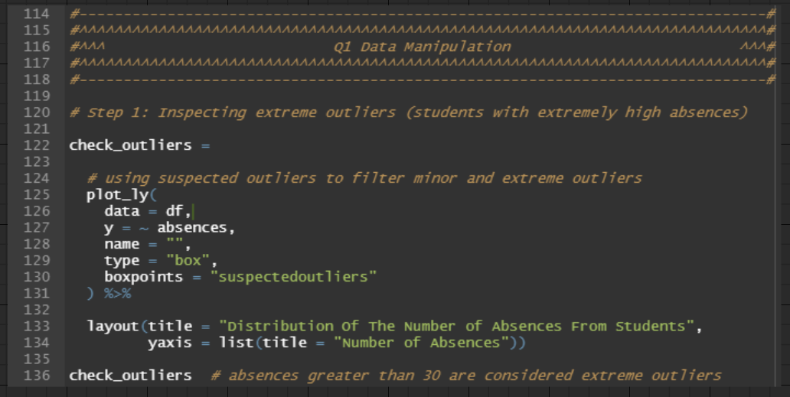

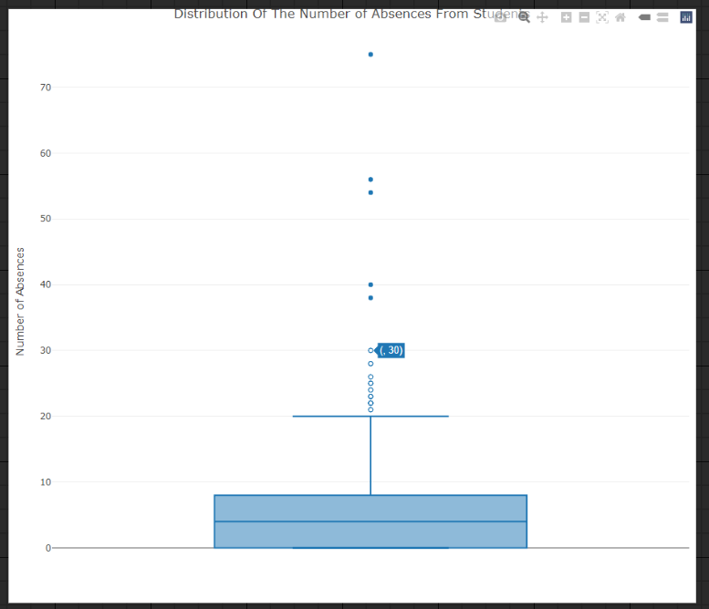

Figure 15: Source Code for drawing Plotly Box Plot to investigate outliers

Data manipulation is required to determine what constitutes a high number of absences. The first step is to remove outliers from the absences column in *df*, which is the original data frame containing all records from both *student-mat.csv* and *student-por.csv*. Hence, a plotly box plot is drawn, passing *df* as the data frame, absences column as the y value, and *"suspectedoutliers"* to its *boxpoints* parameter. The latter will distinguish minor and extreme outliers. Referencing Figure 15, outliers greater than 30 absences are extreme outliers, while outliers less than or equal to 30 absences are minor outliers. The benefit of performing the above action is to avoid excluding excessive records from the dataset, which outcomes in a better reflection of the dataset population.

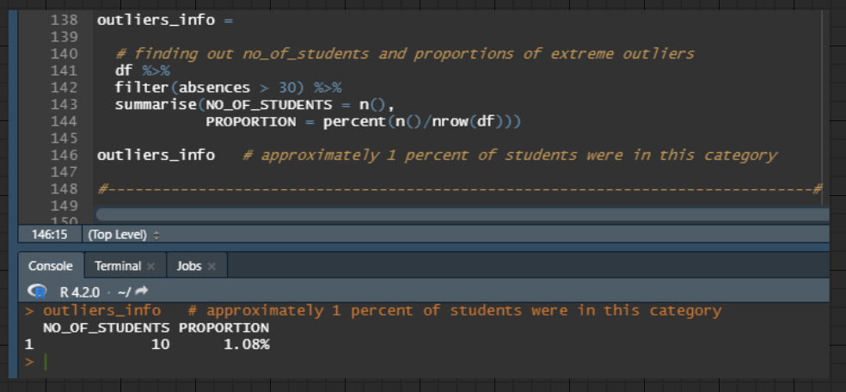

Figure 16: Source Code for finding out the number of students and proportions of extreme outliers

After filtering *df* for rows that have greater than 30 absences, a new data frame, *outliers_info*, is created using the *summarize()* function. It contains two columns: NO_OF_STUDENTS (number of rows of *outliers_info*) and PROPORTION (percentage of the number of rows of *outliers_info* divided by the number of rows of *df*). The result is approximately 1 per cent of students in *df* had absences greater than 30. With this information, we can proceed to remove the 1 per cent of students from this question's analyses to get a more accurate mean number of absences.

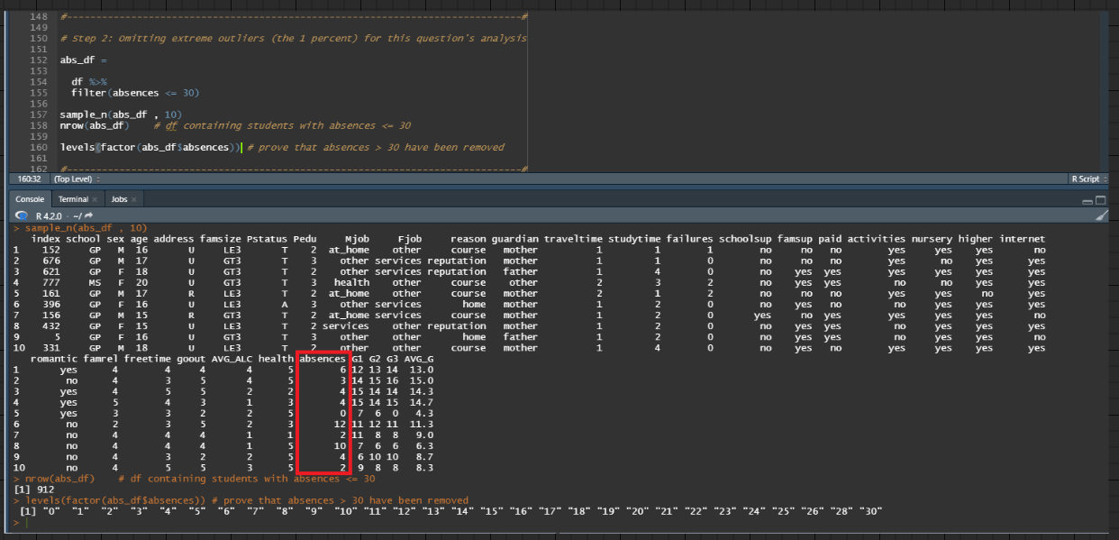

Figure 17: Source Code for removing extreme outliers

By filtering *df* for rows that have less than or equal to 30 absences, the new data frame, *abs_df*, will have records that omit extreme outliers, which is evident in the console output in Figure 17.

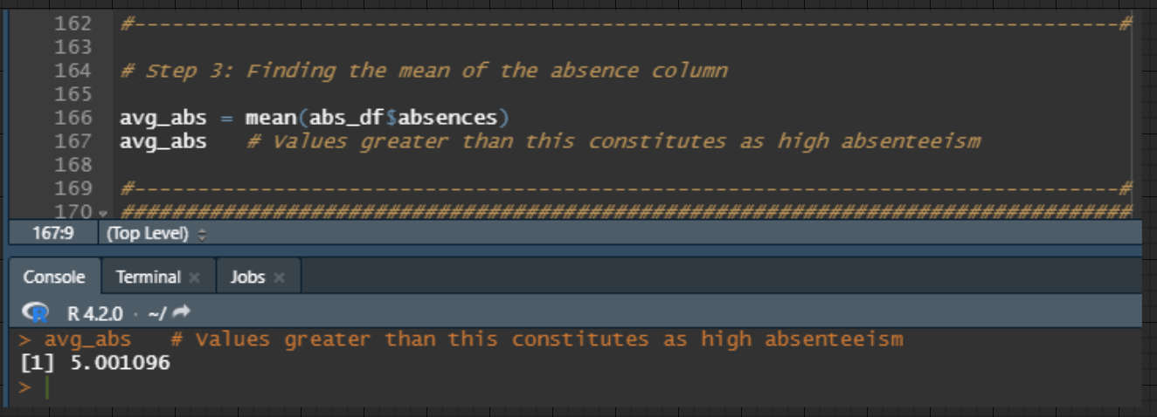

Figure 18: Source Code for calculating mean of the absences column (after removing extreme outliers)

With extreme outliers removed, the mean number of absences can be calculated by passing *abs_df* and its absences column to the *mean()* function. Refering Figure 18, the console output shows that the average number of absences is 5. Thus, number of absences that are greater than 5 are considered above average absence rate, classifying it as a high number of absences for students.

## Analysis 1.1: Investigating the relationship of students' age of those that have high absences

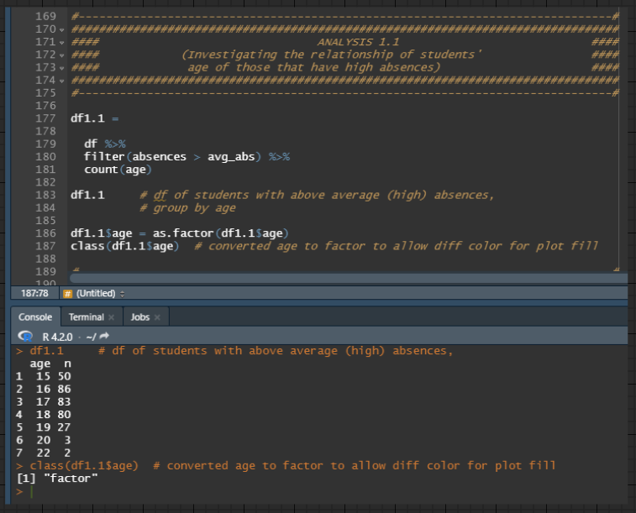

Figure 19: Source Code for filtering high absences students, grouping them by age column and summing observations for each age grouping

By filtering *df* for rows that have above average absences (absences greater than 5), a new data frame, *df1.1*, is created after totalling totalling each observation from *df* and further grouping it by age with the help of the *count()* function. The age column in *df1.1* is converted to factor to allow different colours to fill each age grouping during data visualization.

### Data Visualization 1.1

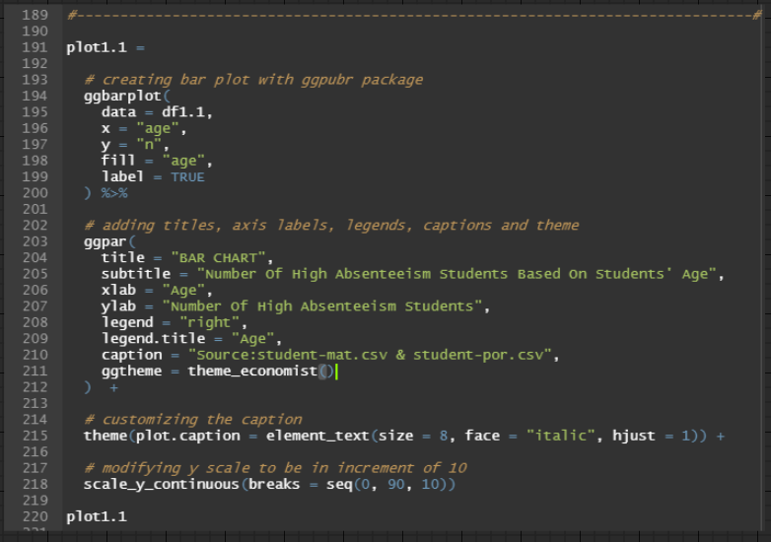

Figure 20: Source Code for producing Bar Chart (Analysis 1.1)

A bar chart, *plot1.1*, is drawn by passing *df1.1* as the data frame, age column as the x value, and n column (total observation for each age grouping) as the y value. Likewise, each bar in *plot1.1* will have a distinct colour as it is filled by the factored age column and a label that corresponds with its y value.

Lines 203 to 215 are for **COSMETIC REASONS**.

Line 218 is to modify the y-axis scale values to range from 0 to 90, with an increment of 10 for each corresponding y tick label to easily quantify each bar with its corresponding y value.

The result of *plot1.1* is illustrated in Figure 21.

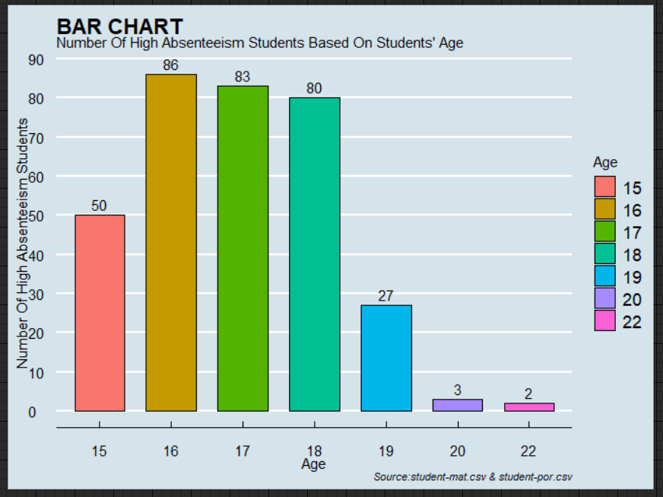

Figure 21: Bar Chart (Analysis 1.1)

### Findings 1.1

Based on Figure 21, the bar chart illustrates that the number of high absenteeism students is highest between 16 to 18. The total number of high absenteeism students from these age groups is 86, 83 and 80, respectively, which are significantly higher than the remaining age groups.

### Justification 1.1

Conforming with the prevailing labour laws in Portugal, individuals aged 16 and over are permitted to work in the country. Likewise, individuals aged 18 and over can lawfully sign a contract of employment with a corporation despite not graduating from school (Expatica, 2022). Therefore, this statute could explain the above findings as students of those age categories may be pursuing work opportunities while attending university. Students between the ages of 16 and 17 may be engaging in freelance ventures, offering their skills such as graphic design, website development, or copywriting on platforms like Upwork, generating side income while studying (Todorov, 2022). 18-year-old students may capitalize on their employment eligibility to undertake internships or part-time jobs to bolster their resumes and gain industry experience, strengthening their future employment potential and salary negotiations. Consequently, time management becomes critical in coordinating academic and work obligations, which is challenging for most students, assuming it is their first work experience (Logsdon, 2020). They are more susceptible to having poorer attendance than the older age groups due to their inability and immaturity in managing additional workloads and job-related stress. Hence, they may be skipping classes to rush work deadlines or recuperate lost sleep attributing to their perception that missed course topics can be revisited later in the semester.

### Recommendation 1.1

Students of these age groups who have begun freelancing or secured part-time positions can improve their time management skills by consistently developing weekly calendar schedules that encompass employment and academic responsibilities (University of Washington, n.d.). By drafting a timetable, it provides a straightforward summary for these students to discern all duties and activities that must be completed throughout the week, such as assignment due dates, module tests, class schedules, client meetings, work deadlines, etc. (Q.E.D. Foundation, n.d.). As a result, these students will feel less overwhelmed when juggling work and academic obligations, mitigating their burnout levels and enabling them to have a better work-study-life balance, culminating in attending more classes due to improved work organization (Florida National University, 2019). Moreover, managing academic and non-academic commitments with an efficient timetable minimizes procrastination for these students since it allows them to split larger tasks into smaller, executable components that are accomplished in stages instead of all at once (University of Georgia, n.d.). For instance, freelance students who construct personal websites for clients are onerous projects. Therefore, these students should organize and divide the project timeline into several sub-sections that undergo a weekly progression. Consequently, these students avoid neglecting their classes and recording high absences as their non-academic projects are meticulously planned to accommodate their student life.

## Analysis 1.2: Investigating the relationship of students' social interaction frequency of those that have high absences

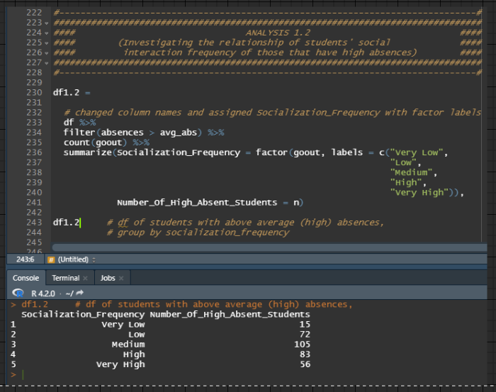

Figure 22: Source Code for filtering high absences students, grouping them by goout column and summing observations for each goout grouping

By filtering *df* for rows that have above average absences (absences greater than 5), a new data frame, *df1.2*, is created after totalling each observation from *df* and further grouping it by goout (students' tendency to hang out with friends) with the help of the *count()* function. Additionally, the goout column and n column (total observation for each goout grouping) in *df1.2* was renamed to Socialization_Frequency and Number_Of_High_Absent_Students, respectively. Furthermore, the Socialization_Frequency column was converted to factor with new labels, "Very Low", "Low", "Medium", "High" and "Very High", for better understanding and to allow different colours to fill each grouping during data visualization.

### Data Visualization 1.2 (Part 1)

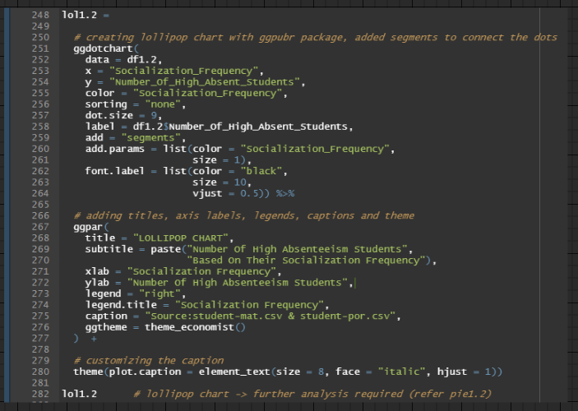

Figure 23: Source Code for producing Lollipop Chart (Analysis 1.2)

A lollipop chart, *lol1.2*, is drawn by passing *df1.2* as the data frame, Socialization_Frequency column as the x value, and Number_Of_High_Absent_Students as the y value. Likewise, each lollipop in *lol1.2* will have a distinct colour as it is filled by the factored Socialization_Frequency column and a label corresponding to its y value. Furthermore, the *sorting* parameter is converted to *"none"* to eliminate descending arrangments of the lollipops and "*segments"* are inserted into the *add* parameter to have line segments to connect each dot (making it appear as a lollipop). The remaining codes between lines 251 and 264 are purely aesthetic customization for the plot elements.

Lines 267 to 280 are for **COSMETIC REASONS**.

The result of *lol1.2* is illustrated in Figure 24.

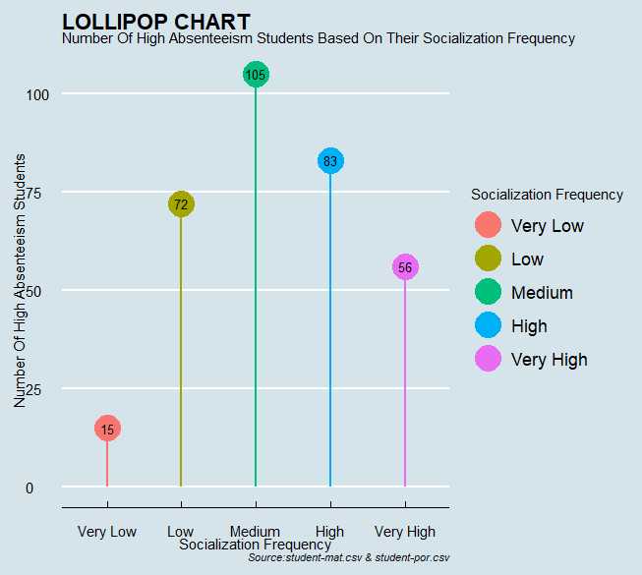

Figure 24: Lollipop Chart (Analysis 1.2)

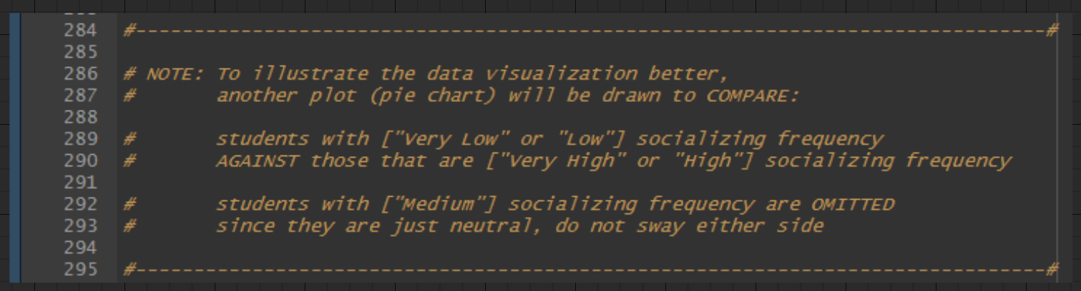

Figure 25: Explanation of why another plot (pie chart) is necessary

However, the lollipop chart alone is not effective in emphasizing the results between high absence students and their social interaction frequency. Thus, further data manipulation is required specifically for this analysis. The goal is omit students with "Medium" socialization frequency as their response is neutral and to only compare between students with "Very Low" or "Low" socialization frequency and students with "Very High" or "High" socialization frequency. The results of which will be drawn using a pie chart for better illustration.

### Additional Data Manipulation for Analysis 1.2

#### Step 1: Calculating students with "Very Low" or "Low" socialization frequency

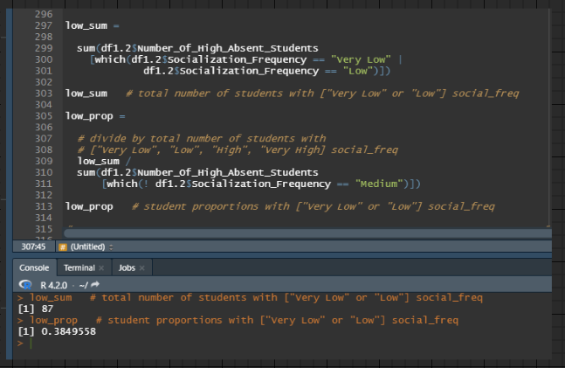

Figure 26: Source Code for calculating students with "Very Low" or "Low" socialization frequency

Between lines 297 and 303, the Number_Of_High_Absent_Students value from *df1.2* where Socialization_Frequency equals to "Very Low" or "Low" is summed with the help of the *which()* function and the *sum()* function. The result from the execution, *low_sum*, shows that the total number of students were 87.

Between lines 309 and 311, the row of "Medium" socialization frequency is omitted when summing the Number_Of_High_Absent_Students value from df1.2. The outcome from the execution is used as the divisor for *low_sum* to calculate the student proportions with "Very Low" or "Low" socialization frequency. The result, *low_prop*, is roughly two-fifth of the total number of students with "Very Low", "Low", "High" and "Very High" socialization frequency.

#### Step 2: Calculating students with "Very High" or "High" socialization frequency

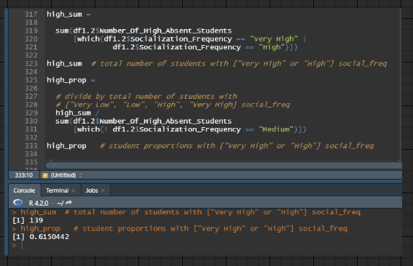

Figure 27: Source Code for calculating students with "Very High" or "High" socialization frequency

By referencing section Calculating students with "Very Low" or "Low" socialization frequency, the source code explanation above is comprehensible.

The only difference is that the execution will be on summing Number_Of_High_Absent_Students value from *df1.2* where Socialization_Frequency equals to "Very High" or "High" into *high_sum*. Afterwards, calculating its proportions against the same divisor from ther last discussion. The result, *high_prop*, is roughly three-fifth of the total number of students with "Very Low", "Low", "High" and "Very High" socialization frequency.

#### Step 3: Ensuring both proportions add up to 1

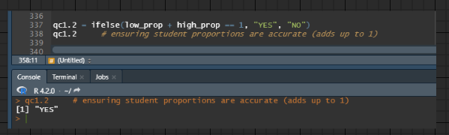

Figure 28: Source Code for checking the proportions are correct

Since a heavy amount of data manipulation was done, a quick check is executed for student proportions of "Very Low" or "Low" socialization frequency and student proportios of "Very High" or "High" socialization frequency to ensure that both proportions add up to 1. Thus, this means that the proportions are accurate and that the earlier data manipulation executions error free.

#### Step 4: Creating new data frame for pie chart

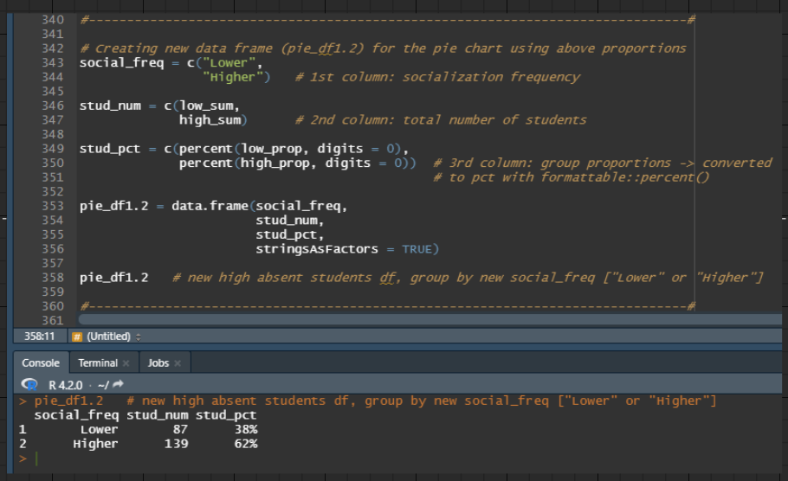

Figure 29: Source Code for creating new data frame for pie chart

Three vectors are created.

Firstly, the vector, social_freq, represents the socialization frequency. Since the comparisons will be between "Very Low" or "Low" socialization frequency "Very High" or "High" socialization frequency, social_freq will have 2 values: "Lower" indicating the former and "Higher" indicating the latter.

Moving on, the second vector, *stud_num*, consist of *low_sum* (number of students with "Very Low" or "Low" socialization frequency) and *high_sum* (number of students with "Very High" or "High" socialization frequency).

The last vector, *stud_pct*, contains *low_prop* (student proportions of "Very Low" or "Low" socialization frequency) and *high_prop* (student proportios of "Very High" or "High" socialization frequency). Both *low_prop* and *high_prop* were converted to percentages with zero decimal places using the *percent()* function from the *formattable* package.

All three vectors are passed to the *data.frame()* function to create the new data frame, *pie_df1.2*. The social_freq column is converted to factor to allow different colours to fill each social_freq grouping during data visualization.

### Data Visualization 1.2 (Part 2)

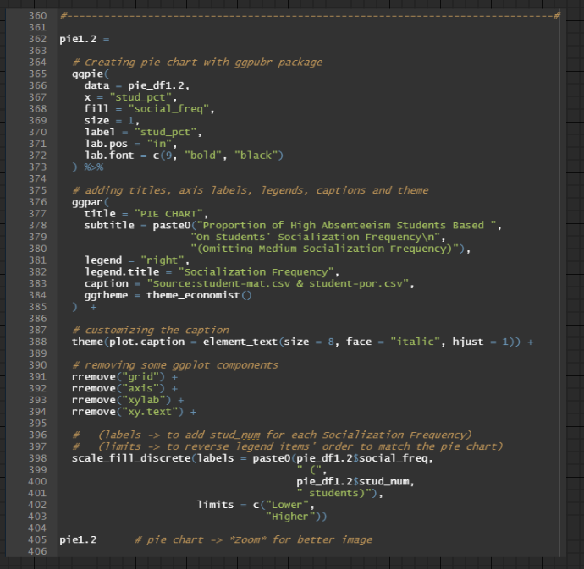

Figure 30: Source Code for producing Pie Chart (Analysis 1.2)

A pie chart, *pie1.2*, is drawn by passing *pie_df1.2* as the data frame and the stud_pct column as the x value. Likewise, each division in *pie1.2* will have a distinct colour as it is filled by the factored social_freq column and a label that corresponds with its x value. The remaining codes between lines 365 and 372 are aesthetic customization for the plot elements.

Lines 376 to 388 are for **COSMETIC REASONS**.

Lines 391 to 394 are for **REMOVING GGPLOT COMPONENTS**.

Lines 398 to 403 are to modify the descriptions of the legend. Firstly, the *labels* parameter is to insert the number of students to each socialization frequency, "Lower" and "Higher", to supplement more information to the pie chart and its student percentages. Moving on, the *limits* parameter is to reverse the order of the legend items to override its default filling of largest to smallest student proportions. Without it, the number of students and the socialization frequency will be inverted.

The result of *pie1.2* is illustrated in Figure 31.

Figure 31: Pie Chart (Analysis 1.2)

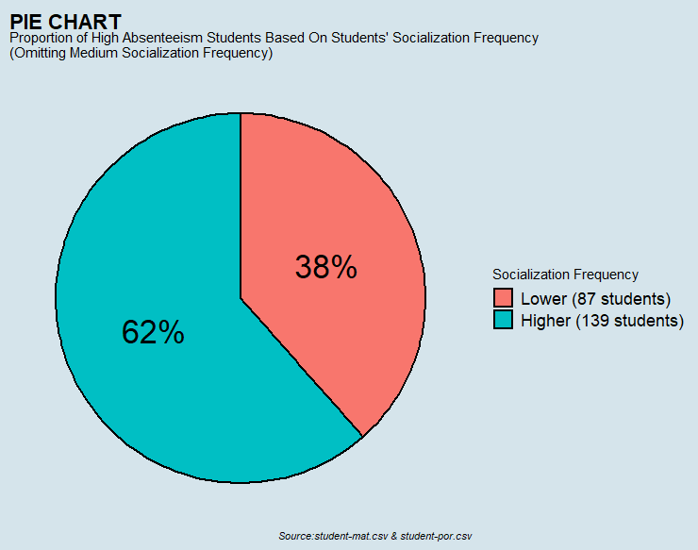

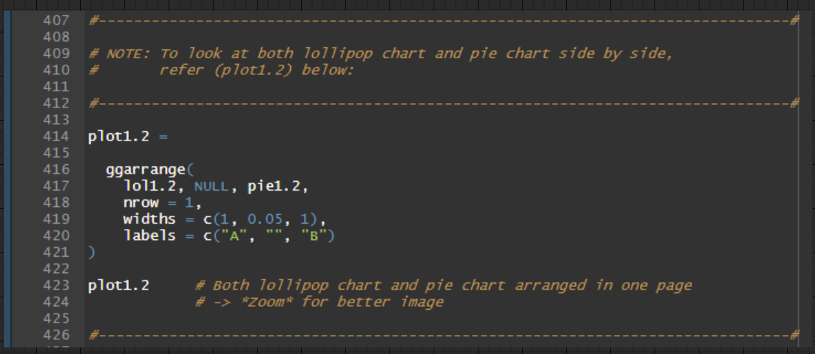

Figure 32: Source Code for arranging Lollipop Chart and Pie Chart together on one page

For easier viewing, plot1.2 is created, which combines the lollipop chart and pie chart side by side on a single page by utilizing the *ggarrange()* function.

The result of *plot1.2* is illustrated in Figure 33.

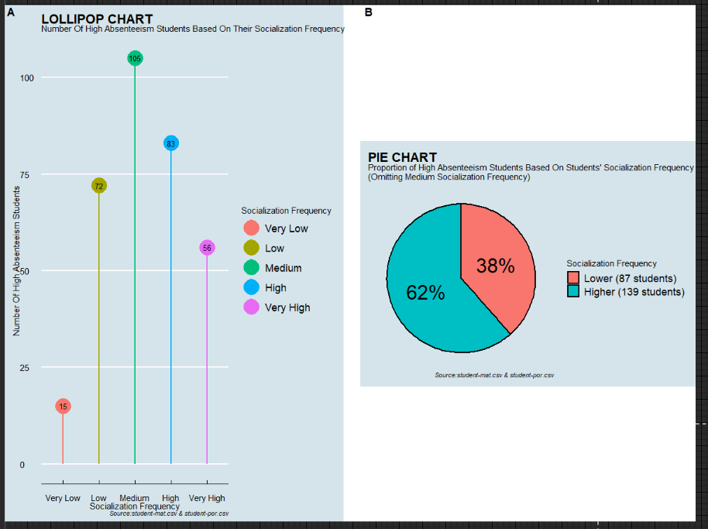

Figure 33: Lollipop Chart and Pie Chart (Analysis 1.2)

### Findings 1.2

Based on Figure 33, the lollipop chart in Part A illustrates that the number of high absenteeism students is highest for students with medium socialization frequency. Hence, students who spend a moderate amount of time interacting with friends and coursemates outside of university are more likely to skip classes. However, medium socialization frequency is a neutral response in the questionnaire when eliciting data for this category. The drawback of a neutral response is that it can conceal the respondents' sentiments, who could have gravitated towards a higher or lower socialization frequency in the absence of this response. In short, the medium socialization frequency option is a gateway for students who are less willing to divulge this information or who want to complete the questionnaire without much deliberation (Sauro, 2011). With this perspective, a pie chart in Part B, excluding the medium socialization frequency, is designed to analyze the percentage of high absenteeism students among those with very low and low socialization frequency against those with very high and high socialization frequency. The pie chart results illustrate that 62 per cent of high absenteeism students have very high to high socialization frequency, which is close to two-thirds of the population sample.

### Justification 1.2

Commencing a degree education for many students is likely to be their first experience living independently from their parents as they reside on the university campus to pursue their education (Lester, n.d.). Likewise, most students begin university alone with a blank slate, which motivates them to seek acquaintances and join social groups as early as possible to avoid feeling like an outcast (Solórzano, 2017). However, this pursuit of forging social connections in a short timeframe may have unintended consequences, such as encouraging students to interact with the wrong crowd and falling victim to peer pressure which may adversely influence their academic performance. For instance, students enrolling in an examination-based module were counselled by senior members of their social groups to satisfy only the minimum attendance criteria for this module since they performed well in the final examination despite missing some lectures. Similarly, when members of a student's social circle are skipping early semester lectures to engage in leisure activities like going to the movies, this may compel the student to do the same to demonstrate group loyalty and avoid being a killjoy. Thus, students within the higher socialization frequency category who often interact with their circle of acquaintances are more vulnerable to negative peer pressure, which may explain their high incidence of university absenteeism.

### Recommendation 1.2

Students suffering from peer pressure should reach out to their parents and pre-university companions to elicit an impartial judgment of their actions in university. By communicating their circumstances to people they trust, these trusted individuals may provide an account of how they behaved before attending university, which is a good indicator of whether their new acquaintances at university are favourably or adversely impacting their academic behaviour (Witts, 2020). Consequently, students can evaluate their actions and consciously behave in manners consistent with their values and beliefs, rather than adopting a particular habit to satisfy their new university contemporaries (University of California Santa Cruz, 2016) (Witts, 2020). For instance, students should politely decline invitations from their social groups who are skipping several lectures early in the semester for a road trip. Conscious students will acknowledge that participation in the above activity may jeopardize their fulfilment of mandatory course obligations, such as meeting minimum attendance requirements to obtain examination dockets. Additional repercussions may include time sacrifices for catching up on module material, poor grades, examination retakes, or, in the worst-case scenario, deportation for international students (Bilton, 2018). If students are pressured by peers, they can always create an excuse like being ill and fearful of infecting others on the road trip, thus removing themselves from difficult situations (Fairfax County Public Schools, n.d.). By adopting a conscientious attitude and having improved self-awareness, students can distance themselves from adverse social circles and establish connections with friends who exert positive peer pressure towards better academic performance like limited class absences.

## Analysis 1.3: Investigating the relationship of students' past class failures of those that have high absences

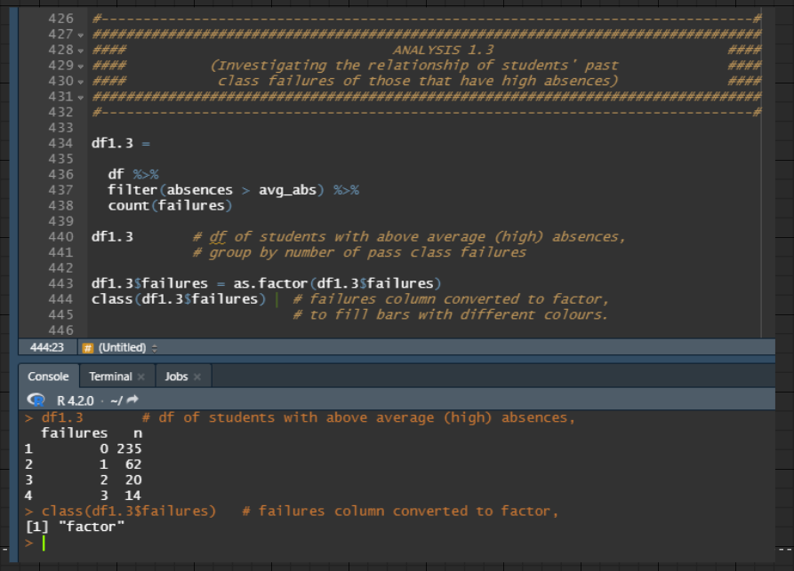

Figure 34: Source Code for filtering high absences students, grouping them by failures column and summing observations for each failures grouping

By filtering *df* for rows that have above average absences (absences greater than 5), a new data frame, *df1.3*, is created after totalling each observation from *df* and further grouping it by failures (number of past class failures by the students) with the help of the *count()* function. The failures column in *df1.3* is converted to factor to allow different colours to fill each failures grouping during data visualization.

### Data Visualization 1.3

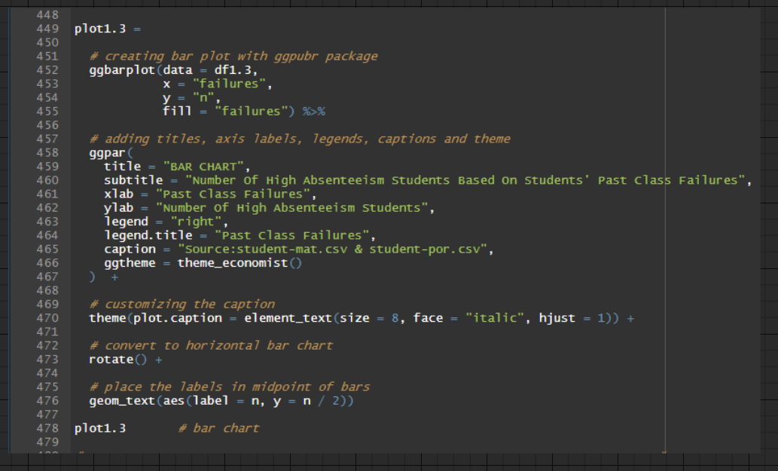

Figure 35: Source Code for producing Bar Chart (Analysis 1.3)

A bar chart, *plot1.3*, is drawn by passing *df1.3* as the data frame, the failures column as the x value, and n (total observation for each failures grouping) as the y value. Likewise, each bar in *plot1.3* will have a distinct colour as it is filled by the factored failures column.

Lines 458 to 470 are for **COSMETIC REASONS**.

Line 473 is to convert the plot to a horizontal bar chart.

Line 476 is to add a label for each bar that corresponds with its y value and position it along the bar's midpoint.

The result of *plot1.3* is illustrated in Figure 36.

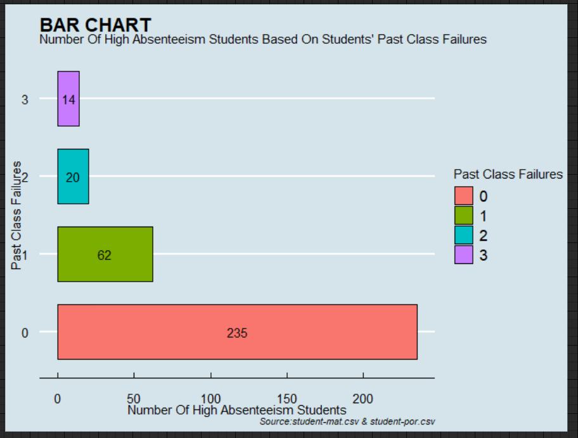

Figure 36: Bar Chart (Analysis 1.3)

### Findings 1.3

Based on Figure 36, the bar chart illustrates that the number of high absenteeism students is highest for students who experience 0 past class failures with 235 students. Hence, students who have not yet failed a course in their degree programme tend to report higher absenteeism rates.

### Justification 1.3

Students who have been absent from university courses but have been able to get Credit or better grades may be naïve, believing that their present conduct will yield similar results throughout each degree level. First-year modules, mostly introductory lectures with no prerequisites, are seen as opportunities for university students to skip classes since they are primarily theory-based and have a lower learning curve (Meier, n.d.). Hence, they perceive the course materials may be studied independently in their spare time or reviewed later in the semester. Considering the fact that examinations and assignments for these courses have a lower level of difficulty when compared to subsequent degree levels, students who were able to maintain satisfactory or better marks may be hoodwinked by their short-term success, thinking they can continue to skip courses in the future and retain their academic performance. Likewise, general education courses are likely to be incorporated into the curricula of most degree programmes, whereby students will typically choose to skip these classes as they believe them to be a waste of time because they are unrelated to their majors (Pracz, 2011). Not to mention, students may elect Pass/Fail modules to fulfil some of their general education requirements, which decreases their incentive to attend classes since they will only concentrate on what is necessary to pass as it does not interfere with their GPA (University of Southern California, 2021).

### Recommendation 1.3

Instead of lecturers regurgitating course materials or recommending that students read course materials independently, universities should revise the syllabi for introductory modules to reduce the weight of their content and incorporate more practical learning sessions that elicit student opinions and develop a dialogue around it (University of Waterloo, n.d.). When students can offer their critical judgement and perspectives during a session, courses will be more interactive and participatory as lecturers and students can discuss and address points of contention, compelling other students to do the same to minimize their doubts (Brown University, n.d.). Consequently, this measure will foster active engagement and collaboration in class, enticing students to attend lectures as each will be unique and immersive. Similarly, narrowing the scope of course materials would provide lecturers the time to perform the above activity without worrying about failing to complete the syllabus (Lujan & DiCarlo, 2006). Hence, the priority of educators and professors would shift from delivering mountains of course materials to ensuring that students thoroughly grasp the subjects being taught (Kenya News Agency, 2019). Moreover, modifying the module assessments for introductory and general education courses, such as tying a portion of overall marks to the completion of in-class tutorials for introductory classes and limiting the number of Pass/Fail modules students can take to fulfil their general education requirements, would necessitate students to attend classes because it provokes a higher likelihood for them to fail the subject (Alcid, n.d.).

## Question 2: What are the reasons that influence heavy alcohol consumption among students ?

### Data Manipulation For Question 2's Analyses

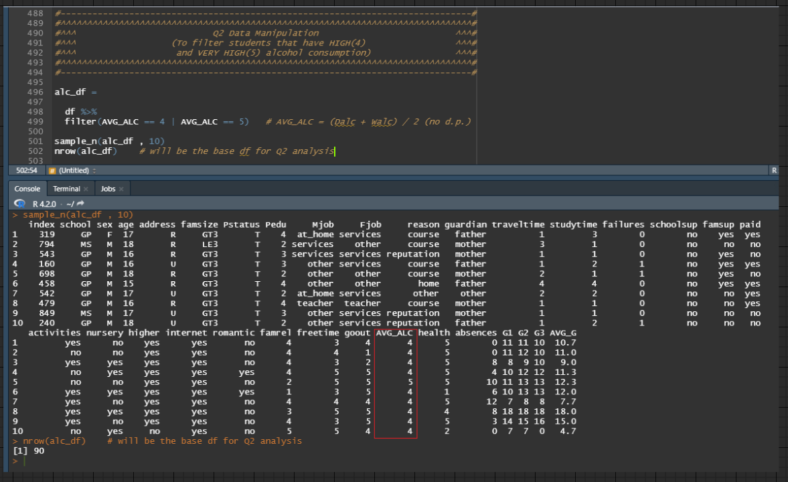

Figure 37: Source Code for filtering records whose AVG_ALC column equals to 4 or 5

According to *attr.txt* (attributes information provided for both *student-mat.csv* and *student-por.csv* dataset), alcohol consumption level that equals to 4 or 5 are considered "High" and "Very High" alcohol consumption rates. It is worth noting that the analyses for this question will be adopting students' weekly average alcohol consumption rates, AVG_ALC column (average of Dalc column and Walc column that has been removed from *df*). With this information, filtering *df* for rows that match the said criteria will produce a new data frame, *alc_df*.

## Analysis 2.1: Investigating if students' sex determine their heavy alcohol consumption

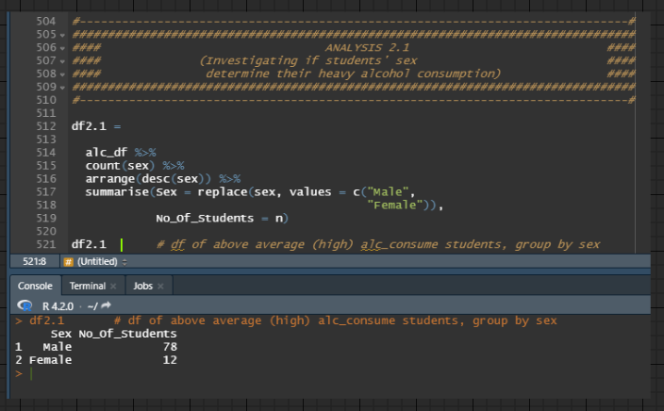

Figure 38: Source Code for grouping heavy alcohol consumption students by sex column and summing observations for each sex grouping

Firstly, each observation from *alc_df* is totalled and grouped according to the sex column with the help of the *count()* function. After arranging the data frame to be in descending order following the sex column, the sex column and n column (total observation for each sex grouping) is renamed to Sex and No_Of_Students, respectively. Furthermore, the Sex column's values was replaced with "Male" and "Female" for better clarification during data visualization. Thus, this produces the data frame, *df2.1.*

### Data Visualization 2.1

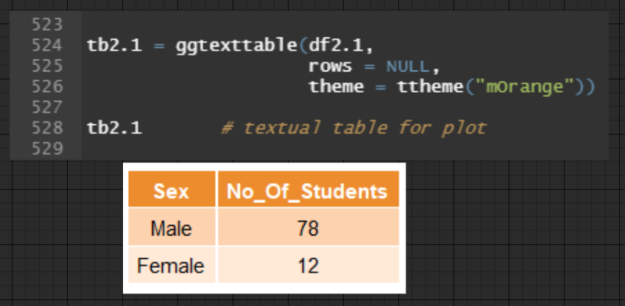

Figure 39: Source Code for creating textual table for data frame, df2.1

A textual table, *tb2.1*, for data frame, *df2.1*,is constructed utilizing the *ggtexttable()* function to be placed in the plot.

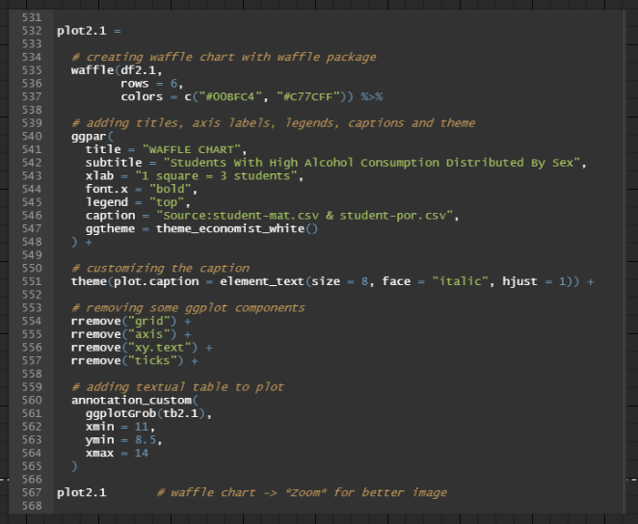

Figure 40: Source Code for producing Waffle Chart (Analysis 2.1)

A waffle chart, *plot2.1*, is drawn by passing *df2.1* as the data frame. The number of rows for the waffle chart is limited to 6, with two colours supplied to distinguish the male and female observations.

Lines 540 to 551 are for **COSMETIC REASONS**.

Lines 554 to 557 are for **REMOVING GGPLOT COMPONENTS**.

Lines 560 to 564 add the textual table, *tb2.1*, to the top right corner of the waffle chart. Firstly, it is converted to a grid graphical object ("grob") using the *ggplotGrob()* function. Afterwards, it and the correct maximum and minimum x and y-coordinates are supplied to the *annotation_custom()* function, which positions it on the plot.

The result of *plot2.1* is illustrated in Figure 41.

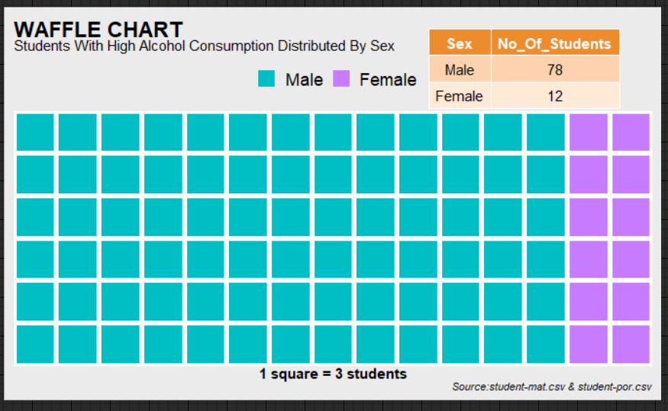

Figure 41: Waffle Chart (Analysis 2.1)

### Findings 2.1

Based on Figure 41, the waffle chart illustrates the proportion of high alcohol consumers tends to be higher among male students than female students. The total number of male students belonging to the fourth and fifth levels of the average alcohol consumption column is 78, which is significantly more than the total number of female students belonging to the same category, which was observed to be 12 students.

### Justification 2.1

According to a research conducted in 2019, while male university students consume fewer alcoholic drinks and beverages per month than their female counterparts, their rates of binge drinking and excessive alcohol consumption continue to be 4 per cent and 3 per cent higher, respectively, than those of female students (Substance Abuse and Mental Health Services Administ [SAMHSA], 2021). Binge drinking raises the alcohol concentration levels in the blood beyond the legal limit of 0.08 per cent due to heavy alcohol intake over a short time frame, which explains why most high alcohol consumers are male students (Smith, 2021). Likewise, the research also reports that male students ingested alcoholic drinks and beverages at a rate 13 per cent higher than female students throughout a two-week window when 10 or more consecutive drinks were consumed and at a rate of 3 per cent higher when 15 or more consecutive drinks were consumed, contributing to the above findings (SAMHSA, 2021). Males are more susceptible to excessive alcohol consumption than females because they perceive it as less hazardous and more compatible with their gender identity (Newport Institute, n.d.). Not to mention, drinking assists in presenting them as masculine students in university, impressing their peers and acquaintances. In terms of human biology, males who consume alcohol have significantly stronger dopamine release in their brains than females, which intensifies emotions of pleasure and enjoyment, stimulating them to increase their alcohol intake (Elsevier, 2010).

### Recommendation 2.1

As it is ludicrous to suggest that male students change their gender to female to reap the biological rewards that contribute to lower alcohol consumption, universities must be the primary driver in addressing this issue by implementing enforcement measures to mitigate excessive alcohol intake for both male and female students since it constitutes as a misdemeanour and a negative reflection on the institution. Among these tactics include universities restricting students' ability to customize their timetables for classes in a semester and mandating Friday and Saturday morning sessions (Fort Behavioral Health, 2021). Based on a study that examined the effects of course schedules and days of the week on the drinking habits of undergraduates, researchers discovered that students who are required to attend Friday classes that commence before 10 a.m. are half as likely to consume alcoholic beverages the night before compared to their peers who completed the week's lectures and tutorials on Thursday (Wood, Sher, & Rutledge, 2007). By including core lessons on Fridays or Saturdays within the student's class schedule, the weekend period for students becomes significantly shorter, meaning fewer opportunities to consume alcoholic drinks, thus diminishing their risk of intoxication (Fort Behavioral Health, 2021). Similarly, institutions that offer tuition rebates to students who choose to attend classes on Fridays and Saturdays can also be another strategy to combat binge drinking among students, which often occurs on the days following the end of the academic week (Preidt, 2008).

## Analysis 2.2: Investigating the relationship of students' social interaction frequency of those that have heavy alcohol consumption

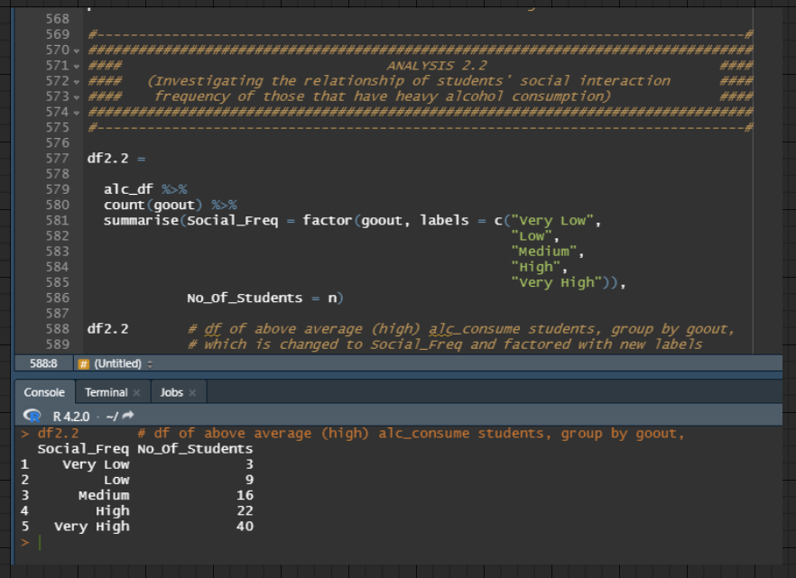

Figure 42: Source Code for grouping heavy alcohol consumption students by goout column and summing observations for each goout grouping

Firstly, each observation from *alc_df* is totalled and grouped according to the goout column (students' tendency to hang out with friends) with the help of the *count()* function. Afterwards, the goout column and n column (total observations for each goout grouping) is renamed to Social_Freq and No_Of_Students, respectively. Lastly, the Social_Freq column was converted to factor with new labels, "Very Low", "Low", "Medium", "High" and "Very High", to improve readibility and to allow different colours to fill each grouping during data visualization. Thus, this produces the data frame, *df2.2.*

### Data Visualization 2.2

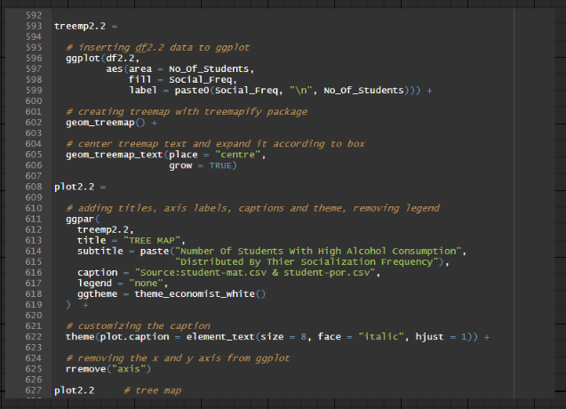

Figure 43: Source Code for producing Tree Map (Analysis 2.2)

A tree map, *plot2.2*, is drawn by first passing *df2.2* as the data frame to the *ggplot()* function. Moving on, the aesthetic mappings are configured per the following. Firstly, the *area* parameter receives the No_Of_Students column so that the tree map's box sizes correspond to the column values. Next, each box will be filled with a distinct colour by passing the factored Social_Freq column to the *fill* parameter. Lastly, the labels for the treemap will accordingly consist of the values from the Social_Freq column and the No_Of_Students column. The tree map plot is produced by appending the *geom_treemap()* function to the configured *ggplot()* function above. Lines 605 and 606 are to place each label in the centre of their boxes and grow or shrink its size to fill according to their boxes.

Lines 611 to 622 are for **COSMETIC REASONS**.

Lines 625 are for **REMOVING GGPLOT COMPONENTS**.

The result of *plot2.2* is illustrated in Figure 44.

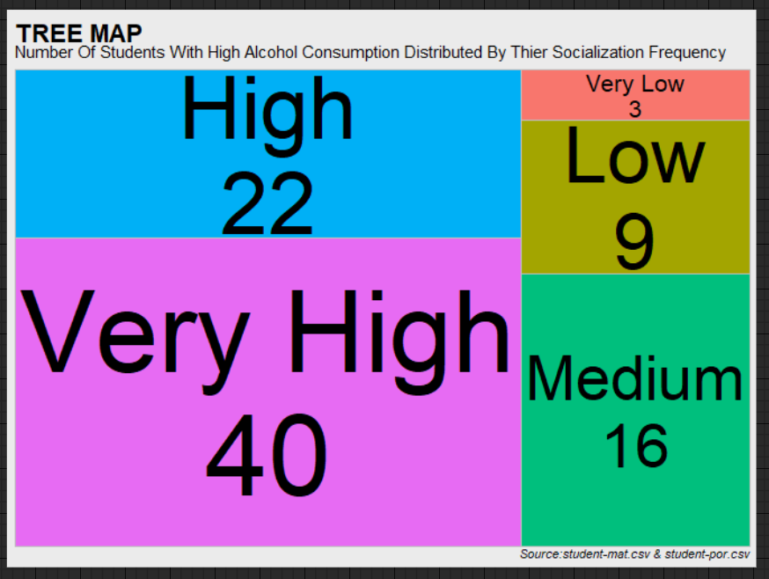

Figure 44: Tree Map (Analysis 2.2)

### Findings 2.2

Based on Figure 44, the treemap illustrates a linear relationship between students with high alcohol consumption and their socialization frequency. The total number of students belonging to the fourth and fifth levels of the average alcohol consumption column for "Very Low", "Low", "Medium", "High" and "Very High" socialization frequency was 3, 9, 16, 22, and 40, respectively, indicating a gradual increase in excessive alcohol intake as students increase their social interaction activities.

### Justification 2.2

When discussing excessive alcohol consumption among university students, it is essential to consider peer pressure, which may be among the main contributors to the issue. In their freshman year of university, students are more inclined to increase their social engagement pursuit to assimilate into the college environment and create new acquaintances (Galbicsek, 2022). With students regularly interacting with classmates of similar ages and ethos, the influence of peer pressure is amplified, which increases their risk of developing social behaviours such as excessive alcohol consumption (Muldoon, 2021). A North Carolina ABC Commission study reported that more than 60 per cent of students were consuming alcoholic beverages under the influences of their social circles (Talk it Out NC, 2019). This suggests that students with a higher frequency of social interaction will inevitably have an increased tendency to intake alcohol, contributing to the findings above. Furthermore, some universities include fraternity and sorority organizations where students can broaden their social network and strengthen their social standing. With the "Greek Life" requiring its members' commitment to organizing and volunteering for events, students are obligated to devote their time to retain their membership, increasing their socialization frequency (EasyUni, 2022). However, the "Greek Life" experience is reported to be a gateway to excessive alcohol consumption, with close to 90 per cent of its members adopting monthly drinking habits that were above the regulatory threshold, possibly due to fraternity parties and drinking games that are traditionally associated with these organizations, thus supplementing the above findings (Morris, 2021).

### Recommendation 2.2

Although the discussion from Recommendation 2.1 may also be included in this section, universities can also adopt additional measures, such as offering free alcohol counselling sessions to their students and reviewing their existing policies to make it more difficult for students to consume alcohol substances. For instance, universities should promote alcohol counselling sessions as a safe space where students can candidly share their drinking habits and experiences while promising that their stories will remain anonymous and omitted from the programme's advertisements (Wright, 2022). Consequently, this will encourage students whose peers have directly or indirectly influenced them to consume alcoholic beverages to seek assistance for their situation. By listening and understanding their patients' circumstances, counsellors can provide professional guidance and advice to students to improve their state of affairs (Wright, 2022). For example, building their courage to say no to their peers when they are offered an alcoholic beverage or that they establish a drink limit when socializing with friends to reduce their total alcohol consumption. Additionally, with most universities lacking the enforcement of curfew for their campus residents, they should reinforce these restrictions to bolster the fear factor among their students (Carmody, n.d.). Not to mention, drinking late at night is discovered to have a more substantial physiological effect on the human body due to the decrease in food consumption, culminating in accelerated alcohol uptake into the bloodstream (Grant, 2019). Therefore, universities implementing a zero-tolerance policy, which prohibits students at dormitories and fraternities and sororities from hosting festivities at odd hours, will minimize the risk of intoxication among students.

## Analysis 2.3: Investigating the relationship of students' age with those that have heavy alcohol consumption

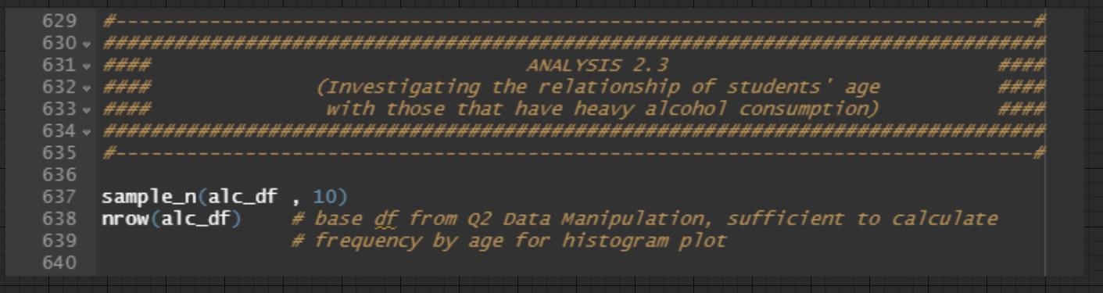

Figure 45: Using data frame, alc_df, from Data Manipulation For Question 2's Analyses

Since histograms are frequency based, it only requires a single continouous variable—the age column from Question 2's base data frame, *alc_df*, to investigate analysis 2.3. Hence, *alc_df* will be used when constructiong the histogram plot later.

### Data Visualization 2.3

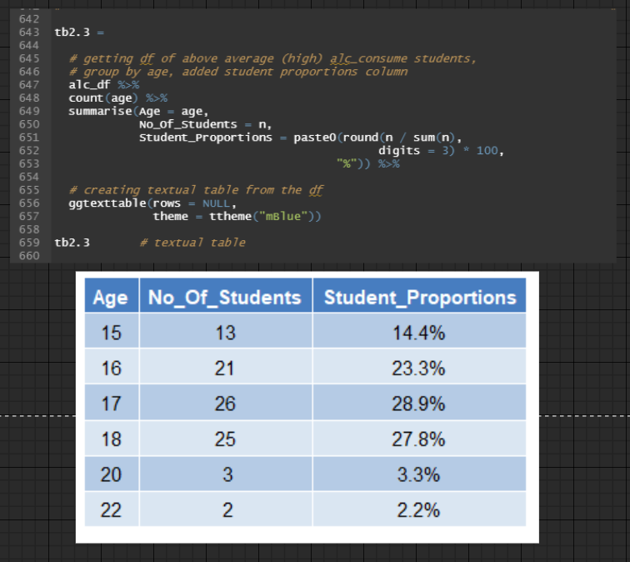

Figure 46: Source Code for grouping heavy alcohol consumption students by age column, summing observations and calculating student proportions for each age grouping, then creating textual table for the data frame

To supply additional information to the histogram, a textual table, *tb2.3*, is constructed. Firstly, each observation from *alc_df* is totalled and grouped according to the age column with the help of the *count()* function. Afterwards, the age column and n column (total observation for each age grouping) is renamed to Age and No_Of_Students, respectively. Furthermore, a new column, Student_Proportion, is also constructed in the *summarize()* function to provide the proportions of heavy alcohol consumption students for each age grouping. The latter is produced by dividing the number of observations for each age grouping over the total number of observations. Subsequently, rounding it to 3 digits, then multiplying by 100 and finally pasting the ampersand symbol to convert the results to percentages. Lastly, the data frame created will be supplied to the *ggtexttable()* function to eventually create the textual table, *tb2.3*.

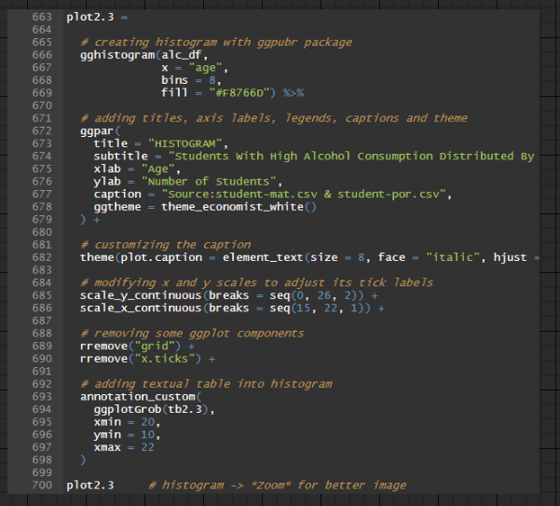

Figure 47: Source Code for producing Bar Chart (Analysis 2.3)

A histogram, *plot2.3*, is drawn by passing *alc_df* as the data frame and the age column as the x value. Since there are only 8 age groupings, the number of bins is set to 8. Likewise, the fill colour is the same across all bins.

Lines 672 to 682 are for **COSMETIC REASONS**.

Line 685 is to modify the y-axis scale values to range from 0 to 26, with an increment of 2 for each corresponding y tick label to easily quantify each bin with its corresponding y value. Likewise, line 690 is to modify the x-axis scale values to range from 15 to 22, with an increment of 1 for each corresponding x tick label since there 8 age groupings are within those values.

Lines 689 and 690 are for **REMOVING GGPLOT COMPONENTS**.

Lines 693 to 697 add the textual table, *tb2.3*, to the top right corner of the histogram. Firstly, it is converted to a grid graphical object ("grob") using the *ggplotGrob()* function. Afterwards, it and the correct maximum and minimum x and y-coordinates are supplied to the *annotation_custom()* function, which positions it on the plot.

The result of *plot2.3* is illustrated in Figure 48.

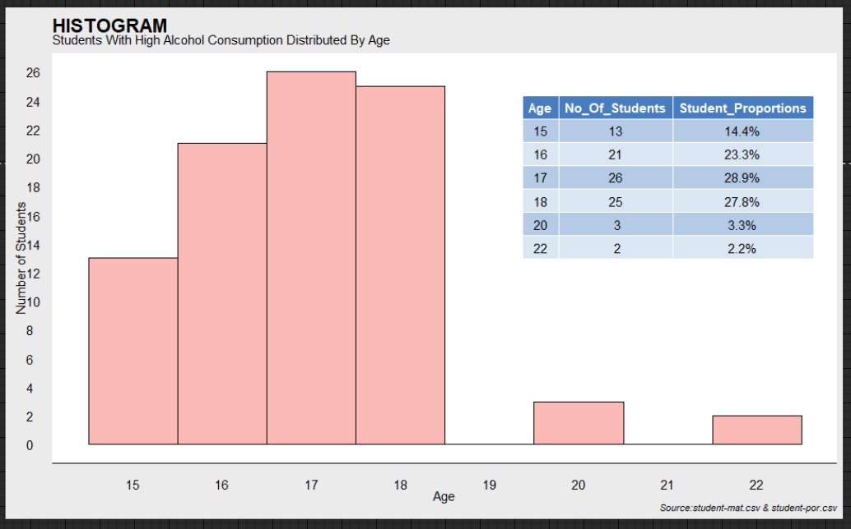

Figure 48 Bar Chart (Analysis 2.3)

### Findings 2.3

Based on Figure 48, the histogram illustrates a significant proportion of high alcohol consumption students are between the ages of 16, 17 and 18, which constitutes 80 per cent of the student population classified under the fourth and fifth levels of the average alcohol consumption column with a total of 21, 26 and 25 students for respective age categories.

### Justification 2.3

As Portugal officially legislated the drinking age to be 18 years old in 2015, 16 and 17-year-olds, who were previously exempt from the statute, are now barred from buying all forms of alcoholic beverages in the open market (The Portugal News, 2015). However, the data contained in the student-mat.csv and student-por.csv datasets were gathered during the 2005 and 2006 academic years, approximately 10 years before the drinking law enactment (Silva & Cortez, n.d.). Therefore, it is reasonable to proceed with the premise that students ages 16 and older were legally permitted to purchase and consume distilled alcoholic beverages, such as wines, beers, and ciders in that period, which may have supplemented the above findings (Whitney, n.d.). Additionally, an article published by the National Institute on Alcohol Abuse and Alcoholism (NIAAA) discovered that adolescents' alcohol perception begins to shift in a favourable direction by age 13 (NIAAA, 2006). The article also mentioned that developing teenagers could consume more alcohol than adults because their brain chemistry was less susceptible to alcohol's adverse effects like lethargy, impaired coordination, and brain fog, consequently supplementing their binge drinking habits. Simultaneously, they are also vulnerable to the positive influence of alcohol, such as lowering inhibitions, allowing them to remain calm in social settings or undertake tasks they would otherwise avoid (NIAAA, 2006) (NI Direct, n.d.). Hence, their heightened sensitivity and tolerance towards alcohol's side effects could have contributed to the above findings. Furthermore, students between the ages of 16 and 18 are more prevalent in Portugal's upper secondary education (Eurydice, 2022). Thus, their early enrollment into university, whether due to natural aptitude or hard work, implies they may lack specific life experiences than the older age groups, making them more prone to societal pressures. For instance, these young enrolees are liable to be misled by their seniors, who expose them to drinking challenges in which they innocently participate without fully comprehending the repercussions of their actions. Consequently, this may also explain why the majority of high alcohol consumers were students ranging from the ages of 16 to 18.

### Recommendation 2.3

Although Portugal's 2015 drinking law enactment imposes severe penalties from 500 to 30,000 euros if establishments were found vending alcoholic beverages to minors, it is just one piece of the jigsaw when it comes to initiatives to reduce the prevalence of alcoholism in adolescence (The Portugal News, 2015). Manuel Cardoso, the Deputy General Director of the Drugs and Addiction Authority (SICAD) in Portugal, stated that the above enforcement was solely a basic foundation and that diminishing alcohol intake requires the active involvement of educational institutions (Faget, 2015). In addition to the arguments provided in Recommendations 2.1 and 2.2, which have a role in mitigating drinking among students, universities may implement extra measures targeted at curbing excessive alcohol consumption among their underage and 18-year-old students. For instance, universities may already have an existing AlcoholEdu programme that increases student awareness about the detrimental consequences of excessive alcohol consumption. Moreover, mandating that all first-year students finish its course requirements as a prerequisite to advance to their second year of undergraduate studies (Boston University, n.d.). However, universities may tailor their existing AlcoholEdu programme to accommodate early enrollees, specifically for their minor and 18-year-old students. Rather than being utterly web-based as a massive online open course (MOOC), the curriculum may incorporate compulsory physical sessions that these high-risk age groups must attend (Busteed, 2020). These in-person sessions may demonstrate social scenarios that they should anticipate in their university journey and accordingly provide them with practical advice and strategies to effectively deter peer pressure associated with drinking. Similarly, the scope of their AlcoholEdu programme can also contain information highlighted in Justification 2.3, ensuring students have sufficient knowledge and information on their present biological nature and tendencies that would otherwise be neglected in its original implementation. For example, even if underage and 18-year-old students are likely to experience a higher tolerance for excessive alcohol consumption at the time, the prudent measure is for them to monitor and be conscious of their intake of alcoholic beverages. As a result, they are mitigating their predisposition to chronic health problems in the future, such as liver damage, blood clots, epilepsy, early-onset dementia, etc. (Slivinski, 2021). Therefore, the revamped AlcoholEdu curriculum will be more applicable and appropriate to these high-risk age demographics, which will mitigate their likelihood of developing excessive drinking behaviours.

## Question 3: Why do some students consistently improve their Math marks for each degree level ?

### Data Manipulation For Question 3's Analyses

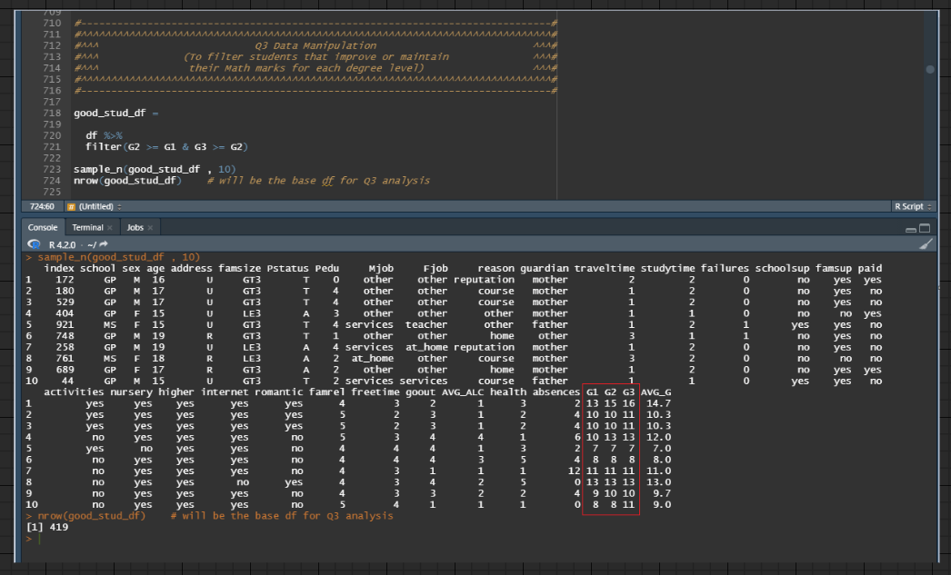

Figure 49: Source Code for filtering records whose G2 column is greater than or equal to G1 column and G3 column is greater than or equal to G2 column

By filtering original data frame, *df*, for rows where students' G2 score are greater than or equal to their G1 score and G3 score are greater than or equal to their G2 score, the new data frame, *good_stud_df*, will have records that match the said criteria, which is evident in the console output at Figure 49. Thus, the data frame, *good_stud_df*, includes only records of students who improved or maintained their mathematics marks at each degree level.

## Analysis 3.1: Investigating if students' relationship status contribute towards them improving or maintaining their Math scores

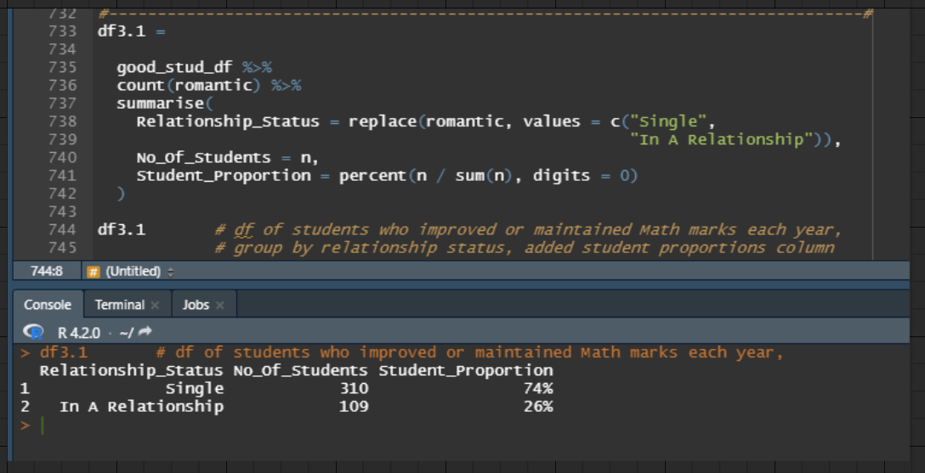

Figure 50: Source Code for grouping improving mathematics marks students by romantic column, summing observations and calculating student proportions for each romantic grouping

Firstly, observations from *good_stud_df* is grouped according to the romantic column with the help of the *count()* function. Afterwards, the *summarize()* function is used to create a new data frame, *df3.1,* with the following 3 columns:

1. Relationship_Status (replaced romantic column with its binary values substituted for character values, "Single" and "In A Relationship")
2. No_Of_Students (replaced n column, which holds the number of observations for each Relationship_Status grouping)
3. Student_Proportion (proportions for each Relationship_Status grouping). The column's values was produced by dividing the number of observations for each Relationship_Status grouping over the total number of observations in *good_stud_df*. Afterwards, those values are converted to zero decimal percentages using the percent *function()* from the *formattable* package.

### Data Visualization 3.1

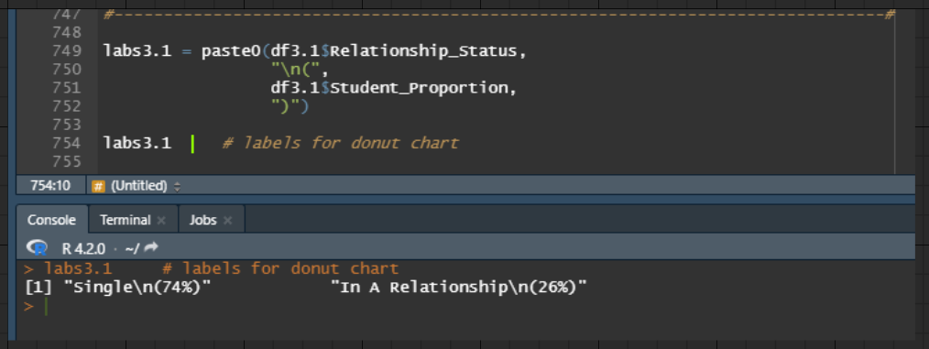

Figure 51: Source Code for creating labels for donut chart

The labels for the plot, *labs3.1*, will include the Relationship_Status and Student_Proportion.

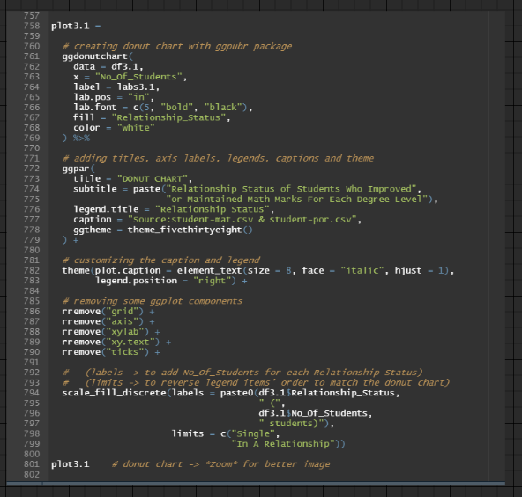

Figure 52: Source Code for producing Donut Chart (Analysis 3.1)

A donut chart, *plot3.1*, is drawn using the *ggdonutchart()* function by passing *df1.3* as the data frame and No_Of_Students as the x value. The labels for the donut chart will utilize *labs3.1* to provide the Relationship_Status and Student_Proportion information for each division. Likewise, each division in the donut chart will have a distinct colour as it is filled by the Relationship_Status column. The remaining codes between lines 761 and 768 are purely aesthetic customization for the plot elements.

Lines 772 to 784 are for **COSMETIC REASONS**. Additionally, lines 786 to 790 are for **REMOVING GGPLOT COMPONENTS**.

Lines 794 to 799 are to modify the descriptions of the legend. Because the donut chart is filled using only values from the Relationship_Status column, the legend items do not include values from the No_Of_Students column. Hence, the *labels* parameter can override said circumstance by inserting Relationship_Status and No_Of_Students columns as the legend item, which supplements the additional information of the number of students for each Relationship_Status grouping. Lastly, the limits parameter overrides the default alphabetical colour filling order by forcing the first fill colour for "Single" relationship status and the second fill colour for "In A Relationship" relationship status. Thus, this helps to match the fill colours in the donut chart and the legend.

The result of *plot3.1* is illustrated in Figure 53.

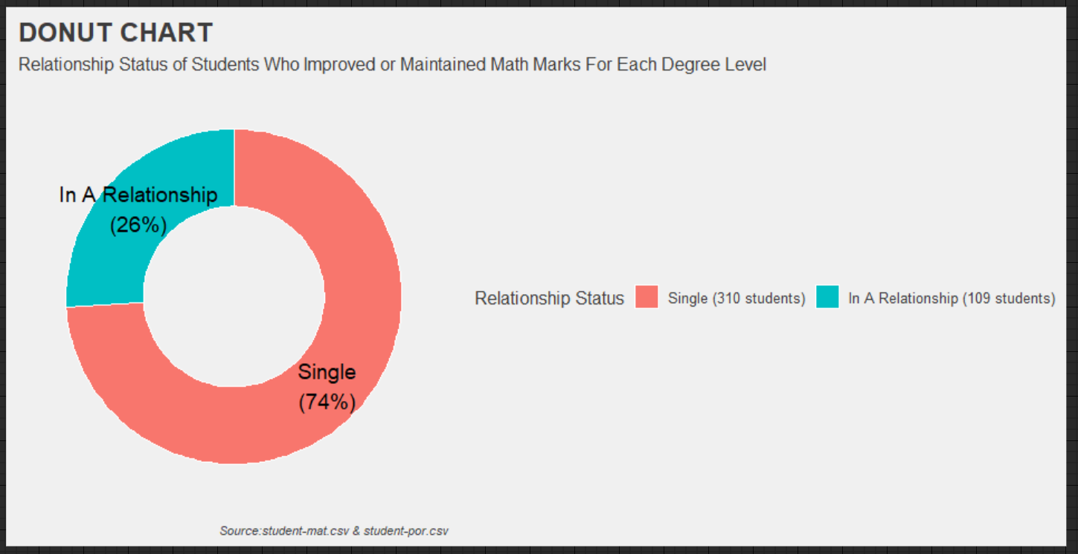

Figure 53: Donut Chart (Analysis 3.1)

### Findings 3.1

Based on Figure 53, the donut chart illustrates that only a quarter of students who improved or maintained their mathematics marks at each degree level were in a relationship, amounting to 109 students, which is 26 per cent of the sample population, while the remaining majority were single during their undergraduate studies. Hence, the findings infer that students who have relationship commitments have a decreased likelihood of improving or maintaining their mathematics marks as they progress in their degree programmes.

### Justification 3.1

Since coupled and single students are polar opposites, this discussion will only present information suggesting why students with romantic commitments have difficulty raising or sustaining their academic performance. The rationale for single students' higher probability of success can be interpreted as diametrically opposed. A study conducted by researchers at the University of Philippines Cebu College concluded that coupled students lack competent time management skills to balance their romantic and academic commitments adequately. They discovered that most of them only dedicate between 1 and 4 hours each week revising their studies while simultaneously spending significantly more time with their partners than their education (Bernales, Tanongon, & Colonia, 2011). With this perspective, students in this dataset who have committed relationships may have long-distance partners who do not attend the same institution. Consequently, they may perform long weekend commutes regularly to meet their partners, diminishing their available study time compared to single individuals (Kadel, 2017). Hence, their lack of comprehensive revision for the Mathematics syllabus and neglection towards its practical tutorials will be compounded when the subject material becomes increasingly difficult as their degree level progresses, contributing to the above findings (University of Sunderland in London, n.d.). Moreover, an investigation by the Loyola University Department of Psychology revealed that students in romantic relationships have a higher tendency to encounter emotional stress and fatigue (Kopfler, 2022). Perhaps coupled students from this dataset may have experienced heightened stress levels than their single peers, impeding their ability to consolidate previous lessons for the long term (Scott, 2021). For instance, they may encode their Mathematics lessons in the short term; however, conflicts in their relationships will gradually elevate their stress receptors over the semester (Centre for Studies on Human Stress, n.d.). Subsequently, this impairs their brain's capacity to recollect prior Mathematics lectures for their examinations, compromizing their Mathematics grade, explaining why only a minority of them were discovered in the above findings.

### Recommendation 3.1:

Similar to the framework in Justification 3.1, the recommendation will exclusively target coupled students as they are less inclined than single students in sustaining or improving their Mathematics marks at each degree level. Firstly, universities should provide a virtual relationship therapy service to foster healthy relationships among coupled students (University Counseling Service, n.d.). Likewise, modifying its criteria to demand just one partner to be a student from the university will entice students with long-distance relationships to engage in its programme (University of Wisconsin-Madison, n.d.). During the counselling session, students with romantic commitments can receive guidance and clarification from a certified relationship therapist to optimize their bonds with their loved ones without neglecting their academic pursuits (Duke Student Affairs, n.d.). For instance, couple counsellors can encourage students experiencing their first long-distance relationships to develop a schedule with their loved ones where they have a designated time and date for physical meetups (Emery, 2016). Consequently, these students will have an overview of their personal and academic calendars, enabling them to better organize time for their independent study, allowing them to revise more and excel in their summative assessments, including their mathematics examinations. Likewise, the availability of relationship therapy in students' university life grants counsellors insights into students' romantic commitments. For example, when coupled students are navigating rough patches in their relationships, they may offer professional advice or participate as a mediator between partners to facilitate the collective pursuit of a consensual resolution (Terrighena, 2019). As a result, these students will endure less emotional burden from their romantic partners, enabling them to better concentrate on their lectures and tutorials. As their minds will be less preoccupied with psychological stress and worry, they will perform better on their semester examinations, including their mathematics assessments.

## Analysis 3.2: Investigating if students' average alcohol consumption contribute towards them improving or maintaining their Math scores

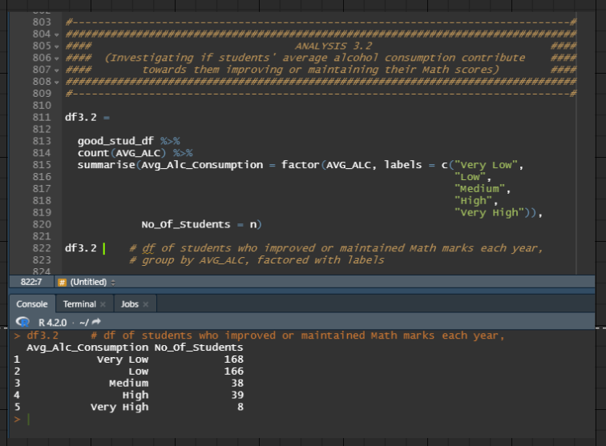

Figure 54: Source Code for grouping improving mathematics marks students by AVG_ALC column and summing observations for each AVG_ALC grouping

Firstly, observations from *good_stud_df* is grouped according to the AVG_ALC column with the help of the *count()* function. Afterwards, the *summarize()* function is used to create a new data frame, *df3.2,* with the following 2 columns:

1. Avg_Alc_Consumption (replaced AVG_ALC column with its numeric values substituted for character values, "Very Low", "Low", "Medium", "High" and "Very High").
2. No_Of_Students (replaced n column, which holds the number of observations for each AVG_ALC grouping).

### Data Visualization 3.2

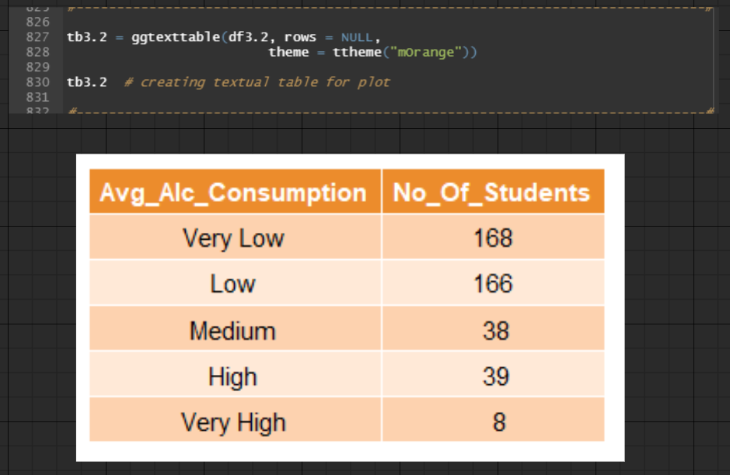

Figure 55: Source Code for creating textual table for data frame, df3.2

A textual table, *tb3.2*, for data frame, *df3.2*,is constructed utilizing the *ggtexttable()* function to be placed in the plot.

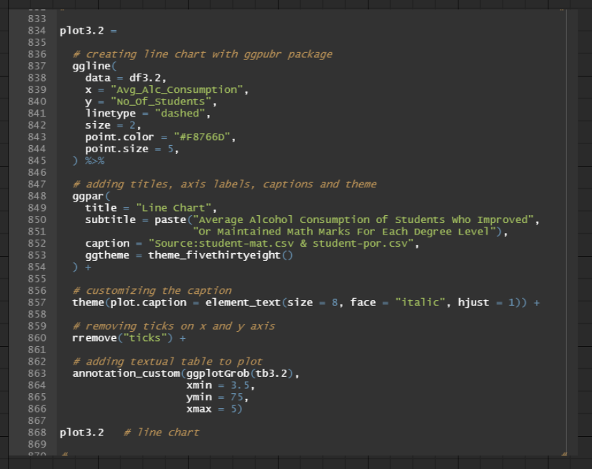

Figure 56: Source Code for producing Line Chart (Analysis 3.2)

A line chart, *plot3.2*, is drawn using the *ggline()* function by passing *df3.2* as the data frame, Avg_Alc_Consumption column as the x value, and No_Of_Students as the y value. Likewise, the *linetype* parameter is set to *"dashed"* to produce dotted lines. The remaining codes between lines 837 and 844 are aesthetic customization for the plot elements.

Lines 848 to 857 are for **COSMETIC REASONS**. Additionally, line 860 is for **REMOVING GGPLOT COMPONENTS**.

Lines 863 to 866 add the textual table, *tb3.2*, to the top right corner of the line chart. Firstly, it is converted to a grid graphical object ("grob") using the *ggplotGrob()* function. Afterwards, it and the correct maximum and minimum x and y-coordinates are supplied to the *annotation_custom()* function, which positions it on the plot.

The result of *plot3.2* is illustrated in Figure 57.

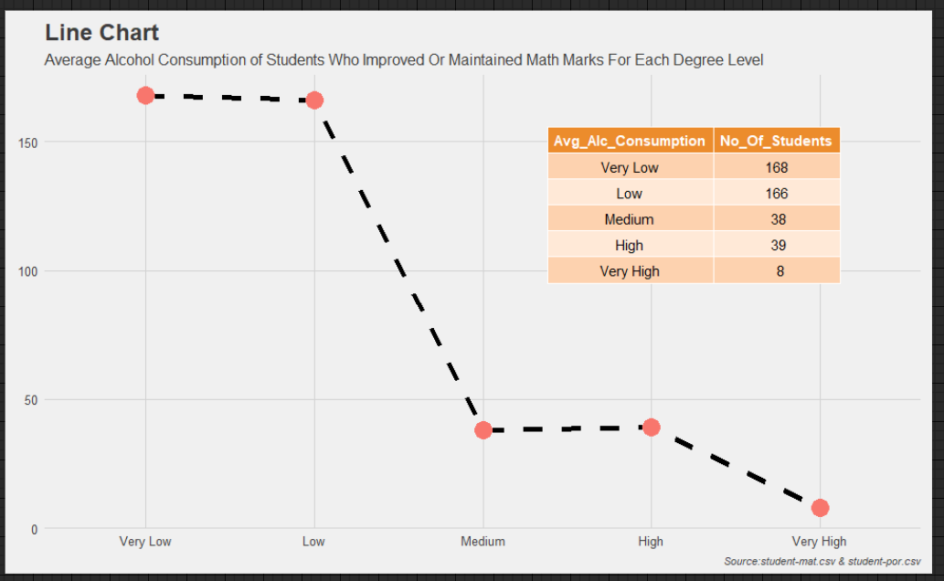

Figure 57: Line Chart (Analysis 3.2)

### Findings 3.2

Based on Figure 57, although there is a minor increment of 1 student from Medium to High average alcohol consumption, it is acceptable to conclude that the line chart illustrates an inverse relationship between average alcohol consumption and the number of students who improved or maintained their mathematics marks for each degree level. Likewise, most of these students also had Very Low and Low average alcohol consumption. Hence, the findings infer that students who wish to increase their chances of improving or maintaining their math marks for each degree level should consume less alcohol on average.

### Justification 3.2

According to research conducted by Trent University, students who consumed alcohol to the degree of mild intoxication on the lecture day could only retain 50 per cent of the lecture's teachings. Surprisingly, students who did not drink on the day of the lecture but consumed the same amount of alcohol several days later could only recall 60 per cent of the lecture's lessons (Khazan, 2017) (Cathy, n.d.). With this perspective, students who increase their average alcohol consumption could deteriorate the function of their brain's hippocampus, thus impairing the transmission of critical neural signals and aggravating their short-term memory lapses (Nall, 2019). The latter statement was proven when a psychiatrist from the University of Oxford concluded that increasing alcohol consumption by two alcoholic beverages each week is coupled with a 0.02 per cent reduction in the size of the hippocampus, which is equivalent to the effects of ageing (Swetlitz, 2017). Hence, students whose alcohol intake multiplies regardless of weekdays or weekends have a higher risk of hindering their ability to fully recollect lessons from their classes. Consequently, they are forced to sacrifice more time than teetotal students to revisit past lessons, which is an additional burden to an already rigorous degree programme. Therefore, they jeopardize their efforts to maintain or boost their mathematics marks, explaining the inverse relationship in the above findings.

### Recommendation 3.2

Although the discussions from Recommendations 2.1, 2.2 and 2.3 can contribute to decreasing the average alcohol consumption of students, universities can bolster their measures of combating student alcoholism by instituting a student-run Alcohol Awareness media outlet. The platform will educate students on the importance of individual accountability concerning alcohol use by emphasizing its ramifications for immoderate drinking behaviour (CoHEASAP, n.d.). For instance, a student-led podcast that invites credible scientists and academics to share their research on binge drinking or driving under the influence will enlighten listeners about their risk of excessive alcohol consumption (University of Reading, 2019). Due to the podcast's peer-led nature, it will attract viewers of similar ages and interests, eventually expanding its viewership and popularity within the student community (Haahr, n.d.). Moreover, the possibility for university students to engage and interact in the podcast by submitting questions through phone calls or social media channels will inevitably promote an active learning environment. Hence, students that subscribe to the podcast will enjoy a more profound comprehension of its alcohol topic discussions and have tremendous success in consolidating the information (Avelino, 2022). Consequently, university students will start monitoring and restraining their inordinate drinking habits, generating a domino effect that influences their peers to conform and follow suit due to the nudge theory (Imperial College London, n.d.). Therefore, cultivating a university culture in which students are responsible and conscientious drinkers who consume alcohol in moderation on and off-campus. As a result, they are less likely to experience premature hippocampal degeneration, as shown in Justification 3.2, enabling them to retain more lessons from their lectures, subsequently contributing to their attainment of sustaining or strengthening their mathematics marks as they progress through their degree programme.

## Analysis 3.3: Investigating if students' desire for higher education contribute towards them improving or maintaining their Math scores

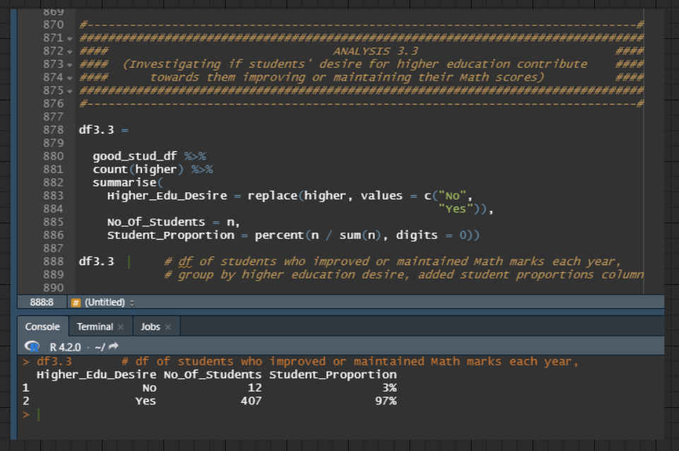

Figure 58: Source Code for grouping improving mathematics marks students by higher column, summing observations and calculating student proportions for each higher grouping

Firstly, observations from *good_stud_df* is grouped according to the higher column with the help of the *count()* function. Afterwards, the *summarize()* function is used to create a new data frame, *df3.3,* with the following 3 columns:

1. Higher_Edu_Desire (replaced higher column with its binary values substituted for character values, "No" and "Yes")
2. No_Of_Students (replaced n column, which holds the number of observations for each Higher_Edu_Desire grouping)
3. Student_Proportion (proportions for each Higher_Edu_Desire grouping). The column was produced by dividing the number of observations for each Higher_Edu_Desire grouping over the total number of observations in *good_stud_df*. Afterwards, those values are converted to zero decimal percentages using the percent *function()* from the *formattable* package.

### Data Visualization 3.3

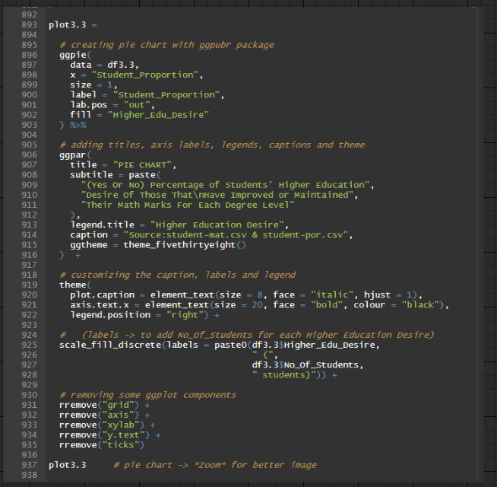

Figure 59: Source Code for producing Pie Chart (Analysis 3.3)

A pie chart, *plot3.3*, is drawn using *ggpie()* function by passing *df3.3* as the data frame and Student_Proportion as the x value. The labels for the pie chart will utilize values from the Student_Proportion column. Likewise, each division in the pie chart will have a distinct colour as it is filled by the Higher_Edu_Desire column. The remaining codes between lines 896 to 902 are purely aesthetic customization for the plot elements.

Lines 906 to 922 are for **COSMETIC REASONS**.

Lines 925 to 928 are to modify the descriptions of the legend. Because the pie chart is filled using only values from the Higher_Edu_Desire column, the legend items do not include values from the No_Of_Students column. Hence, the *labels* parameter can override said circumstance by inserting Higher_Edu_Desire and No_Of_Students columns as the legend item, which supplements the additional information of the number of students for each Higher_Edu_Desire grouping.

Lines 931 to 935 are for **REMOVING GGPLOT COMPONENTS**.

The result of *plot3.3* is illustrated in Figure 60.

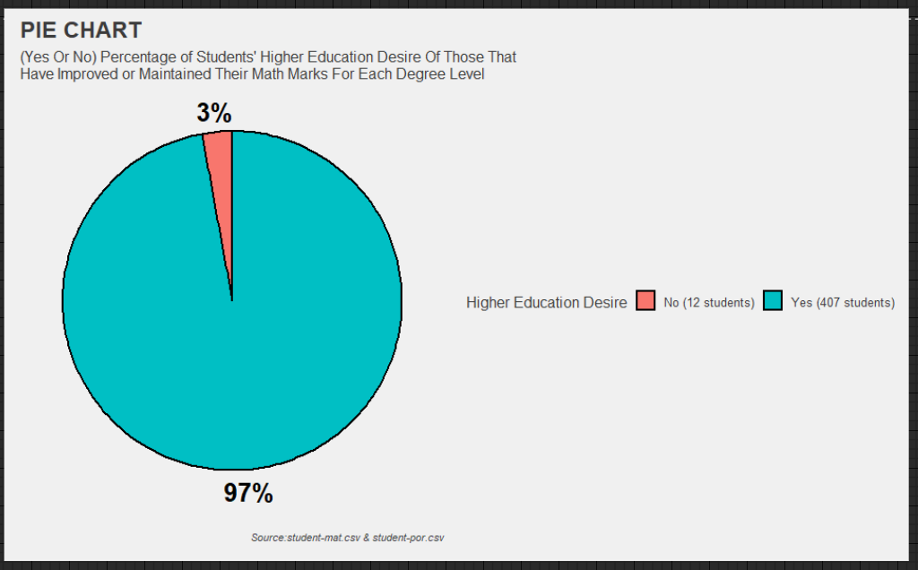

Figure 60: Pie Chart (Analysis 3.3)

### Findings 3.3

Based on Figure 60, the pie chart illustrates an overwhelming majority of students who   
have improved or maintained their mathematics marks for each degree level desire to   
continue their education after completing their Bachelor's degrees. In terms of number, 97 per   
cent or 407 students were recorded as belonging to this group. Only 12 students with no   
higher education desires after their degree programmes could attain the same results. Hence,   
the findings infer that students who aspire to a postgraduate degree are more likely to   
improve or retain their mathematics marks at each degree level than those who do not.

### Justification 3.3

In Portugal, individuals possessing Doctor of Philosophy (PhD) or Professional Doctorate   
degrees have an annual median income of roughly 47,000 euros, which is 4,000 euros more   
than Master's degree holders and 10,000 euros higher than Bachelor's degree graduates (Average Salary Survey, 2022). Likewise, money is a potent extrinsic incentive that may reward its recipients with a profound feeling of financial stability and personal satisfaction (University of Minnesota, n.d.). For instance, individuals with higher salaries are in a more   
fortunate position to afford better medical treatments, more premium insurance coverages,   
nicer housing, lengthier vacation stays, etc. Meanwhile, those with lower earnings may not be   
able to undertake the previously mentioned activities as they will have to carefully consider   
life choices that can jeopardize their financial burden. Hence, acquiring a postgraduate degree   
and providing its holders with higher financial income in employment may have  
supplemented the above findings as students with intentions of furthering their education  
studied diligently to be successfully admitted into Master's and subsequently Doctoral degree   
courses. Furthermore, postgraduate scholarships, which partially or wholly compensate for   
Master's degree tuition, are also an attractive prospect for students (Bennett, 2022).  
Therefore, they strive to improve or maintain their mathematics marks at each degree level,   
resulting in higher GPAs in their final year. Consequently, they achieve First Class or Second   
Class Honours, which is often the minimum requirement for applying for postgraduate   
scholarships, thus contributing to the above findings (Forigen, n.d.).

### Recommendation 3.3

*\*will be focusing on methods to help students with no higher education desire to improve or maintain their maths score*

As it is absolutely acceptable for some students to be content with their Bachelor's degree, the   
following discussion will explore other extrinsic motivators to encourage them to maintain or   
improve their mathematics marks. Firstly, a degree programme is a costly financial   
investment for all students, regardless of whether the funding comes from their parents,   
government loans, or personal savings (Hoffower, 2019). This is particularly true for those   
who do not qualify for educational grants and stipends. Hence, institutions may assist in this  
department by offering financial rewards to students who consistently improve or maintain   
their semester grades (McArdle, 2010). For instance, universities may provide discounts on   
their accommodation fees provided that students satisfy the above criteria. Thus, this will   
incentivize campus residents to proverbially "go the extra mile" during their undergraduate   
studies as they can enjoy lower rental payments. In addition to being eligible for the above   
discount, freelance students who independently finance their campus living expenses may   
afford to work on fewer paid projects, subsequently allowing them more time to review   
course materials. Consequently, all students who live in residence halls will be more   
motivated to improve their study time, complete tutorials, attend seminars, engage in class   
discussions, and produce higher-quality assignments. All of these contribute to the additional   
effort necessary for students to improve or retain their semester grades, including their   
mathematics marks. Alternative financial incentives, such as cafeteria coupons, grocery   
vouchers, textbook price reductions, parking exemptions, student card top-ups, etc., can also   
entice students to produce similar results as the previous example. However, for obvious   
reasons, it is prudent that the university establishes a minimum qualifying grade for the above   
requirement to deter students who intentionally perform poorly in their first year and   
capitalize on an easier jump in grades for their following semesters. Therefore, only those   
students who have put genuine commitment into their coursework and assessments would   
earn the financial rewards.

## Question 4: Why do some students' Math marks decline over each degree level ?

### Data Manipulation For Question 4's Analyses

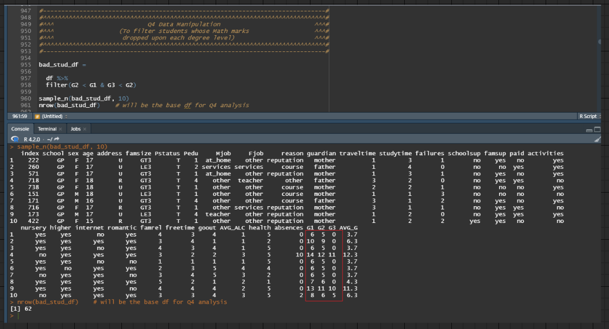

Figure 61: Source Code for filtering records whose G2 column is less than G1 column and G3 column is less than G2 column

By filtering original data frame, *df*, for rows where students' G2 score is less than their G1 score and G3 score is less than their G2 score, the new data frame, *bad_stud_df*, will have records that match the said criteria, which is evident in the console output at Figure 61. Thus, the data frame, *bad_stud_df*, includes only records of students who declined their mathematics marks at each degree level.

## Analysis 4.1: Investigating if the educational level of students' parents contribute towards their declining Math scores

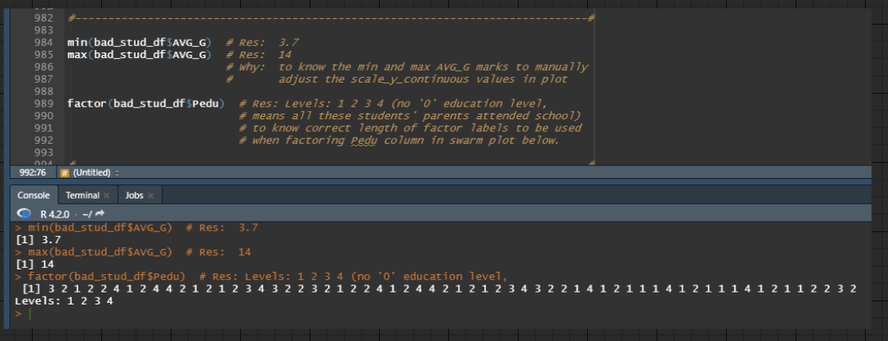

Figure 62: Source Code for determining the minimum and maximum value from the AVG_G column and factor levels from Pedu column

Lines 984 and 985 determines the minimum and maximum value of the AVG_G column from data frame, *bad_stud_df*, respectively. The former records 3.7 points, while the latter records 14 points. By understanding these values, the y-axis scale values can be modified later in the plot.

Line 989 calls the *factor()* function for Pedu column from data frame, *bad_stud_df* to view the factor levels for the column. Upon investigation, the Pedu column has levels between 1 and 4, no 0 level was observed, which means all parents of declining mathematics score students have attended primary school before. Thus, this information will be crucial when assigning new factor labels for Pedu column in the following bee swarm plot.

### Data Visualization 4.1

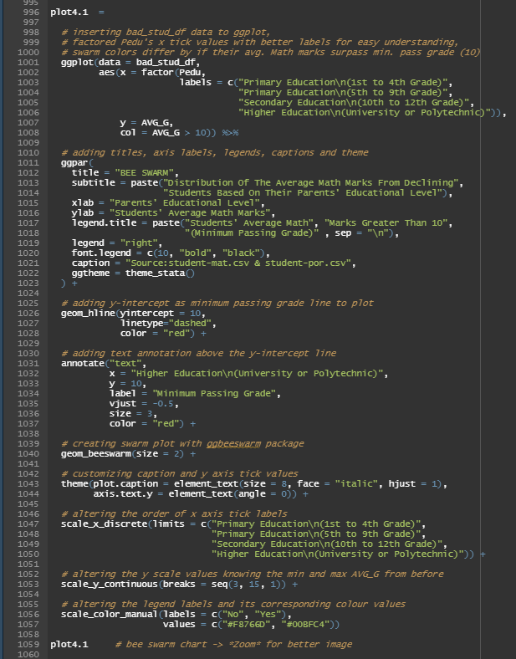

Figure 63: Source Code for producing Bee Swarm Plot (Analysis 4.1)

A bee swarm plot, *plot4.1*, is drawn by first passing *bad_stud_df* as the data frame to the *ggplot()* function. Afterwards, the x aesthetic mapping receives the Pedu column, which is temporary factored with new factor labels substituting its numeric value. Subsequently, the y aesthetic mapping receives the AVG_G column, and the colour aesthetic mapping is set to show two colours depending on the values from the AVG_G column. If the values from the AVG_G column are greater than 10, the points adopt one colour; however, if the values from the AVG_G column are less than or equal to 10, the points adopt the other colour.

Lines 1011 to 1022 are for **COSMETIC REASONS**.

Lines 1026 to 1028 are for inserting a horizontal line on the bee swarm plot using the *geom_hline()* function. The y-intercept will be at y = 10 to provide the minimum passing grade line. Similarly, lines 1031 to 1037 are for inserting a text annotation on the bee swarm plot using the *annotate()* function. The text "Minimum Passing Grade" will be positioned just above the y-intercept line aligning with "Higher Education" from the x-axis to indicate that the value of 10 from the AVG_G column is the minimum passing grade. The remaining codes between lines 1026 to 1037 are aesthetic customization for the above elements.

Line 1040 appends the *geom_beeswarm()* function to the *ggplot()* function above to create the beeswarm plot.

Lines 1043 to 1044 are for **COSMETIC REASONS**.

Lines 1047 to 1050 alter the order of the x-axis tick labels with the desired format of ascending education level. This execution was required after the addition of the text annotation as it modified the order of the x-axis tick labels.

Line 1053 is to modify the y-axis scale values to range from 3 to 15, with an increment of 1 for each corresponding y tick label. The specific starting and end value for the sequence was obtained by knowing the minimum and maximum value of the AVG_G column from earlier.

Lines 1056 and 1057 modify the default legend items' descriptions from "TRUE" or "FALSE" to "Yes" or "No" and adopt customized colour values for the color aesthetic mapping, respectively.

The result of *plot4.1* is illustrated in Figure 64.

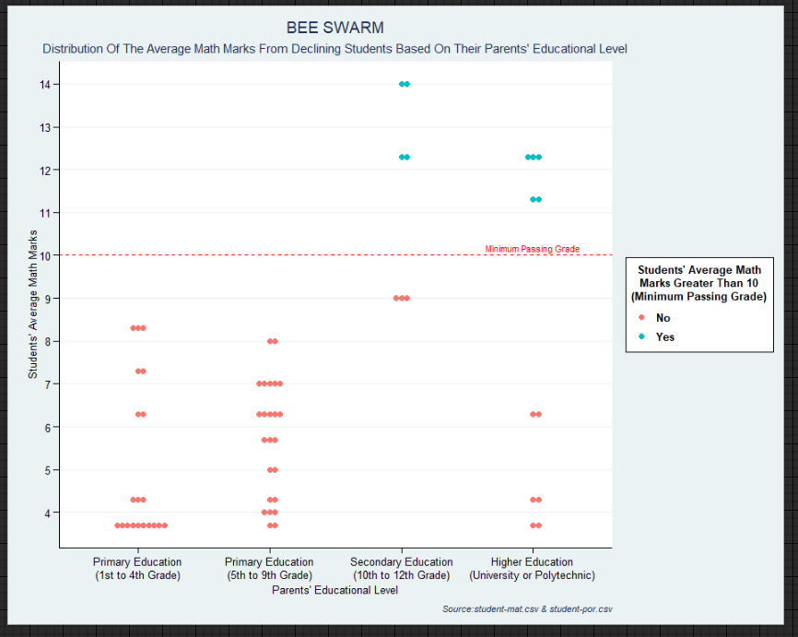

Figure 64: Bee Swarm Plot (Analysis 4.1)

### Findings 4.1

Based on Figure 64, the bee swarm plot illustrates all students with declining mathematics marks whose parents only completed their primary education achieved an average subject mark that fails to meet the minimum passing grade requirements, 10 out of 20. In fact, students with the best overall score for that category were approximately 20 per cent below the minimum passing criteria, with an average mathematics mark of 8.3. Meanwhile, some declining mathematics marks students whose parents have finished secondary or tertiary education have at least surpassed the minimum passing grade, albeit more students with parents that finished their tertiary education than those who did not. Hence, the findings infer that students with decreasing mathematics marks whose parents fail to complete primary education or continue their education beyond primary school have a higher likelihood of attaining lower average mathematics marks in their undergraduate studies than their counterparts whose parents continued their postprimary education.

### Justification 4.1

According to a report issued by the United States Education Department's National Centre for Education Statistics, one-third of students that were the first in their family to pursue tertiary education dropped out after three years, as opposed to 14 per cent of their peers who are not first-generation university students (Bird, 2018). Likewise, they are approximately 20 per cent less likely to graduate during their first academic tenure than their counterparts whose parents pursued higher education (Bird, 2018). It was argued that the above phenomena might be attributable to parents who joined the employment sector without a diploma or degree credentials may place a lower significance and value on secondary and tertiary education than those who did (Lamar University, 2021). With parents being educational role models for their children, their disregard for furthering education can have a detrimental impact on their children (Raising Children, 2021). For instance, first-generation university students that are struggling to cope with their mathematics curriculum may look to the guidance of their inexperienced parents who only completed primary education. Consequently, these parents may fail to provide their children with the necessary encouragement to improve their efforts since they themselves succeeded without tertiary education. In contrast, parents with achievements of undergraduate or postgraduate degrees can recall their lessons and experiences from university. Subsequently, they can counsel their children on ways to effectively manage their schedules or personal obligations to make time for revising their mathematics course materials (Bakar, Mamat, & Ibrahim, 2017). Hence, this interaction between university students and their parents, which should be anticipated as they undergo hardships and uncertainties in university, may have indirectly contributed to the above findings.

### Recommendation 4.1

As some parents may have forfeited their secondary or tertiary education due to financial or academic constraints, they can still contribute to the improvement of their children by becoming proactive and diligent listeners throughout their undergraduate studies. A conventional three-year degree programme requires a degree of mental fortitude that most students find difficult to sustain consistently (Moorhouse, 2021). Hence, it should not come as a surprise that approximately three-quarters of students suffer from mental health episodes, with one-third of them battling depressive disorders during their university tenure (Beresin, Schlozman, & Abdu-Glass, 2017). If parents are receptive to their children's challenges and struggles, they may be able to alleviate some of their mental anguish, which may have impeded their academic performance. For instance, regardless of their level of education, parents may be effective listeners by acknowledging and rationalizing the internal turmoil experienced by their children in their tertiary education (Parents, 2020). With them not rushing to snap judgments and behaving in a manner where parents know best, their children will feel more comfortable expressing their apprehensions and concerns since their feelings will not be overlooked or diminished (Cleare, n.d.). Moreover, parents who are attuned and aware of their children's psychological state will empower them to take measures that address their mental health issues, such as exercising or pursuing hobbies (Health Direct, 2020) (Head to Health, 2019). Consequently, their emotional burden begins to subside, allowing them to recuperate more effectively and experience less stress and anxiety (Parents, 2020) (Canadian Mental Health Association Toronto [CMHA Toronto], n.d.). When students' internal distress dwindles, it becomes less disruptive to their academic studies. Subsequently, they can concentrate their attention and efforts towards enhancing their intellectual development, outcoming to better scores for their summative assessments, including their mathematics marks.

## Analysis 4.2: Investigating if the study time of students contribute towards their declining Math scores

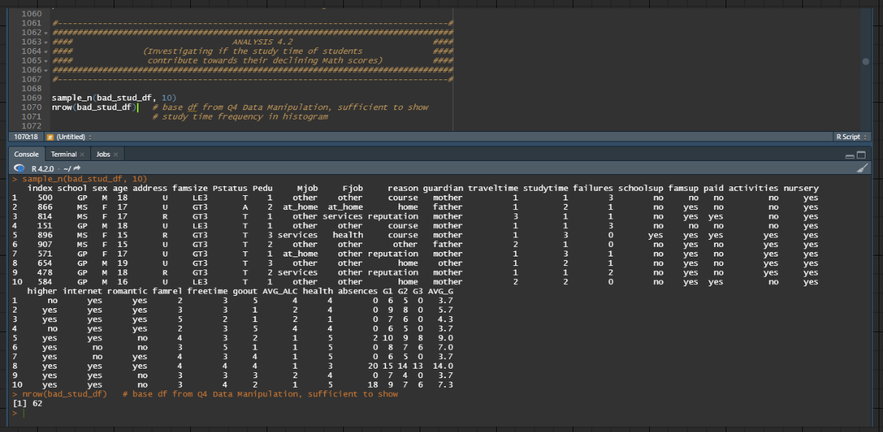

Figure 65: Using data frame, bad_stud_df, from Data Manipulation For Question 4's Analyses

Since histograms are frequency based, it only requires a single continouous variable—the studytime column from Question 4's base data frame, *bad_stud_df*, to investigate analysis 4.2. Hence, *bad_stud_df* will be used when constructiong the histogram plot later.

### Data Visualization 4.2

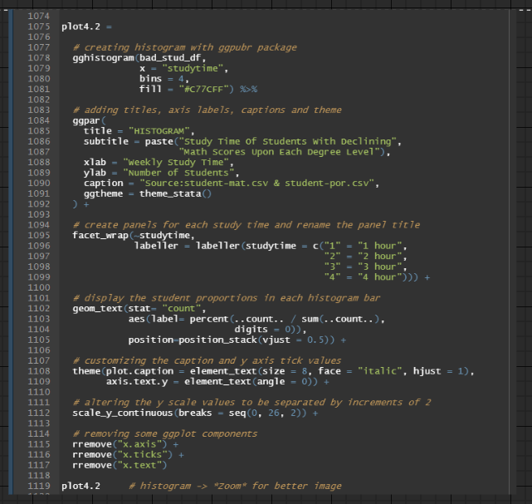

Figure 66: Source Code for producing Histogram (Analysis 4.2)

A histogram, *plot4.2*, is drawn by passing *bad_stud_df* as the data frame and the studytime column as the x value. Since there are only 4 studytime groupings, the number of bins is set to 4. Likewise, the fill colour is the same across all bins.

Lines 1084 to 1091 are for **COSMETIC REASONS**.

Lines 1095 to 1099 create a panel for each studytime grouping by calling the *facet_wrap()* function and renaming each panel's title by supplying the desired label to the *labeller()* function.

Lines 1102 to 1105 displays the students proportions in percentages for each histogram bar using *geom_text()* function. Firstly, *stat="count"* gets the number of observations for each studytime grouping. By dividing each *"count"* with the total number of observations and converting it to zero decimal percentages using the *percent()* function from the *formattable* package, the result can be supplied to the label aesthetic mapping. Finally, each label is placed in the middle of its corresponding bin.

Lines 1108 and 1109 are for **COSMETIC REASONS**.

Line 1112 is to modify the y-axis scale values to range from 0 to 26, with an increment of 2 for each corresponding y tick label to easily quantify each bin with its corresponding y value.

Lines 1115 to 1117 are for **REMOVING GGPLOT COMPONENTS**.

The result of *plot4.2* is illustrated in Figure 67.

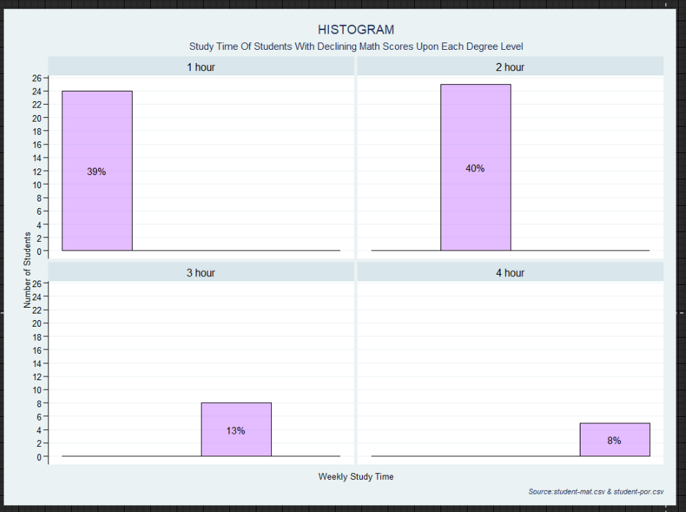

Figure 67: Histogram (Analysis 4.2)

### Findings 4.2

Based on Figure 67, the histogram illustrates approximately 80 per cent, or 49 students with declining mathematics marks for each degree level, devoted an average of 1 to 2 hours of study time per week. Only 13 students with decreasing mathematics scores recorded spending a mean study time of 3 to 4 hours every week. Hence, the findings infer that students who only revised less than 2 hours a week are more likely to experience a decline in their mathematics marks at each degree level.

### Justification 4.2

According to the guidelines of most universities, if these students are enrolled in a three-credit-hour mathematics course, they should devote between 6 and 9 hours each week to study the subject (University of Wisconsin, n.d.). Furthermore, the study time above is interpreted as the number of hours these students spent revising mathematics and reviewing other subjects, undertaking formative assessments, and completing assignments (McGee-Thompson, 2021). Hence, these students are already at a significant disadvantage when it comes to reinforcing their mathematics lessons and lectures. For instance, they may be preoccupied with meeting report deadlines for other subjects, or they could be studying the class materials of different modules in preparation for its in-semester test. Consequently, students with a limited study time of fewer than 2 hours each week are more susceptible to being wholly occupied by the previously mentioned obligations than their peers who commit more weekly study time, which jeopardizes their mathematics grades, contributing to the above findings. Similarly, the mathematics curriculum at each degree level will eventually become increasingly tricky, demanding more independent study and effort by the students. With mathematics being a cumulative discipline that requires a solid foundation to comprehend more challenging and complex topics, students whose personal schedules fail to accommodate more revision time will inevitably experience a steeper learning curve for the subject (Blutick, n.d.). For example, students that do not routinely practice on algebra quizzes or thoroughly understand the principles of their mathematical solutions will find it problematic when revisiting the module late in the semester to prepare for its end-of-semester examination (Santos, 2019). Therefore, students who average fewer than 2 hours of weekly study time increase their chances of encountering these complications, which explains why they constitute the majority in the above findings.

### Recommendation 4.2

Since the preceding issue is time-related, Recommendation 1.1 can be adopted here regarding strengthening students' time management skills by establishing weekly schedules. By designating multiple study time slots in advance and an overview of their weekly academic obligations, students can easily adhere to the predetermined study calendar, thus boosting their weekly revision frequency (Intelligent, 2022). However, it is worth noting that some students may be unable to devote more than 2 hours of study time each week due to non-academic commitments, such as those with apprenticeships and part-time employment. Hence, these students should explore alternative methods to improve their study time. Firstly, they can liaise with their academic counsellors to allow them to undertake fewer subjects in a semester, even if it means graduating later than their peers. For instance, university freshmen with part-time jobs should consider taking in fewer credit hours during their first year of undergraduate studies as they may be inexperienced with the workload and independent study requirements (Burton, 2016). Consequently, these working students will have more time each week to revise their course materials since they will have fewer academic responsibilities like fewer lectures and assessments. Gradually, as these students develop maturity in their time management skills and understand the demands of their subsequent semester, they may rationalize raising their course credit hours and be competent in maintaining their regular weekly study time (Burton, 2016).

## Analysis 4.3: Investigating if the students' number of absences contribute towards their declining Math scores

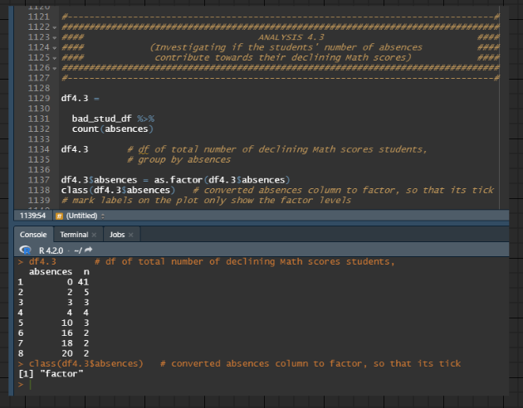

Figure 68: Source Code for grouping declining mathematics marks students by absences column, summing observations for each absences grouping, and factoring the absences column

The data frame, *df4.*3, contains observations from *bad_stud_df* that are grouped according to the absences column with the help of the *count()* function.

The absences column from the data frame, *df4.*3, is converted to a factor solely for displaying only its factor levels at the x-axis tick labels. Without it, the x-axis tick labels will follow an undesired value sequence ranging from 0 to the maximum value of the absences column.

### Data Visualization 4.3

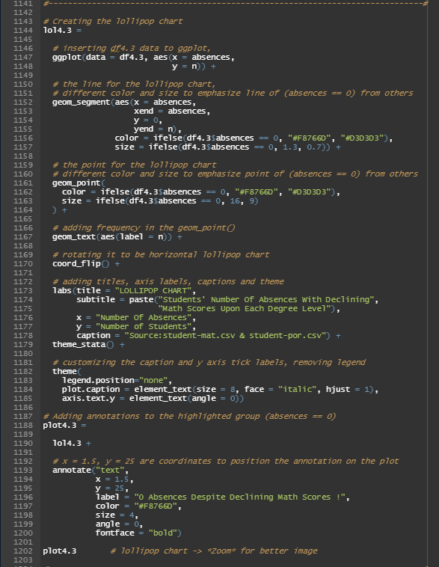

Figure 69: Source Code for producing Lollipop Chart (Analysis 4.3)

The lollipop chart, *plot4.3*, is drawn by first passing *df4.*3as the data frame to the *ggplot()* function. Afterwards, the x aesthetic mapping receives the absences column, while the y aesthetic mapping receives the n column (number of observations for each absences grouping).

Lines 1152 to 1157 called the *geom_segment()* function to insert the line segment for the lollipop chart. The aesthetic mapping specifies the position and the length for each line segment. A unique colour and size are provided to the 0 absences line segment to emphasize its observations, while the remaining line segments adopt another colour and size.

Lines 1161 to 1163 called the *geom_point()* function to provide a unique colour and size for the 0 absences point to emphasize its observations, while the remaining points adopt another colour and size. It is worth noting that the unique colours of the 0 absences point will be similar to the colour provided to the 0 absences line segment. Meanwhile, the colour provided for the remaining points will be similar to the colour provided for line segments that do not equal 0 absences.

Line 1167 calls the *geom_text()* function to insert the n column (number of observations for each absences grouping) to the label aesthetic mapping, which labels the frequency for each absences grouping in the *geom_point()*.

Lines 1173 to 1185 are for **COSMETIC REASONS**.

Lines 1193 to 1200 are for inserting a text annotation on the lollipop chart using the *annotate()* function. The text "0 Absences Despite Declining Math Scores !" will be positioned just above the 0 absences line segment by providing the correct x and y coordinates. The text colour will also adopt the same unique colour provided for the 0 absences line segment and 0 absences point to emphasize its connection. The remaining codes between 1193 to 1200 are purely aesthetic customization for the annotation elements.

The result of *plot4.3* is illustrated in Figure 70.

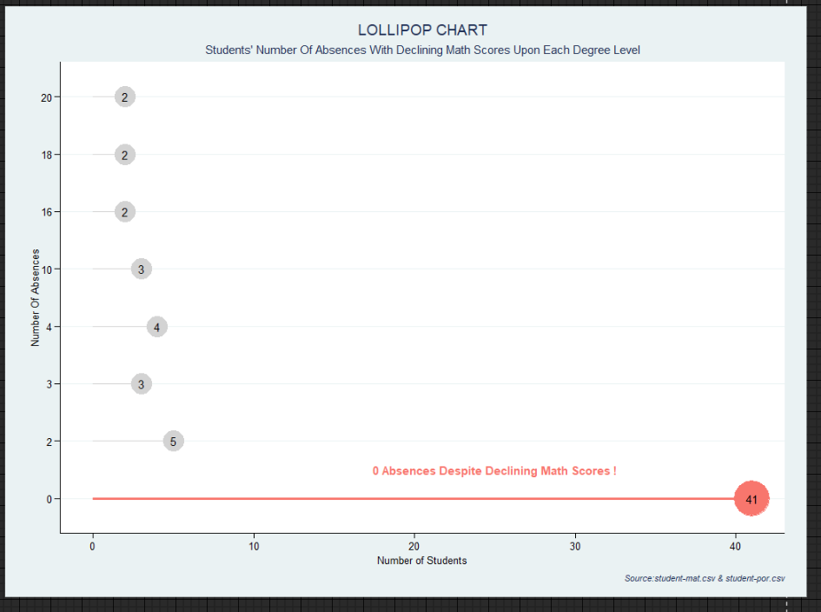

Figure 70: Lollipop Chart (Analysis 4.3)

### Findings 4.3

Based on Figure 70, the red lollipop indicates that most students with declining mathematics marks at each degree level surprisingly record 0 absences during their undergraduate studies. The number of declining mathematics marks students who attended every class throughout the semester was 41, which is proportionally more significant than those who reported one or more absences. Hence, the findings infer that number of absences is not a metric for assessing students with decreasing mathematics marks at each degree level.

### Justification 4.3

Attending class frequently over the semester is not an assurance that students will actually learn in class (University of Southern Maine, n.d.). According to the University of North Carolina at Chapel Hill, active note-taking during class lectures is essential for university students to maximize their academic learning since it aids in absorbing and consolidating the teaching materials (The Learning Center, n.d.). However, university students are independently accountable for jotting down notes in their classes (Post University, 2020). Lecturers do not demand it, nor are there disciplinary or grading penalties if students fail to do so. In fact, the latter is true across all formative assessments and tutorials in most universities (ExamSoft, 2019). With this perspective, it is not unreasonable to imagine that some of the declining mathematics marks students above may take advantage of this lack of oversight as there are no academic repercussions. Nevertheless, their failure to perform notes in class or complete take-home exercises can easily result in them forgetting lectures, thus increasing their strain to revise the mathematics contents at the end of the semester in preparation for its summative assessments. Consequently, they compromize their mathematics grades despite maintaining flawless class attendance rates, contributing to the above findings.

### Recommendation 4.3

As formative assessments are intended to evaluate students' understanding, with lecturers providing feedback on their tutorial or exercise answers, pairing a letter grade will distract students from fully processing the given input (Carnegie Mellon University, n.d.) (Loewus, 2015). Hence, academic instructors and professors should attempt to increase the interactive and engaging nature of their formative assessments to boost the participation of students. Using a game-based e-learning platform such as Kahoot, the mathematics lecturers of the above students may construct digital arithmetic quizzes, which are conveniently accessible to any student with a smartphone or a laptop—a commonplace on today's university campus (Edwards, 2022). For instance, the lecturers may utilize Kahoot to host live-play team-mode sessions for portions of their tutorial lessons, which divides the class into groups while answering the questions (Grattan, 2021). As Kahoot has a podium that monitors the top three teams that recorded the highest score, this will foster healthy competition among students as they collaborate to come up with the correct solutions for the questions to climb up the scoreboard (Kahoot, 2016). Likewise, the faster a student solves a question, the higher the points are awarded to the student's team, mitigating procrastination among team members while sparking fruitful and productive discussions during the quiz (Smore, n.d.). Hence, it should not come as a surprise that more than 80 per cent of students acknowledged that Kahoot elevated their interest, engagement and motivation for participating in a quiz based on the conclusion submitted by the Seberang Perai Polytechnic institute (Ahmad, 2017). Consequently, these students will indirectly engage in active learning, compounding their comprehension and long-term memory retention of the subject, which benefits their academic performance and future attainment of better mathematics marks (Grattan, 2021).

## Question 5: What are the factors that influence students' average Math marks ?

### Data Manipulation For Question 5's Analyses

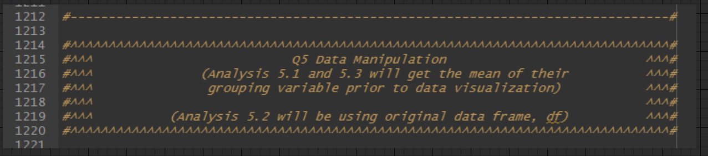

Figure 71: Explanation of how the data manipulation is carried out for Question 5's Analyses

This is just a reminder that Analysis 5.1 and 5.3 will be carrying out additional data manipulation, while Analysis 5.2 will be adopting the original data frame, *df*, for its analysis; hence the latter does not execute additional data manipulation. The gist of the additional data manipulation in Analysis 5.1 and 5.3 is that they will be getting the mean for each grouping following the attribute they are investigating.

## Analysis 5.1: Investigating if the students' travel time to school has an impact on their average Math scores

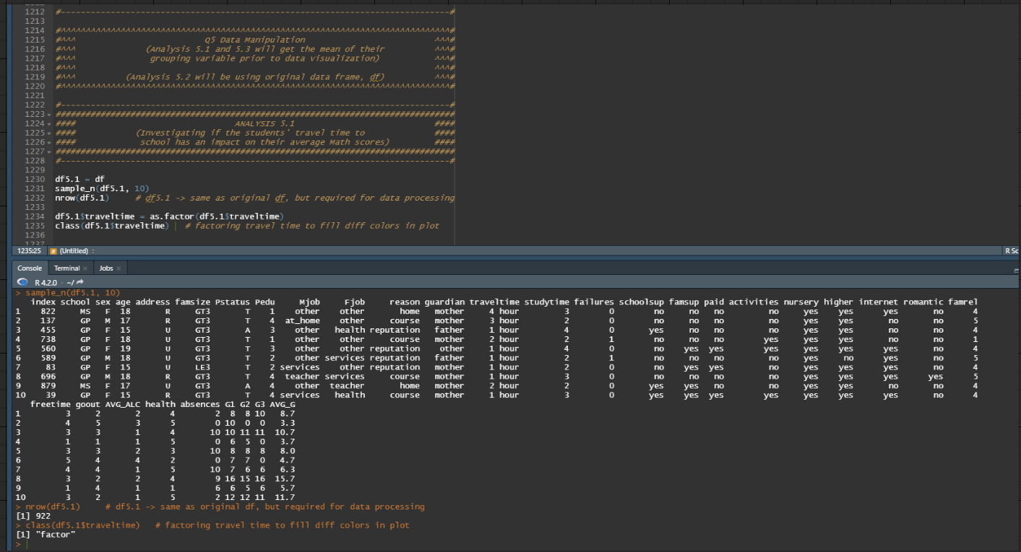

Figure 72: Souce Code for copying original data frame, df, to new data frame, df5.1, and then factoring the traveltime column of the new data frame, df5.1

The data frame, *df5.1*, has the exact same rows and columns as the original data frame, *df*. However, it is required for additional data manipulation without modifying the original data frame, *df*. As seen in line 1234, the traveltime column in the data frame, *df5.1*, is converted to a factor to allow different colours to fill each traveltime grouping during data visualization.

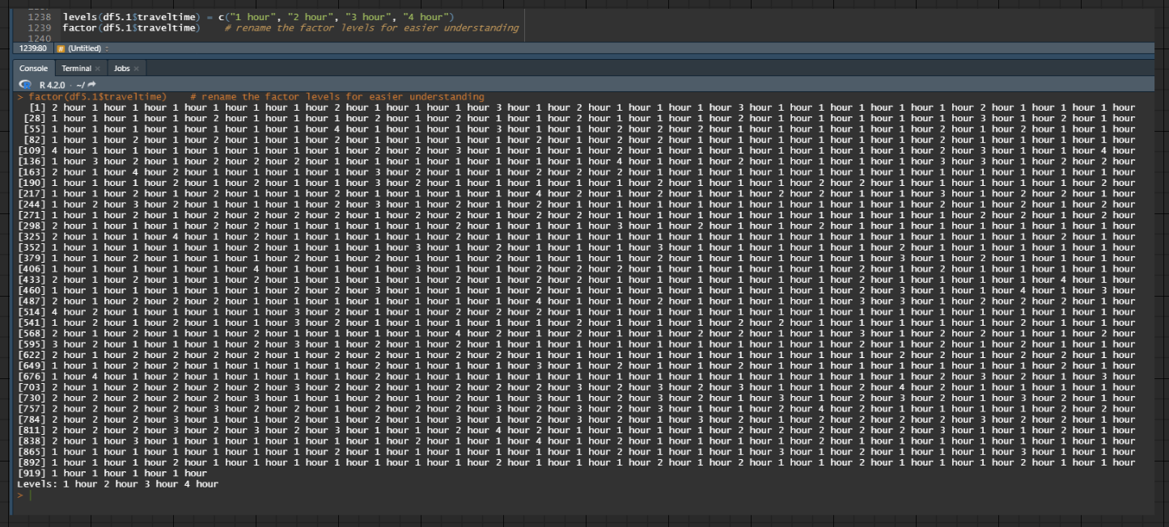

Figure 73: Souce Code for replacing factor levels in traveltime column from the data frame, df5.1

The factor levels for the traveltime column in the data frame, *df5.1*, are replaced with character values that are easier to comprehend.

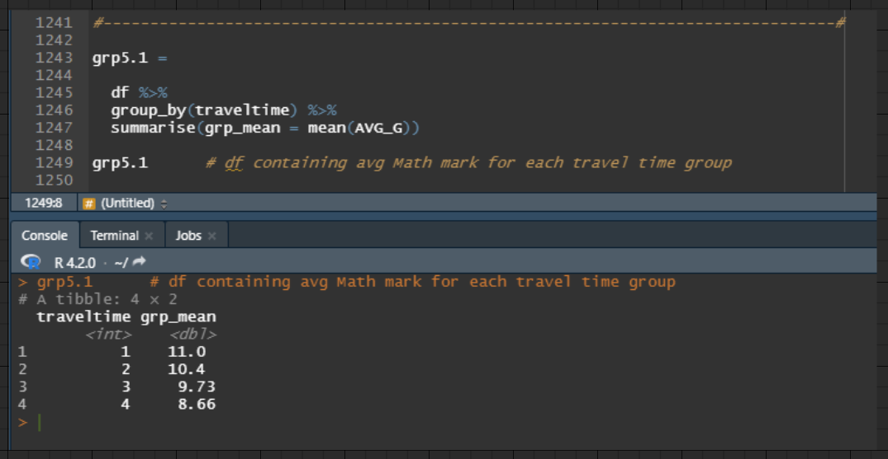

Figure 74: Source Code for grouping all students by traveltime column and calculating the mean average mathematics score (AVG_G) for each traveltime grouping

The new tibble object, *grp5.1*, is the combination of grouping the records in the original data frame, *df*, by the traveltime column and further calculating the group mean of their AVG_G (three-year average mathematics score) observations. Thus, the result is a data frame containing the mean AVG_G (three-year average mathematics score) for each traveltime grouping.

### Data Visualization 5.1

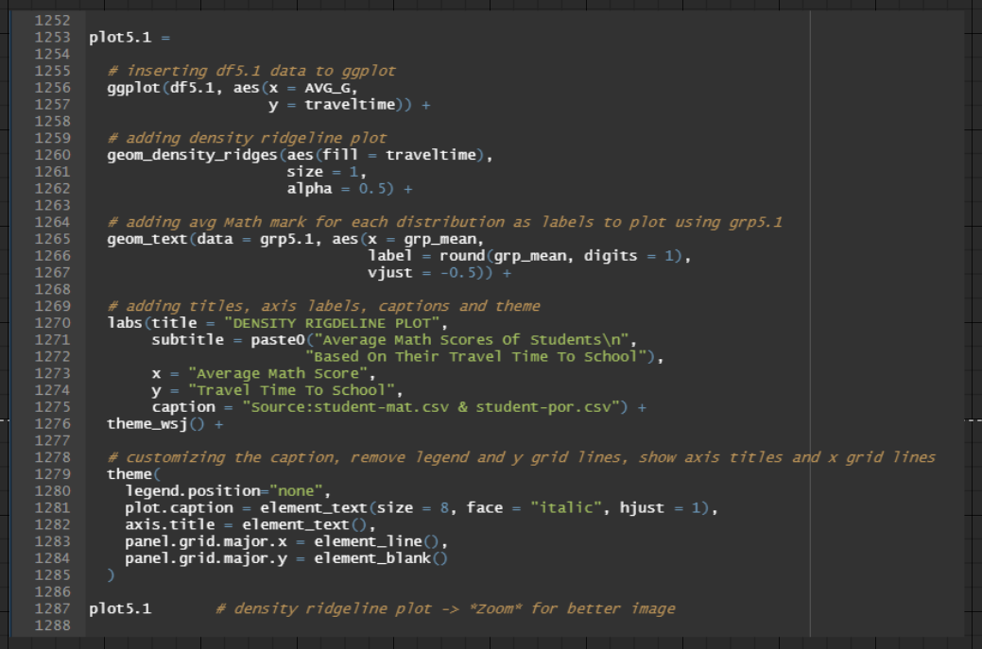

Figure 75: Source Code for producing Density Ridgeline Plot (Analysis 5.1)

The density ridgeline plot, *plot5.1*, is drawn by first passing *df5.*1as the data frame to the *ggplot()* function. Afterwards, the x aesthetic mapping receives the AVG_G column, while the y aesthetic mapping receives the traveltime column. In line 1260, the density ridgeline plot is produced by calling the *geom_density_ridges()* function and supplying the traveltime column to its fill aesthetic mapping to allow different colours for each traveltime distribution. Lines 1261 and 1262 are adjusting the size of each distribution line and the colour-fill opacity, respectively, purely for aesthetic reasons.

Between lines 1265 to 1267, the group mean from the tibble object, *grp5.1*, will be inserted as labels into its corresponding distribution by using the *geom_text()* function. Each group mean label in each distribution is placed at the exact x-position that corresponds to its mean value and rounded to one decimal place.

Lines 1270 to 1282 are for **COSMETIC REASONS**. Additionally, lines 1283 and 1284 are for **REMOVING GGPLOT COMPONENTS**.

The result of *plot5.1* is illustrated in Figure 76.

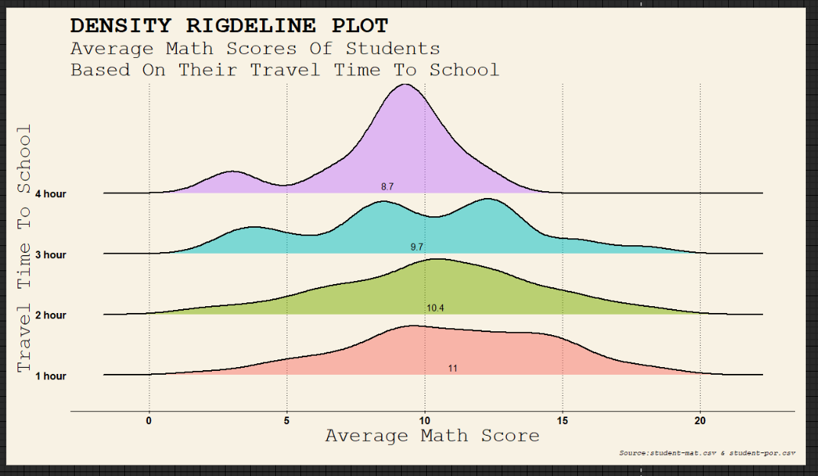

Figure 76: Density Ridgeline Plot (Analysis 5.1)

### Findings 5.1

Based on Figure 76, the density ridgeline plot illustrates a linear relationship between students' travel time to school and their three-year average mathematics marks. For instance, students with the longest commute time of 4 hours to school had the lowest mean mathematics score of 8.7, while students with the shortest commute time of 1 hour to school had the highest mean mathematics score of 11. Hence, the findings infer that the longer it takes students to travel to university, the worse their average mathematics grades are.

### Justification 5.1

According to a collaborative analysis undertaken by researchers from California Polytechnic State University, Rutgers University and University of California, Los Angeles, students with lengthier commutes to school are more likely to experience sleep deprivation and insufficient exercise. They can only sleep an average of fewer than 6 hours each night, and their daily exercise amount is 75 minutes fewer than students with shorter commutes (Florida, 2019). With this perspective, it is reasonable to suggest that the above students with longer travel hours to school suffer poorer mental and physical health than those with shorter travel hours. Firstly, when students fail to obtain an average sleep of 7 to 10 hours a day recommended for their age, they can experience temporary cognitive impairment that hinders their problem-solving capacity and concentration in class (Nazario, 2020). Similarly, inadequate sleep compromises memory retrieval, which obscures their ability to effectively recall course materials for presentations and examinations (ISD Health Solutions, n.d.). In terms of physical health, students who struggle to exercise regularly fail to stimulate the interaction and amalgamation of their nerve cells, which is storing new knowledge at the molecular level (Barile, n.d.). Thus, they compromize their memory encoding and consolidation capacity, rendering it substantially more problematic for them to fully absorb lessons in lectures. Based on an article commissioned by the North Carolina Research Campus, students with low fitness levels had approximately a 40 per cent higher risk of developing upper respiratory disease and worsening their symptoms than students who exercise frequently (Nieman, Henson, Austin, & Sha, n.d.). Consequently, they tend to report sick for school, forcing them to miss academic lectures and tutorials where they are deprived of valuable insights and perspectives on a subject topic presented by lecturers. Therefore, inadequate sleep and insufficient exercise can culminate in students experiencing a weaker psychological and physical state that negatively impacts their end-of-semester marks, including their mathematics scores. Hence, this could be the phenomenon experienced by students with longer commutes, which explains why their mean mathematics marks are lower than those of their peers with shorter commutes in the above findings.

### Recommendation 5.1

In most cases, students with long commutes to school are burdened by the geographical location of their homes. Hence, these students can consider their universities' available on-campus and off-campus accommodations. These housing alternatives are strategically located within walking distance of the university premise (on-campus accommodation) or residential areas that are close to the university (off-campus accommodation) (University of Nottingham Malaysia, n.d.) (Taylor's Hostel Management, n.d.). Moreover, most universities also equip two-way transportation services, such as free shuttle busses to and from their off-campus residence halls, as an additional perk for students who choose these housing options (Asia Pacific University of Technology & Innovation, n.d.). Hence, the shorter distance to school and not getting up at odd hours or dealing with traffic jams will allow students to have sufficient sleep and exercise (StudyMalaysia, 2014). Consequently, these students will heighten their mental and physical condition to efficiently consume knowledge from their lectures, enhancing their academic performance. However, universities should also have supplementary measures to aid students whose financial circumstances are less fortunate to afford the supplied housing options. For instance, they can actively promote student concession cards provided by domestic public transportation systems, which offer savings for students pursuing tertiary education. According to the descriptions provided by MyRapid, which conducts bus and train rides in Malaysia, university students that register for their student concession cards with a nominal fee will halve their regular transit prices (Prasarana Malaysia Berhad, n.d.). Hence, the Portuguese universities in this dataset can explore similar discounts issued by their regional public transit providers. Subsequently, they can construct a virtual application process through which students can conveniently acquire reference letters from their institution, validating their tertiary education status for the approval process required for the student concession card (Hadi, 2022). As a result, students whose long commutes reasons are financial constraints, such as their parents only having one vehicle to simultaneously send them and their siblings to school daily, can utilize the student concession card to receive significant savings when adopting public transport as an alternative mode of travel to commute to their university. Therefore, they avoid arriving late for classes and missing essential tips provided by their lecturers, which can benefit their revision or report writing, thus increasing their likelihood of achieving better marks for their final assessments.

## Analysis 5.2: Investigating if students' legal guardian has an impact on their average Math scores

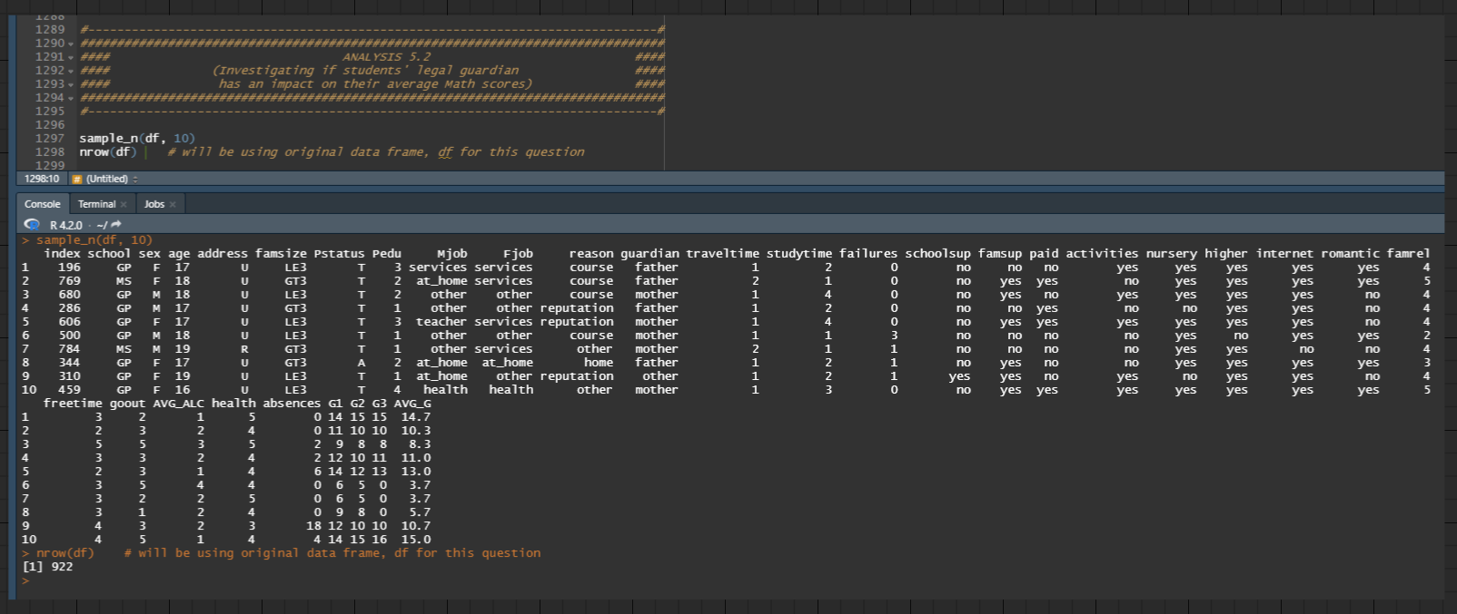

Figure 77: Using original data frame, df

As mentioned previously, analysis 5.2 will be adopting the original data frame, *df*, for its data visualization. Thus, there is no additional data manipulation executed in this analysis.

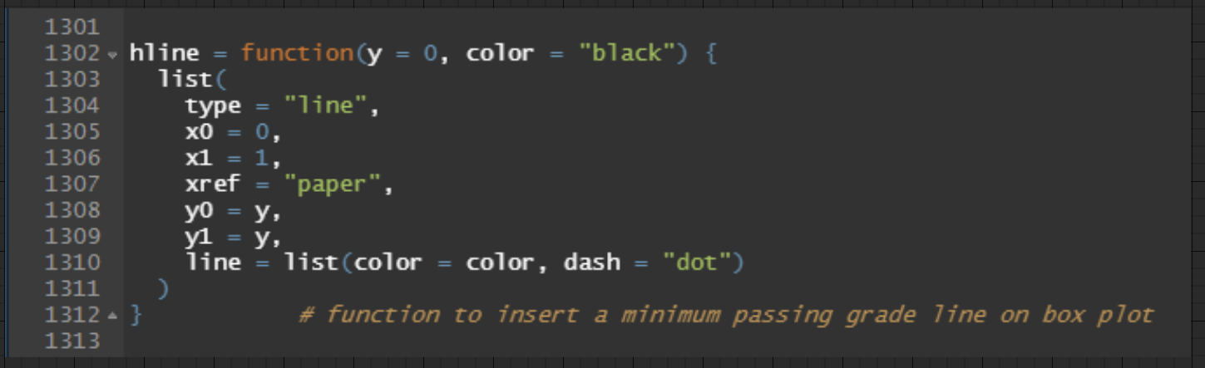

Figure 78: Source Code for creating hline() function to insert a horizontal line on box plot

The function, *hline*, is created to insert a horizontal line to display the minimum passing grade line on the plot. It takes in 2 arguments, y-coordinate (integer) and line colour (character). The former is to position the horizontal line at the desired y-intercept. The latter is to modify the line colour of the y-intercept. It is worth noting that both the parameters of the *hline* function have default arguments where the horizontal line will align at a y-coordinate of 0 and be of black colour if no arguments are provided.

### Data Visualization 5.2

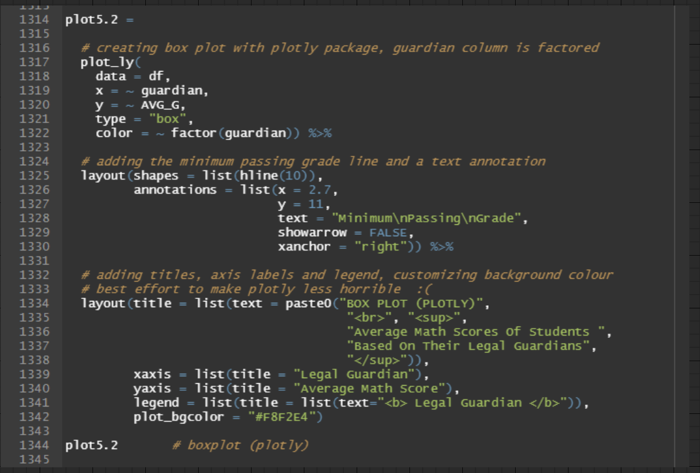

Figure 79: Source Code for producing Plotly Box Plot (Analysis 5.2)

The box plot, *plot5.2*, is drawn using the *plot_ly()* function by passing *df* as the data frame, guardian column as the x value, and AVG_G(three-year average mathematics mark) column as the y value. The color parameter receives a temporary factored guardian column to allow different colours for each box plot.

Lines 1325 to 1330 are to add a horizontal line and text annotation to the box plot by using the *layout()* function. Line 1325 adopts the *hline* function to modify the default y-coordinate argument to 10, which produces the minimum passing grade line on the box plot. Lines 1326 to 1330, add the text "Minimum\nPassing\nGrade" to be just above the horizontal line and the right side of the box plot to provide text information that the line is the minimum passing grade for the mathematics subject.

Lines 1334 to 1342 are for **COSMETIC REASONS.**

The result of *plot5.2* is illustrated in Figure 80.

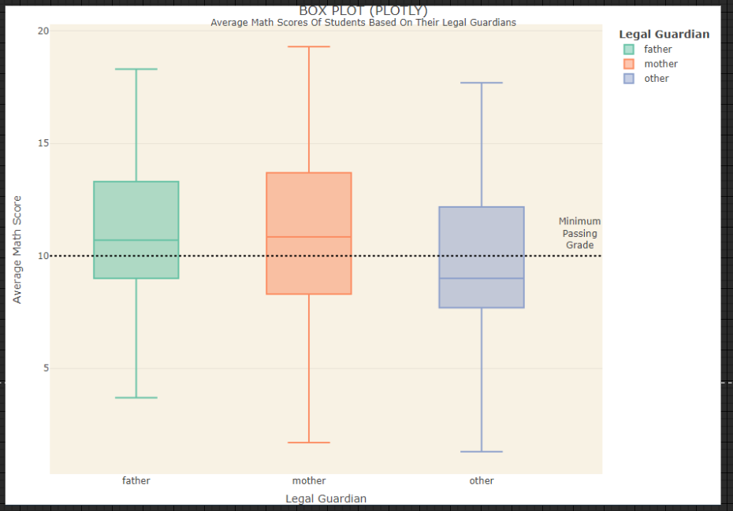

Figure 80: Plotly Box Plot (Analysis 5.2)

### Findings 5.2

Based on Figure 80, the box plot illustrates that most students whose legal guardians are neither their biological parents recorded lower average mathematics marks than those under the custody of either their birth fathers or mothers. In fact, students under the guardianship of "other" legal guardians, such as their foster or adoptive parents, have a median mathematics score of 9, which does not meet the module's minimum passing requirements. Hence, the findings infer that students residing with neither of their biological parents have a higher likelihood of experiencing lower mathematics scores in their undergraduate studies.

### Justification 5.2

According to a study commissioned by the Harvard Medical School, the University of Michigan and Casey Family Programs, individuals from foster homes twofold their development of post-traumatic stress disorders (PTSD) compared to military servicemen (Plotkin, 2005). Likewise, according to an article published by The Guardian, approximately 50 per cent of foster children do not receive adequate mental health support, which has contributed to incidences of domestic violence, parasuicide, running away from home and entanglement with law enforcement officials (Sissay, 2019). Hence, it is fair to suggest that students of "other" legal guardianship who were in foster care before adoption or are still living with their foster parents may have suffered acute or chronic psychological trauma. For instance, several of them might have tragically witnessed the death of their biological parents in a car crash (acute psychological trauma), or they grew up in a hostile environment due to the excessive drinking behaviour of their biological mothers or fathers (chronic psychological trauma) (Bence, 2021). Without proper diagnosis and treatment for their emotional distress, they are susceptible to worsening their PTSD symptoms, such as persistent flashbacks and apprehension (Mayo Clinic, 2018). As a result, their academic performance may deteriorate as abrupt and invasive thoughts can swiftly engulf their minds with memories from the past, raising their anxiety and tension when recounting traumatic experiences. Consequently, the latter will inhibit their ability to concentrate during academic sessions, including lectures, revision, report writing, assessments, etc., as they may need to isolate themselves from other engagements to subside their PTSD flare-up (Mental Health America [MHA], n.d.). When their headspace is sensitive to tragic accounts, they will find it difficult to fully immerse themselves in their academic activities, which compromizes their grades in the semester. Thus, these phenomena may explain why they have lower average mathematics scores than their peers with biological fathers or mothers as their legal guardians.

### Recommendation 5.2

With 85 per cent of students recorded having one or more traumatic episodes before enrolling on a university, there is a need for tertiary instructors to adopt trauma-informed teaching throughout their academic engagements (Frazier, et al., 2009). Firstly, trauma-informed teaching is not requesting university lecturers and professors to become mental health specialists or psychologists. It is merely the mindset for instructors to have the foresight and comprehension of how trauma might influence the educational experience of students who have PTSD (Kaufman, n.d.). When instructors are equipped with basic trauma knowledge and understanding, they may devise personal psychosocial interventions that can be incorporated into their classroom sessions to subdue the heightened "fight or flight" syndrome experienced by most PTSD students (Waters & Brunzell, 2018). For instance, academic educators can begin their lectures and tutorials by inviting students to perform a mindful breathing exercise with the cycle of inhaling deeply through the nose and exhaling through the mouth for several minutes (Resilient Educator, 2021) (Woerkom, 2020). When this occurs, students practice self-regulation, which allows them to be more aware and present with their surroundings. For students with PTSD, the action can alleviate their anxiety and trepidation as the breathing practice diminish their likelihood of recalling traumatic experiences and memories before class (Harvard Medical School, 2020). With lecturers emphasizing the earlier breathing practice as one of the take-home messages before class dismissal, students will be conscious of applying the self-regulation technique when stressful and overwhelming situations demand it (Woerkom, 2020). For instance, PTSD students who have a higher propensity to exaggerate their emotional instability can adopt the breathing exercise before the commencement of a class presentation or a final paper. Consequently, they can relax and soothe their minds, mitigating the emergence of tragic flashbacks and temporary dissociation (Tull, 2022). Thus, they can increase their focus and engagement on the subject at hand, excelling in their presentation delivery or examination performance, which outcomes in achieving better end-of-semester grades (Woerkom, 2020). Therefore, it is concisely demonstrated here that instructors who embrace trauma-informed teaching can profoundly impact trauma-affected students since their therapeutic techniques can positively influence their academic interactions, which increases their attainment of higher assessment results.

## Analysis 5.3: Investigating if students' past class failures has an impact on their average Math scores

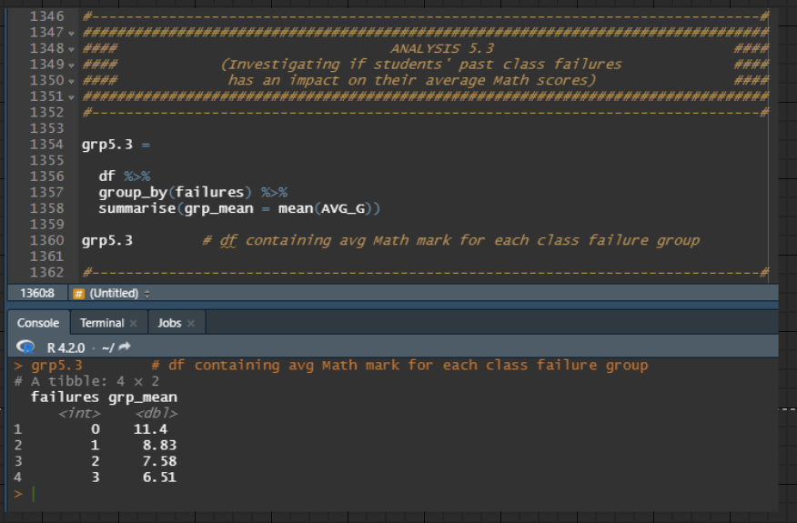

Figure 81: Source Code for grouping all students by failures column and calculating the mean average mathematics score (AVG_G) for each failures grouping

The new tibble object, *grp5.3*, is the combination of grouping the records in the original data frame, *df*, by the failures column and further calculating the group mean of their AVG_G (three-year average mathematics score) observations. Thus, the result is a data frame containing the mean AVG_G (three-year average mathematics score) for each failures grouping.

### Data Visualization 5.3

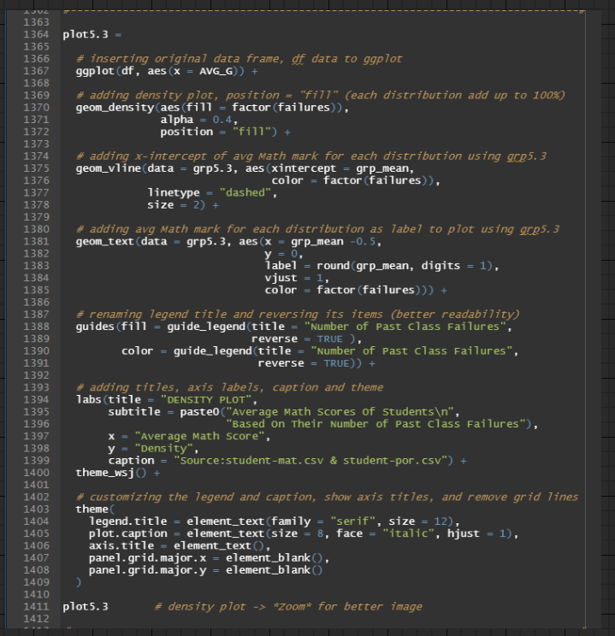

Figure 82: Source Code for producing Density Plot (Analysis 5.3)

The density plot, *plot5.3*, is drawn by first passing *df5.*3as the data frame to the *ggplot()* function. Afterwards, the x aesthetic mapping receives the AVG_G column. In line 1370, the density plot is produced by calling the *geom_density()* function and supplying the failures column to its fill aesthetic mapping to allow different colours for each failures distribution. Afterwards, line 1371 adjusts the colour-fill opacity, while line 1372 layers each distribution together where the total distribution equals 100 per cent.

Lines 1375 to 1378, insert a vertical line for each distribution by using the group mean from the tibble object, *grp5.3*, as the x-intercept coordinate in the *geom_vline()* function. The result produces an x-intercept in each distribution, reflecting the mean average mathematics score for each number of failures.

Lines 1381 to 1385, insert a label for each distribution by using the group mean from the tibble object, *grp5.3* and supplying it to the *geom_text()* function. Each group mean label in each distribution is placed along the same y-position and slightly above the x-position that corresponds to its mean value. Likewise, each group mean label is rounded to one decimal place and adopts the same colour that was earlier provided in the fill aesthetic mapping in the *geom_density()* function.

Lines 1388 to 1391 rename the legend title for easier comprehension and override the default ascending arrangement of the legend items to be in descending order, matching the bottom-up arrangement of the density plot.

Lines 1394 to 1406 are for **COSMETIC REASONS**. Additionally, lines 1407 to 1408 are for **REMOVING GGPLOT COMPONENTS**.

Likewise, line 690 is to modify the x-axis scale values to range from 15 to 22, with an increment of 1 for each corresponding x tick label since there 8 age groupings are within those values.

The result of *plot5.3* is illustrated in Figure 83.

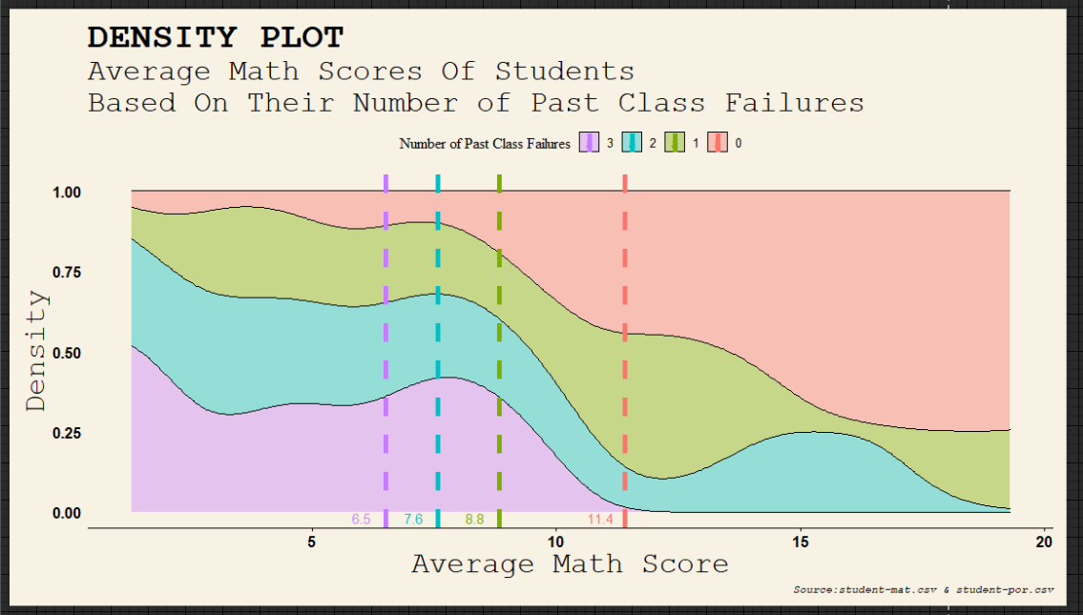

Figure 83: Density Plot (Analysis 5.3)

### Findings 5.3

Based on Figure 83, the density plot illustrates a linear relationship between students' three-year average mathematics marks and their number of past class failures for the subject. For instance, students that recorded 3 past class failures had the lowest mean mathematics score of 6.5, while students that had yet to fail the subject had the highest mean mathematics score of 11.4. Likewise, the density plot also showed that students with 1 or more past class failures for the mathematics subject on average fail to meet the score of 10, which is the minimum passing criteria in Portugal's tertiary education grading system. Hence, the findings infer that students with a lower number of past class failures for the mathematics module have a higher likelihood of attaining better average marks for the subject; however, if they have 1 or more previous class failures for the mathematics module, their average marks is still highly likely to fall short of the minimum passing standards.

### Justification 5.3

Internationally, most universities adhere to a standard convention of capping the marks for their examination resits to be equivalent to the minimum passing grade unless the student provides extenuating circumstances. Similarly, if a student fails to attain the minimum passing mark on their second examination attempt, they have the option to repeat the course, but only once (Oxford Brookes University, n.d.). However, it is worth noting that their first and second assessment attempts while retaking the module will also be limited to the lowest passing score (Sheffield Hallam University, n.d.). With this perspective, it is reasonable to assume that both Gabriel Pereira University and Mousinho da Silveira University, included in this dataset, also implement similar marks restrictions for their examination resits and module retake policy. Hence, this means that students who failed their mathematics subject in a semester can only earn a maximum score of 10 points when they resit for it in their second attempt to pass the module. In contrast to their first examination attempt, the total marks attainable for the subject was 20 points, which means they effectively halved the range of their assessment scores by failing once for the module. Even if they opt to retake the mathematics module, their two examination attempts will still be capped at 10 points —the minimum passing mark. Not to mention, most universities also do not immediately announce students' summative assessment results at the conclusion of the semester. The provisional results may come several weeks or months later when students are already engaging in subsequent semesters (Swansea University, n.d.). Hence, if students discover they had just failed their mathematics subject from the past semester, it is an additional burden for them as they have to allocate study time to independently revisit the course materials in preparation for the scheduled reassessment. Suppose they failed their reassessment attempt and choose to repeat the module, this means they are obligated to re-attend all classes for the subject on top of classes in their current semester (University of Westminster, n.d.). Thus, they overload their usual credit hours for the semester, straining their ability to revise and reinforce the learning resource for each subject as they have less time outside of class. Consequently, some of them may fail to execute sufficient practice for their mathematics exercise and tutorials, leaving them in a compromized position to perform well in its examination. If they fail to attain the minimum passing requirement again, they are afforded a second attempt, but it will be their last reassessment attempt for the module. Hence, they continue to repeat the vicious cycle of studying a module which initially was supposed to be completed many semesters

ago. Therefore, the combination of halving the maximum attainable points, coupled with students having to undergo multiple revisions, or potentially repeat classes if they failed their initial two assessment attempts, may have explained why students with 1 or more past class failures on average fail to reach the minimum passing score in the above findings.

### Recommendation 5.3

In most universities, provisional marks are published weeks or months after the end-of-semester date to allow sufficient time for internal moderation. It ensures each examiner adheres to a specific marking standard and that all students' assessment marks are distributed equitably (Cambridge University Press & Assessment, n.d.). Thus, the following discussion will serve to guide students on measures to improve their likelihood of passing the mathematics subject on their first attempt. Firstly, students should increase their efforts in preparing the necessary study materials before the semester begins. For instance, students can survey their academic calendars to view the mathematics courses they will be attending in their upcoming semesters. Afterwards, they can communicate with their academic counsellors to elicit the names of instructors who will be teaching the subjects. By approaching these lecturers or professors through school email, students can request the modules' latest lecture slides and tutorial exercises. Some academic instructors may also recommend acquiring supplementary reading resources from the library or their seniors, given their willingness to prepare early (Herzing University, n.d.). Thus, even before the commencement of the semester, students may begin making arrangements to borrow study resources from the library or contact seniors about purchasing them at a discounted price. Consequently, they avoid wasting time in the first few weeks of the semester to carry out the above actions, enabling them to devote more time to revision and practising tutorial questions. Moreover, the possession of the course materials beforehand allows students to be more familiar with them and read them in advance (Herzing University, n.d.). Subsequently, students arrive at lectures with fundamental knowledge and awareness of the mathematics subject, decreasing the learning curve for complex topics. Because a single failure jeopardizes a student's ability to acquire the minimum passing grade, they may consider complementing their tertiary learning with online educational resources, such as Course Hero, albeit paying a subscription plan (Stancheva, 2022). Course Hero is a virtual repository that allows members to view former learning materials contributed by their peers, such as tutorials, lecture notes, assignments, etc., and upload their educational resources to the platform (Garg, 2021) (Wiede, n.d.). Likewise, they also have a feature enabling its members to filter study resources depending on their school, allowing them to tailor their search for more relevant courses and materials that correspond with their university. (Course Hero, n.d.) For example, students can search for additional practice problems and exercises in Course

Hero that matches their mathematics subject's module code. By consistently working on these questions, they can reinforce their mathematical concepts and principles, which strengthens their foundation to tackle more demanding materials (Blutick, n.d.). Consequently, they place themselves in a more favourable position to succeed in their summative assessments as they have supplemented their learning and revision beyond what was required for the subject. Therefore, students taking the initiative to prepare early for a semester and utilizing online educational resources to bolster their mathematics proficiency will increase their propensity to surpass the minimum passing criteria for that subject on their first attempt.

# Additional Features

## Annotations

### annotation_custom()

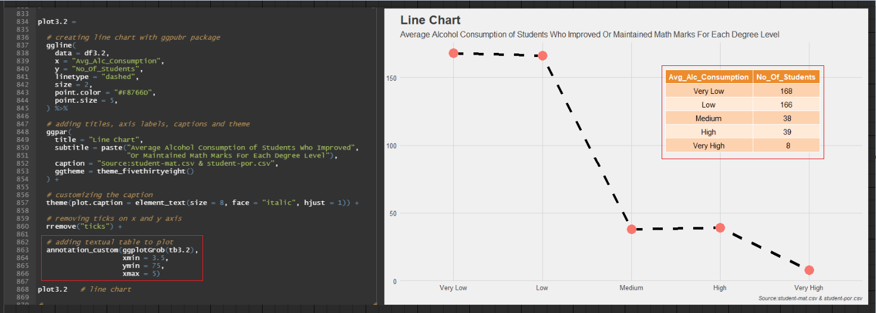

Figure 84: Source Code for the annotation() custom function used in Line Chart (Analysis 3.2)

Referencing Figure 84, the table in the line chart was inserted using the *annotation_custom()* function. The reason for this implementation is to show the number of students for each average alcohol consumption level. As the y-axis scale values range from 0 to 150, with an increment of 50 for each corresponding tick label, providing the line chart itself will be insufficient for the audience to accurately decipher the total number of students for each average alcohol consumption level. Hence, placing the table in the top right corner of the line chart provides a quick reference point for the audience to visibly interpret the number of students for each average alcohol consumption level. Likewise, the *annotation_custom()* functiondoes not interfere or interact with the *ggline()* functionconfigurations as it operates as a static annotation on the plot (Howson, 2022). For instance, the line chart does not increase in size or height to accommodate the table. Referencing Figure 84, lines 863 to 866 show that the table is integrated into the line chart by hardcoding the x and y coordinates' minimum and maximum values, which follows the line chart's x and y scale values. Hence, it is an added benefit for programmers as they can conveniently append the

*annotation_custom()* functionto any *ggplot* package without worrying about modifying the data visualization.

### annotate()

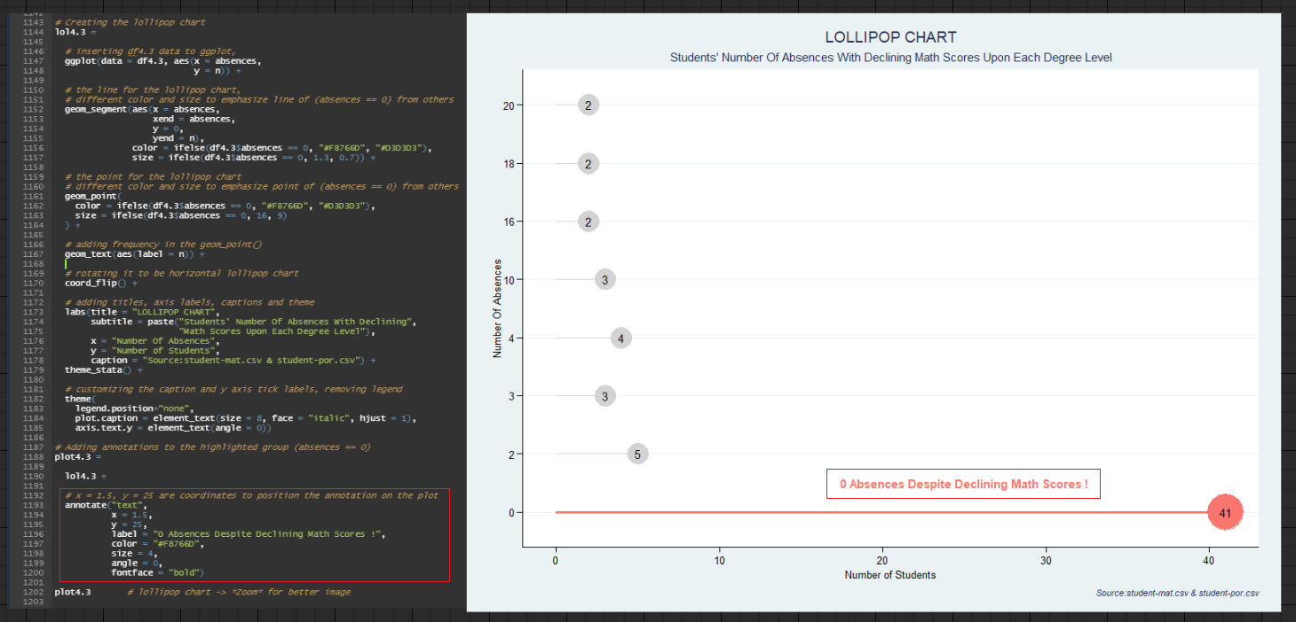

Figure 85: Source Code for the annotate() function used in Lollipop Chart (Analysis 4.3)

Referencing Figure 85, the "0 Absences Despite Declining Math Scores !" textual informationis inserted using the *annotate()* function. This execution aims to draw the audience's attention to the red lollipop, which belongs to the 0 absences category, and reinforce the message that absences are not to blame for students who declined their mathematics marks (Holtz, n.d.). By providing this insightful knowledge, the audience can immediately direct their concentration to the bottommost red lollipop first, instead of the conventional top-down approach intrinsic to the human eye. Consequently, they can accurately interpret the take-home message from the lollipop chart as the *annotate()* function emphasizes the conclusion from the data visualization (Holtz, n.d.). Moreover, it is also a shorter and cleaner implementation than combining the *annotation()* function and the *geom_text()* function to produce the same result. The *annotation()* function takes in a data frame containing x and y coordinates' minimum and maximum values as well as the take-away message as the label, then passes it to the *geom_text()* function for customization and incorporation into the lollipop chart (R Graph Gallery, n.d.). In contrast, referencing Figure 85, the *annotate()* function on lines 1193 to 1200 shortens the preceding execution by permitting x and y alignment, labelling, and customizing to be performed within it and appending the results to the lollipop chart. Hence, if issues arise with the textual information on the lollipop chart, the programmer can quickly narrow down the error detection to the *annotation()* function (Gwentech LLC, n.d.).

## Plotly

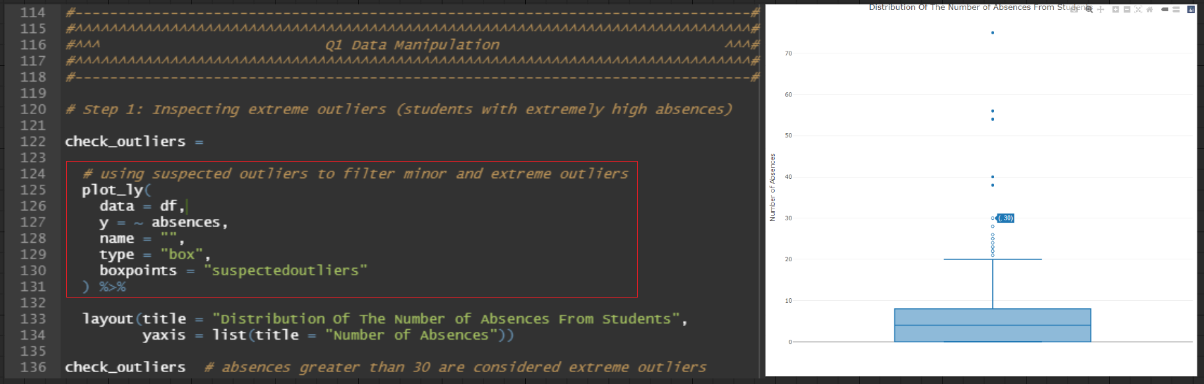

Figure 86: Source Code for the Plotly implementation used in Plotly Box Plot (Data Manipulation For Question 1's Analyses)

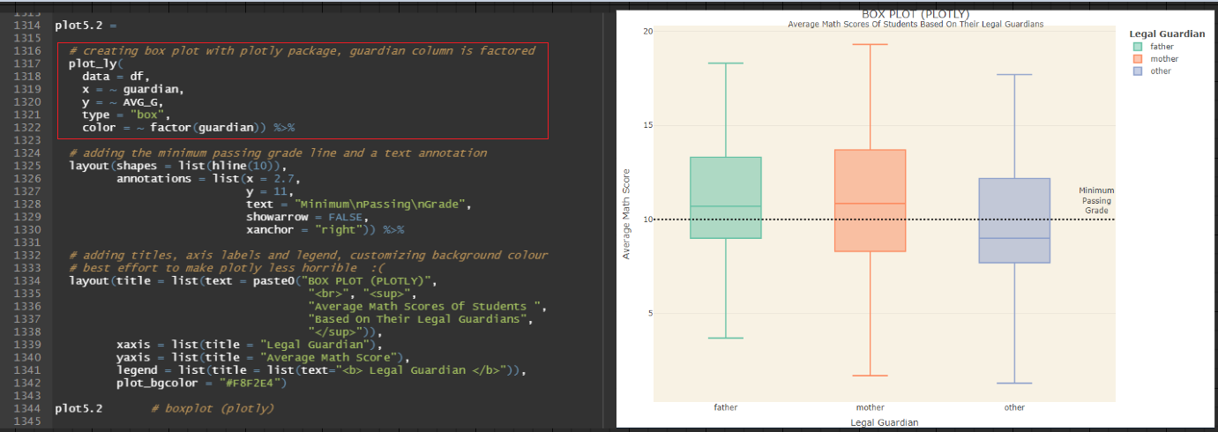

Figure 87: Source Code for the Plotly implementation used in Plotly Box Plot (Analysis 5.2)

Referencing Figure 86 and Figure 87, both box plots were constructed using the *plotly* package. Both implementations were to leverage the interactive nature embedded within the *plot_ly* function (Miller & Shalhout, 2021).

In Figure 86, the *plot_ly* box plot can filter between minor and extreme outliers by passing *"suspectedoutliers"* to its *boxpoints* parameter (Plotly, n.d.). Meanwhile, the *geom_boxplot()* function from the *ggplot2* package and the *ggboxplot()* function from the *ggpubr* package do not provide this feature (RDocumentation, n.d.) (Kassambara, n.d.). Thus, the *plot_ly* box plot may reduce the amount of data eliminated during data manipulation. For instance, referencing Figure 86, the number of absences categorized as outliers in the box plot is separated into two distinctions: the number of absences greater than 20 are minor outliers; however if the number of absences exceeds 30, it is classified as an extreme outlier. By having the option to distinguish the outliers, the programmer can include the minor outliers when calculating students' mean number of absences to avoid omitting excessive data. Thus, the estimated mean from the absences column will more accurately represent the dataset, resulting in better data analysis.

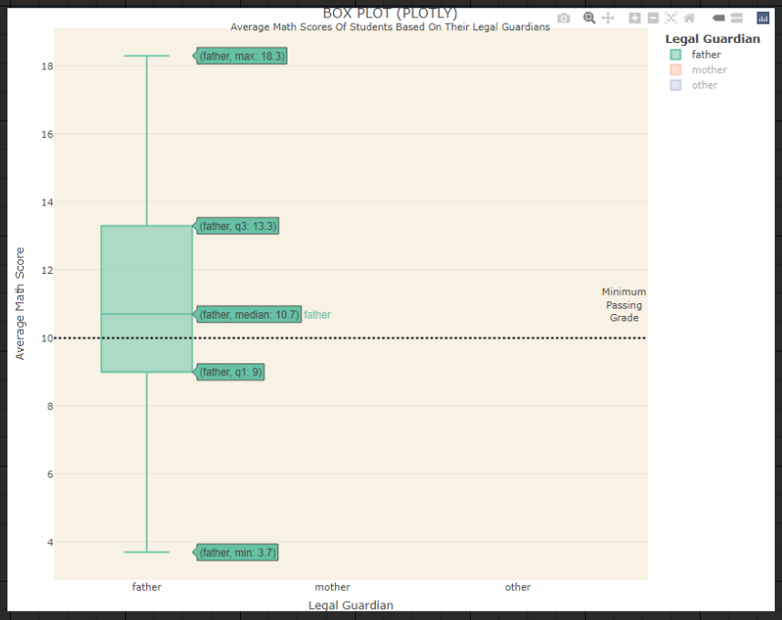

Figure 88: Individual Box Plot showing summary information of students' average mathematics scores if they have their fathers as legal guardians.

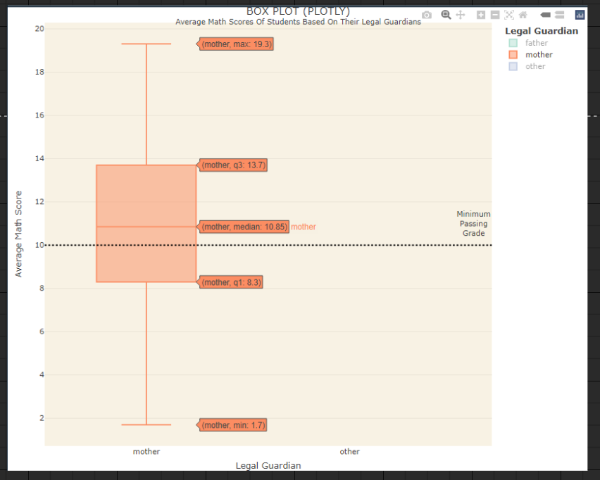

Figure 89: Individual Box Plot showing summary information of students' average mathematics scores if they have their mothers as legal guardians.

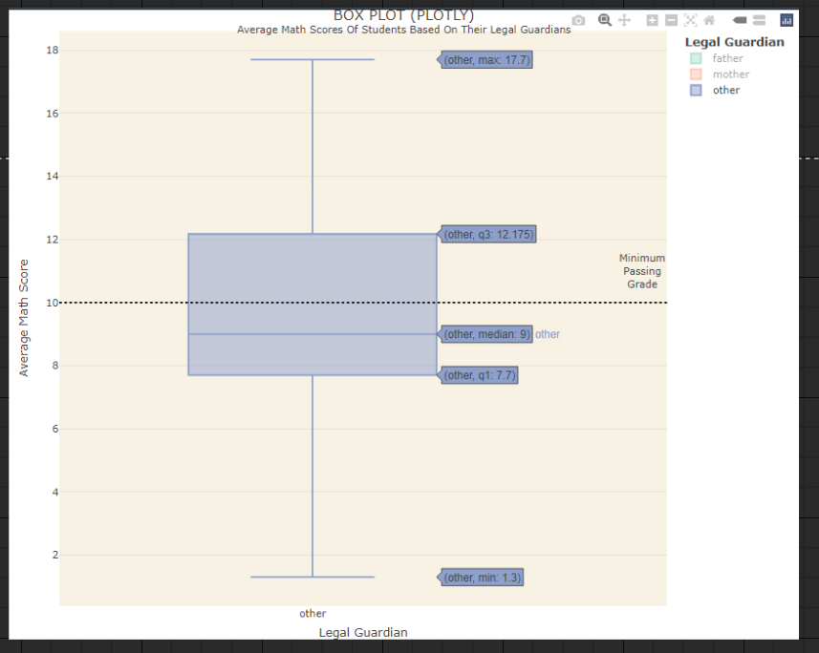

Figure 90: Individual Box Plot showing summary information of students' average mathematics scores if they have others as legal guardians (foster or adoptive parents).

In Figure 88, Figure 89, and Figure 90, the *plot_ly* box plot was utilized to lend its interactive feature during data presentation (Miller & Shalhout, 2021). By default, the *plot_ly* box plot supplements the visibility and comprehension of its summary information by displaying the minimum, first quartile, median, third quartile, and maximum values when a cursor hovers over each box plot (Schork, n.d.). This is especially helpful when the summary information contains decimal points that cannot be effectively read if the accompanying y-axis scale values fail to follow suit. For instance, referencing Figure 90, the y-axis scale values range from 0 to 20, with an increment of 5 for each corresponding tick label. With the summary information being of 1 decimal place, the audience cannot accurately quantify all values from the box plot if the *geom_boxplot()* function or the *ggboxplot()* function was utilized. However, as Figure 90 is created using the *plot_ly* package, the summary information immediately shows when the audience hovers over the box plot. Thus, this initiative eliminates ambiguity and vagueness among audiences, facilitating a thorough understanding of the box plot.

## Bee Swarm Plot

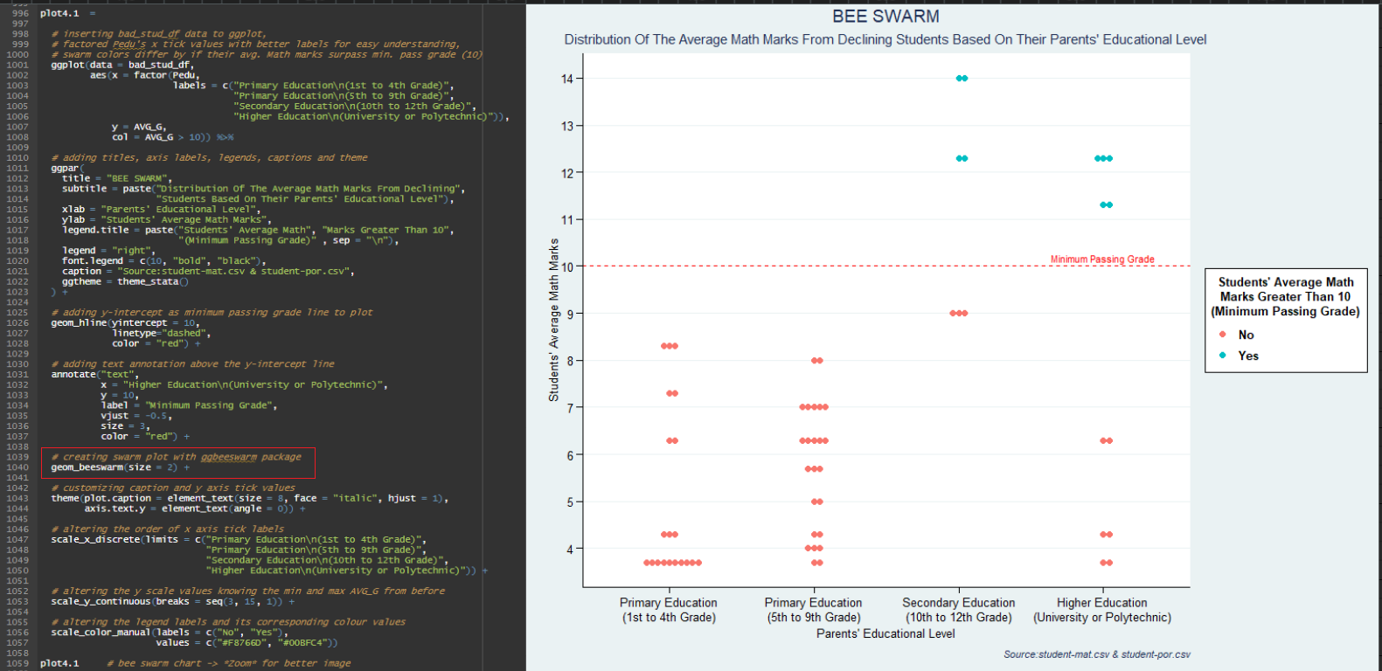

Figure 91: Source Code for the geom_beeswarm() function used in Bee Swarm Plot (Analysis 4.1)

Referencing Figure 91, the distribution of students' average mathematic marks based on their parents' education level was illustrated using a bee swarm plot, albeit students with declining mathematics marks at each degree level. The *geom_beeswarm()* function from the *ggbeeswarm* package is a box plot alternative as it accepts the same kind of data: one categorical data, the other continuous data (Döring, 2018).

Its implementation in Figure 91 is due to its ability to show each average mathematics score as a single point on the plot (Döring, 2018). Likewise, points with the same average mathematics score will not overlap as the *geom_beeswarm()* function default places them across from each other by default, albeit with minimal distance and adjustable spacing. Consequently, audiences can easily observe and distinguish the number of students for each average mathematics score as no data points will be obscured from sight (Rho, 2014).

In contrast, using scatter plots or strip charts for the above distribution will clutter points that have the same average mathematics score, making it impossible for audiences to comprehend the data in its entirety. Subsequently, those data visualization techniques necessitate an additional step of jittering the points to separate their overlay (Rho, 2014). However, adopting the *geom_jitter()* function does not guarantee it will effectively arrange each

average mathematics score in an ordered manner. In most cases, numerous trial and error attempts are required to achieve the desired effect and jittering the plot frequently outcomes in the undesired movement of other points (Rho, 2014).

Hence, using a bee swarm plot would alleviate the above issue since it employs functionality that eradicates overplotting (Döring, 2018). Thus, this contributes to a cleaner and shorter code, which may enhance the readability and clarity of the programme (Gregory, 2017).

# Conclusion

In conclusion, the preceding analyses demonstrated many surprising factors which impacted the academic performance of Gabriel Pereira University and Mousinho da Silveira University students, albeit some more grave than others. For example, those who have failed their mathematics examination on one or more occasions are unlikely to achieve the minimum passing grade when they retake the exam or module. Meanwhile, most students whose mathematics scores plummeted at each degree level had practically perfect attendance rates (0 absences). Now, these are just two of the many findings that were concluded from the preceding discussion. However, these discoveries might serve as a benchmark for university and tertiary students to enhance their tertiary education. By observing the case study of Gabriel Pereira University and Mousinho da Silveira University students, they may get a stronger insight into how they can optimize their actions to facilitate academic achievement. For example, universities imposing curfews on residence halls, fraternities, and sororities would discourage late-night drinking among university students. Likewise, first-year students lowering their credit hours in their first few semesters would help them acclimatise to the rigours of university. Therefore, participants in the higher education sector may benefit from the data analyses, supplementary justifications and practical recommendations that are included in this report.

# References

Ahmad, N. S. (2017). *INTERACTIVE QUIZZES KAHOOT! AS MULTIMEDIA TOOLS THAT EFFECT STUDENTS’ INTEREST, ENGAGEMENT AND MOTIVATION IN ENGINEERING MATHEMATICS 2 COURSE AT POLITEKNIK SEBERANG PERAI .* Retrieved from Adobe Acrobat PDF: chrome-extension://efaidnbmnnnibpcajpcglclefindmkaj/https://www.puo.edu.my/webportal/wp-content/uploads/JTKSS/JKTSSNacosc2017/JKTSS-1-2017-1-291-298.pdf

Alcid, A. (n.d.). *What You Need to Know About the Pass/Fail Grading System*. Retrieved from Colleges of Distinction: https://collegesofdistinction.com/advice/what-you-need-to-know-about-the-pass-fail-grading-system/

Asia Pacific University of Technology & Innovation. (n.d.). *Shuttle Services (Campus Connect)*. Retrieved from New Apu: https://new.apu.edu.my/shuttle-services-campus-connect

Avelino, J. (2022). *Benefits of Active Learning10 Benefits of Active Learning*. Retrieved from EdApp: https://www.edapp.com/blog/benefits-of-active-learning/

Average Salary Survey. (2022). *PORTUGAL / SALARY*. Retrieved from Average Salary Survey: https://www.averagesalarysurvey.com/portugal

Bakar, N. A., Mamat, I., & Ibrahim, M. (2017). *Influence of Parental Education on Academic Performance of Secondary School Students in Kuala Terengganu.* Retrieved from Human Resource Management Academic Research Society [HRMARS]: chrome-extension://efaidnbmnnnibpcajpcglclefindmkaj/https://hrmars.com/papers_submitted/3230/Influence_of_Parental_Education_on_Academic_Performance_of_Secondary_School_Students_in_Kuala_Terengganu.pdf

Barile, N. (n.d.). *Exercise and the Brain: How Fitness Impacts Learning*. Retrieved from Western Governors University: https://www.wgu.edu/heyteach/article/exercise-and-brain-how-fitness-impacts-learning1801.html

Bence, S. (2021). *What’s the difference between acute, chronic, and complex trauma?* Retrieved from Verywell Health: https://www.verywellhealth.com/acute-trauma-vs-chronic-trauma-5208875#:~:text=Acute%20trauma%20is%20a%20single,and%20one's%20sense%20of%20self.

Bennett, M. (2022). *Masters Scholarships – A Guide for 2022*. Retrieved from FindAMasters: https://www.findamasters.com/guides/scholarships

Beresin, G., Schlozman, S., & Abdu-Glass, E. (2017). *The College Mental Health Crisis: A Call for Cultural Change – Part 2*. Retrieved from Clay Center for Young Healthy Minds: https://www.mghclaycenter.org/parenting-concerns/college-mental-health-crisis-call-cultural-change-part-2/#:~:text=Mental%20health%20issues%20are%20increasingly,depressed%20that%20they%20had%20trouble

Bernales, A. M., Tanongon, C., & Colonia, F. (2011). *The Effects of Romantic Relationships on the AcademicPerformance of University of the Philippines*. Retrieved from Academia: https://www.academia.edu/7736954/The_Effects_of_Romantic_Relationships_on_the_Academic_Performance_of_University_of_the_Philippines_Cebu_College_Students_ACKNOWLEDGMENTS

Bilton, I. (2018). *Why it’s crucial that international students don’t skip classes*. Retrieved from Study International: https://www.studyinternational.com/news/why-its-so-crucial-international-students-dont-skip-classes/

Bird, G. (2018). *The Impact of Parents' Education Levels*. Retrieved from Inside Higher Ed: https://www.insidehighered.com/news/2018/02/08/students-postsecondary-education-arcs-affected-parents-college-backgrounds-study#:~:text=One%2Dthird%20of%20first%2Dgeneration,percent%20of%20first%2Dgeneration%20students.

Blutick. (n.d.). *Why Do People Find Maths So Hard?* Retrieved from Blutick: https://blutick.com/why-do-people-find-maths-so-hard/

Boston University. (n.d.). *AlcoholEdu for College*. Retrieved from Boston University: https://www.bu.edu/shs/wellness/our-programs/substance-use-recovery/alcoholedu-for-college/

Brown University. (n.d.). *Interactive Classroom Activities*. Retrieved from Brown University: https://www.brown.edu/sheridan/teaching-learning-resources/teaching-resources/classroom-practices/active-learning/interactive

Burton, B. (2016). *5 Students Explain Why You Really, Really Shouldn’t Take Tons of Classes in One Semester.* Retrieved from WayUp: https://www.wayup.com/guide/community/contributor-oversubscribe-too-many-classes-brittany-burton/

Busteed, B. (2020). *The Largest Online Course Ever? A Surprising Answer And Timely Example*. Retrieved from Forbes: https://www.forbes.com/sites/brandonbusteed/2020/05/23/the-largest-online-course-ever-a-surprising-answer-and-timely-example/?sh=7c0ce9a059d6

Cambridge University Press & Assessment. (n.d.). *Internal moderation*. Retrieved from Cambridge International: https://www.cambridgeinternational.org/support-and-training-for-schools/support-for-teachers/teaching-and-assessment/internal-moderation/

Canadian Mental Health Association Toronto [CMHA Toronto]. (n.d.). *Benefits of Good Mental Health*. Retrieved from CMHA Toronto: https://toronto.cmha.ca/documents/benefits-of-good-mental-health/

Carmody, A. (n.d.). *College Curfew: Everything Students Should Know*. Retrieved from OutScholar: https://outscholar.com/college-curfew-everything-students-should-know/#:~:text=Most%20colleges%20do%20not%20enforce,at%20military%20and%20religious%20schools.

Carnegie Mellon University. (n.d.). *What is the difference between formative and summative assessment?* Retrieved from Carnegie Mellon University: https://www.cmu.edu/teaching/assessment/basics/formative-summative.html#:~:text=The%20goal%20of%20formative%20assessment,students%20to%20improve%20their%20learning.

Cathy. (n.d.). *If I Drink 3 Ounces Of Vodka, How Much Liquor Is That?* Retrieved from BlackTailNYC: https://blacktailnyc.com/if-i-drink-3-ounces-of-vodka-how-much-liquor-is-that/#:~:text=If%20you%20want%20to%20get,I'm%20still%20not%20intoxicated.

Centre for Studies on Human Stress. (n.d.). *IS YOUR MEMORY AFFECTED BY STRESS?* Retrieved from Human Stress: https://humanstress.ca/stress/effects-of-stress-on-memory/is-your-memory-affected-by-stress/

Cleare, A. (n.d.). *Thinking Parenting Blog*. Retrieved from Anita Cleare: https://anitacleare.co.uk/importance-of-listening-to-children/

CoHEASAP. (n.d.). *National Collegiate Alcohol Awareness Week*. Retrieved from Coalition of Higher Education Associations Substance Abuse Prevention [CoHEASAP]: https://coheasap.myacpa.org/ncaaw/

Course Hero. (n.d.). *Find Study Resources by School*. Retrieved from Course Hero: https://www.coursehero.com/study-materials/

Döring, M. (2018). *Box Plot Alternatives: Beeswarm and Violin Plots*. Retrieved from Data Science Blog: https://www.datascienceblog.net/post/data-visualization/boxplot_alternatives/

Duke Student Affairs. (n.d.). *COUPLES COUNSELING*. Retrieved from Duke Student Affairs: https://studentaffairs.duke.edu/caps/how-we-can-help/couples-counseling

Dunn, J. (2019). *Moving to Portugal – how to choose the right school for your children*. Retrieved from Sable International.: https://www.sableinternational.com/blog/schooling-in-portugal

EasyUni. (2022). *5 Things To Expect When Joining Sororities or Fraternities*. Retrieved from EasyUni: https://www.easyuni.my/en/advice/5-things-to-expect-when-joining-sororities-or-fraternities-1121/

Edwards, L. (2022). *What is Kahoot! and How Does it Work for Teachers? Tips & Tricks*. Retrieved from Tech Learning: https://www.techlearning.com/how-to/what-is-kahoot-and-how-does-it-work-for-teachers

Elsevier. (2010). *Why Are Men More Susceptible to Alcoholism?* Retrieved from Elsevier: https://www.elsevier.com/about/press-releases/research-and-journals/why-are-men-more-susceptible-to-alcoholism

Emery, L. R. (2016). *7 Habits Of Happy Long-Distance Couples*. Retrieved from Bustle: https://www.bustle.com/articles/172408-7-habits-of-couples-in-successful-long-distance-relationships

Eurydice. (2022). *Stages of the education system*. Retrieved from European Education and Culture Executive Agency (EACEA): https://eacea.ec.europa.eu/national-policies/eurydice/content/portugal_en#:~:text=The%20Portuguese%20education%20system%20is,15%20to%2018%20years%20old).

ExamSoft. (2019). *How Not to Use Assessments: Common Mishaps Implementing Formative Assessments and How to Correct Them*. Retrieved from ExamSoft: https://examsoft.com/resources/how-not-to-use-assessments/

Expatica. (2022). *Employment contracts in Portugal*. Retrieved from Expatica: https://www.expatica.com/pt/working/employment-law/portuguese-labor-law-419435/#:~:text=need%20to%20know.-,Employment%20contracts%20in%20Portugal,employment%20contract%20without%20completing%20school.

Faget, J. (2015). *Portuguese debate new laws to curb drinking*. Retrieved from DW Akademie [Dw]: https://www.dw.com/en/portuguese-debate-new-laws-to-curb-drinking/a-18403606

Fairfax County Public Schools. (n.d.). *How to Handle Peer Pressure*. Retrieved from Fairfax County Public Schools: https://www.fcps.edu/student-wellness-tips/peer-pressure

Florida National University. (2019). *Tips for Preventing Student Burnout*. Retrieved from Florida National University: https://www.fnu.edu/tips-preventing-student-burnout/

Florida, R. (2019). *Long School Commutes Are Terrible for Kids*. Retrieved from Bloomberg: https://www.bloomberg.com/news/articles/2019-05-07/how-distance-to-school-affects-student-well-being

Forigen. (n.d.). *Portugal Scholarships 2021-2022*. Retrieved from Forigen: https://forigen.com/portugal-scholarships/

Fort Behavioral Health. (2021). *7 Ways Colleges Can Reduce Binge Drinking*. Retrieved from Fort Behavioral: https://www.fortbehavioral.com/addiction-recovery-blog/7-ways-colleges-can-reduce-binge-drinking/

Frazier, P., Anders, S., Perera, S., Tennen, H., Park, C., Tomich, P., & Tashiro, T. (2009). Traumatic Events Among Undergraduate Students:Prevalence and Associated Symptoms. *Journal of Counseling Psychology, 56*(3), 450–460. doi:10.1037/a0016412

Galbicsek, C. (2022). *College Alcoholism*. Retrieved from Alcohol Rehab Guide: https://www.alcoholrehabguide.org/resources/college-alcohol-abuse/

Garg, S. (2021). *What is Course Hero and How Does it Work*. Retrieved from All Things How: https://allthings.how/what-is-course-hero-and-how-does-it-work/

Grant, E. T. (2019). *6 Unexpected Ways Drinking During The Day Affects Your Body Differently Than At Night*. Retrieved from Bustle: https://www.bustle.com/p/6-unexpected-ways-drinking-during-the-day-affects-your-body-differently-than-at-night-15925059

Grattan, S. L. (2021). *How to Use Kahoot in Your Classroom: An Overview for Teachers*. Retrieved from Teaching Expertise: https://www.teachingexpertise.com/technology/how-to-use-kahoot-in-your-classroom/

Gregory, B. (2017). *Coding with Clarity*. Retrieved from A List Apart: https://alistapart.com/article/coding-with-clarity/

Gwentech LLC. (n.d.). *The Advantages of Modular Software and Programming*. Retrieved from Gwentech Embedded: http://gwentechembedded.com/the-advantages-of-modular-software-and-programming/

Haahr, T. (n.d.). *Why Are Podcasts So Popular? 5 Reasons Why People Love Pods*. Retrieved from The Podcast Host: https://www.thepodcasthost.com/mindset/why-are-podcasts-so-popular/

Hadi, A. A. (2022). *How to request for Rapid KL/LRT Card?* Retrieved from APU Knowledge Base: https://apiit.atlassian.net/wiki/spaces/AA/pages/221087028/How+to+request+for+Rapid+KL+LRT+Card

Harvard Medical School. (2020). *Relaxation techniques: Breath control helps quell errant stress response*. Retrieved from Harvard Health: https://www.health.harvard.edu/mind-and-mood/relaxation-techniques-breath-control-helps-quell-errant-stress-response

Head to Health. (2019). *Overview*. Retrieved from Head to Health: https://www.headtohealth.gov.au/meaningful-life/purposeful-activity/hobbies#:~:text=Spending%20time%20on%20an%20activity,feel%20happier%20and%20more%20relaxed.

Health Direct. (2020). *Benefits of exercise*. Retrieved from Health Direct: https://www.healthdirect.gov.au/exercise-and-mental-health#:~:text=Mental%20health%20benefits%20of%20exercise,in%20touch%20with%20other%20people.

Herzing University. (n.d.). *5 Tips to Help You Prepare for the New Semester*. Retrieved from Herzing: https://www.herzing.edu/blog/5-tips-help-you-prepare-new-semester

Hoffower, H. ( 2019). *College is more expensive than it's ever been, and the 5 reasons why suggest it's only going to get worse*. Retrieved from Business Insider: https://www.businessinsider.com/why-is-college-so-expensive-2018-4

Holtz, Y. (n.d.). *ANNOTATION IS CRUCIAL FOR YOUR DATAVIZ*. Retrieved from Data To Viz: https://www.data-to-viz.com/caveat/annotation.html

Howson, I. (2022). *Annotation: Custom grob*. Retrieved from Rdrr: https://rdrr.io/cran/ggplot2/man/annotation_custom.html

Imperial College London. (n.d.). *What is Nudge Theory?* Retrieved from Imperial: https://www.imperial.ac.uk/nudgeomics/about/what-is-nudge-theory/

Intelligent. (2022). *CREATE A STUDY PLAN.* Retrieved from Intelligent: https://www.intelligent.com/create-a-study-plan/

ISD Health Solutions. (n.d.). *What Is the Effect of Poor Sleep on School Performance?* Retrieved from ISD Health Solutions: https://isdhealthsolutions.com/better-sleep-better-grades/#:~:text=Without%20adequate%20sleep%2C%20memories%20may,Worsened%20sequential%20thinking.

Kadel, J. (2017). *Being Single at University Vs. Being in A Relationship*. Retrieved from Urbanest: https://uk.urbanest.com/journal/being-single-at-university-vs-being-in-a-relationship/

Kahoot. (2016). *Kahoot! Podium: rewarding top 3 players*. Retrieved from Kahoot: https://kahoot.com/blog/2016/09/06/kahoot-podium-rewarding-top-3-players/

Kassambara, A. (n.d.). *Box plot*. Retrieved from Rpkgs Datanovia: https://rpkgs.datanovia.com/ggpubr/reference/ggboxplot.html

Kaufman, T. (n.d.). *What is trauma-informed teaching?* Retrieved from Understood: https://www.understood.org/en/articles/what-is-trauma-informed-teaching#:~:text=Trauma%2Dinformed%20teaching%20starts%20with,who%20may%20be%20experiencing%20trauma.

Kenya News Agency. (2019). *Do Not Rush Over The Syllabus Just For The Sake Of It, Teachers Warned*. Retrieved from Kenya News: https://www.kenyanews.go.ke/do-not-rush-over-the-syllabus-just-for-the-sake-of-it-teachers-warned/

Khazan, O. (2017). *Even Small Amounts of Alcohol Impair Memory*. Retrieved from The Atlantic: https://www.theatlantic.com/health/archive/2017/12/even-small-amounts-of-alcohol-impair-memory/548474/

Kopfler, M. E. (2022). *Effects of Romantic Relationships on Academic Performance*. Retrieved from National Undergraduate Research Clearinghouse: http://www.webclearinghouse.net/volume/6/KOPFLER-EffectsofR.php

Lamar University. (2021). *Correlation Between Parents’ Education Level and Children’s Success*. Retrieved from Lamar University: https://degree.lamar.edu/articles/undergraduate/parents-education-level-and-childrens-success/#:~:text=The%20findings%20suggest%20that%20people,to%20pursue%20their%20desired%20career.

Lester, J. (n.d.). *Coming to University: The Experience of Students Leaving Home.* Retrieved from University of Nottingham, School of Psychology: chrome-extension://efaidnbmnnnibpcajpcglclefindmkaj/https://psychology.nottingham.ac.uk/staff/ddc/c8cxpa/further/sequence_projects/Going_to_Uni.pdf

Loewus, L. (2015). *Should Formative Assessments Be Graded?* Retrieved from EdWeek: https://www.edweek.org/teaching-learning/should-formative-assessments-be-graded/2015/11

Logsdon, A. (2020). *Time Management for Working Students*. Retrieved from Verywell Mind: https://www.verywellmind.com/time-management-tips-for-working-students-2161979

Lujan, H. L., & DiCarlo, S. E. (2006). *Too much teaching, not enough learning: what is the solution?* Retrieved from American Physiological Society Journals: https://journals.physiology.org/doi/full/10.1152/advan.00061.2005

Lungu, M. (2022). *How to Get a Student Visa for Portugal*. Retrieved from Masters Portal: https://www.mastersportal.com/articles/1665/how-to-get-a-student-visa-for-portugal.html#:~:text=Working%20in%20Portugal%20as%20an,full%2Dtime%20employment%20during%20vacations.

Mayo Clinic. (2018). *Post-traumatic stress disorder (PTSD)*. Retrieved from Mayo Clinic: https://www.mayoclinic.org/diseases-conditions/post-traumatic-stress-disorder/symptoms-causes/syc-20355967

McArdle, E. (2010). *Right on the Money*. Retrieved from Harvard Graduate School of Education: https://www.gse.harvard.edu/news/ed/10/01/right-money

McGee-Thompson, D. (2021). *How to study efficiently and effectively*. Retrieved from Simon Fraser University: https://www.lib.sfu.ca/about/branches-depts/slc/learning/exam-prep/efficient-effective-study

Meier, D. K. (n.d.). *What Courses Do You Take in the First Two Years of College?* Retrieved from Seattlepi: https://education.seattlepi.com/average-years-earn-bachelors-degree-3115.html

Mental Health America [MHA]. (n.d.). *How Trauma Impacts School Performance*. Retrieved from MHA National: https://mhanational.org/how-trauma-impacts-school-performance

Miller, D. M., & Shalhout, S. (2021). *Create Interactive Data Visualization with Plotly in R*. Retrieved from The Miller Lab: https://www.themillerlab.io/post/plotly/#:~:text=Why%20use%20Plotly%3F,a%20few%20lines%20of%20code.

Moorhouse, D. (2021). *Preparing for College: Getting into the Right Mindset*. Retrieved from School History: https://schoolshistory.org.uk/topics/preparing-for-college-getting-into-the-right-mindset/

Morris, R. (2021). *The extent of Substance Abuse in College Groups*. Retrieved from A Better Today Recovery Services: https://www.abtrs.com/news/fraternities-sororities-substance-abuse#:~:text=The%20overall%20alcohol%20consumption%20in,admitted%20to%20monthly%20binge%20drinking.

Muldoon, M. (2021). *The Relationship Between Peer Pressure And Addiction*. Retrieved from Addiction Center: https://www.addictioncenter.com/addiction/peer-pressure-substance-use/

Nall, R. (2019). *Alcohol and memory loss*. Retrieved from Healthline: https://www.healthline.com/health/alcoholism/alcohol-and-memory-loss#:~:text=Alcohol%20affects%20short%2Dterm%20memory,term%20memory%20loss%20can%20occur.

Nazario, B. (2020). *How Many Hours of Sleep Do You Need?* Retrieved from WebMD: https://www.webmd.com/sleep-disorders/sleep-requirements#:~:text=Most%20adults%20need%207%20to,hours%20of%20sleep%20than%20usual.

Newport Institute. (n.d.). *The Latest Research on Young Men and Binge Drinking*. Retrieved from Newport Institute: https://www.newportinstitute.com/resources/treatment/young-men-and-binge-drinking/

NI Direct. (n.d.). *Risky behaviour - sex*. Retrieved from NI Direct: https://www.nidirect.gov.uk/articles/young-people-and-risks-alcohol#toc-1

NIAAA. (2006). *Why Do Adolescents Drink, What Are the Risks, and How Can Underage Drinking Be Prevented?* Retrieved from NIAAA: https://pubs.niaaa.nih.gov/publications/AA67/AA67.htm#:~:text=Sensitivity%20and%20Tolerance%20to%20Alcohol,such%20as%20drowsiness%2C%20lack%20of

Nieman, D. C., Henson, D. A., Austin, M. D., & Sha, W. (n.d.). *Upper respiratory tract infection is reduced in physically fit and active adults*. Retrieved from British Journal of Sports Medicine [BJSM]: https://bjsm.bmj.com/content/45/12/987.abstract?sid=e6594508-3aaa-4c61-99ba-4ea138580947

Oxford Brookes University. (n.d.). *Resits and retakes*. Retrieved from Brookes: https://www.brookes.ac.uk/students/your-studies/resits-and-retakes/

Parents. (2020). *How to Be an Effective Listener For Your Child*. Retrieved from Parents: https://www.parents.com/parenting/better-parenting/i-went-to-a-birthday-party-during-my-miscarriage-and-realized-i-had-to-stop-trying-to-do-it-all-as-a-mom/

Plotkin, C. N. (2005). *Study Finds Foster Kids Suffer PTSD*. Retrieved from The Crimson: https://www.thecrimson.com/article/2005/4/11/study-finds-foster-kids-suffer-ptsd/

Plotly. (n.d.). *Styling Outliers*. Retrieved from Plotly: https://plotly.com/r/box-plots/#styling-outliers

Post University. (2020). *Notetaking Hacks: Supercharge Your College Experience with These Notetaking Tips*. Retrieved from Post University: https://post.edu/blog/preventing-information-overload-note-taking-tips-students/#:~:text=Taking%20good%20notes%20in%20college,tips%20to%20use%20in%20college.

Pracz, A. (2011). *General education courses are a waste of time and money*. Retrieved from Northern Star: https://northernstar.info/48459/opinion/opinion-columnists/general-education-courses-are-a-waste-of-time-and-money/

Prasarana Malaysia Berhad. (n.d.). *Student Concession Card*. Retrieved from My Rapid: https://myrapid.com.my/product/student-concession-card/

Preidt, R. (2008). *Early Friday Classes Could Cut College Drinking*. Retrieved from ABC News: https://abcnews.go.com/Health/Healthday/story?id=4507721&page=1

Q.E.D. Foundation. (n.d.). *Meeting Deadlines and Keeping Schedules: Impact of Temporal-Sequential Thinking*. Retrieved from All Kinds Of Minds: https://allkindsofminds.org/meeting-deadlines-and-keeping-schedules-impact-of-temporal-sequential-thinking/

R Graph Gallery. (n.d.). *How to annotate a plot in ggplot2*. Retrieved from R Graph Gallery: https://r-graph-gallery.com/233-add-annotations-on-ggplot2-chart.html

Raising Children. (2021). *Your influence on pre-teens and teenagers.* Retrieved from Raising Children: https://raisingchildren.net.au/pre-teens/behaviour/encouraging-good-behaviour/being-a-role-model#:~:text=As%20a%20parent%2C%20you%20influence,value%20your%20opinion%20and%20support.

RDocumentation. (n.d.). *geom_boxplot: Box and whiskers plot.* Retrieved from RDocumentation: https://www.rdocumentation.org/packages/ggplot2/versions/1.0.1/topics/geom_boxplot

Resilient Educator. (2021). *Essential Trauma-Informed Teaching Strategies for Managing Stress in the Classroom (and Virtual Classrooms)*. Retrieved from Resilient Educator: https://resilienteducator.com/classroom-resources/trauma-informed-teaching-tips/

Rho. (2014). *I Swarm, You Swarm, We All Swarm for Beeswarm (Plots)*. Retrieved from Rho World: https://www.rhoworld.com/i-swarm-you-swarm-we-all-swarm-for-beeswarm-plots-0/#:~:text=A%20beeswarm%20plot%20improves%20upon,one%20another%20to%20avoid%20overlays.&text=It%20looks%20a%20bit%20like,data%20are%20obscured%20by%20overplotting.

Santos, D. (2019). *How to Study Maths: 7 Tips for Solving Maths Problems*. Retrieved from GoConqr: https://www.goconqr.com/en/examtime/blog/how-to-study-maths/

Sauro, J. (2011). *Survey Items Should Include A Neutral Response: Agree, Disagree, Undecided?* Retrieved from MeasuringU: https://measuringu.com/neutral-option/

Schork, J. (n.d.). *Basic Boxplot*. Retrieved from Statistics Globe: https://statisticsglobe.com/plotly-boxplot-r#basic-boxplot

Scott, E. (2021). *How Stress Works With and Against Your Memory*. Retrieved from Verywell Mind: https://www.verywellmind.com/stress-and-your-memory-4158323#:~:text=Stress%20and%20Memory&text=When%20stressed%2C%20people%20have%20a,memories%20we%20form%20as%20well.

Sheffield Hallam University. (n.d.). *What happens if I retake a module?* Retrieved from Sheffield Hallam University: https://students.shu.ac.uk/shuspacecontent/assessment/happens-retake-module

Silva, A., & Cortez, P. (n.d.). *USING DATA MINING TO PREDICT SECONDARY SCHOOL STUDENT PERFORMANCE.* Retrieved from Adobe Acrobat PDF: chrome-extension://efaidnbmnnnibpcajpcglclefindmkaj/http://www3.dsi.uminho.pt/pcortez/student.pdf

Sissay, L. (2019). *We don’t value these vulnerable children – or the foster parents who care for them*. Retrieved from The Guardian: https://www.theguardian.com/society/2019/feb/02/foster-care-report-we-dont-value-children-or-those-who-look-after-them

Slivinski, N. (2021). *Health Risks of Chronic Heavy Drinking*. Retrieved from WebMD: https://www.webmd.com/mental-health/addiction/addiction-heavy-drinking

Smith, K. (2021). *Binge Drinking: What It Is And What You Can Do*. Retrieved from Psycom: https://www.psycom.net/binge-drinking

Smore. (n.d.). *Kahoot!* Retrieved from Smore: https://www.smore.com/2fdxt-kahoot

Solórzano, D. (2017). *How to Make Friends in Your First Year of College*. Retrieved from EDUopinions: https://www.eduopinions.com/blog/student-life/make-friends-first-year-college/

Stancheva, T. (2022). *Course Hero Review 2022 – Does Course Hero Really Help?* Retrieved from Review 42: https://review42.com/reviews/education/course-hero/

StudyMalaysia. (2014). *Living on Campus: The Pros and Cons*. Retrieved from StudyMalaysia: https://www.studymalaysia.com/education/top-stories/living-on-campus-the-pros-and-cons

Substance Abuse and Mental Health Services Administ [SAMHSA]. (2021). *FACTS on College Student Drinking.* Retrieved from SAMHSA: chrome-extension://efaidnbmnnnibpcajpcglclefindmkaj/https://store.samhsa.gov/sites/default/files/SAMHSA_Digital_Download/PEP21-03-10-006.pdf

Swansea University. (n.d.). *When will results be made available?* Retrieved from My Uni Swansea: https://myuni.swansea.ac.uk/fse/coe-student-info/assessmentregulations/results/#when-will-results-be-made-available=is-expanded

Swetlitz, I. (2017). *Even a Moderate Amount of Drinking Could Cause Brain Decline*. Retrieved from Scientific American: https://www.scientificamerican.com/article/even-a-moderate-amount-of-drinking-could-cause-brain-decline/#:~:text=In%20essence%2C%20%E2%80%9Cthe%20more%20people,the%20size%20of%20the%20hippocampus.

Talk it Out NC. (2019). *6 Teenage Alcohol Misuse Statistics: The Shocking Reality*. Retrieved from Talk it Out NC: https://www.talkitoutnc.org/blogs/teenage-alcohol-abuse-statistics/

Taylor's Hostel Management. (n.d.). *Off-campus*. Retrieved from Taylors Hostel : https://taylorshostel.taylors.edu.my/accommodations/off-campus

Terrighena, D. E. (2019). *Couple Therapy – A Last Resort?* Retrieved from Mind-Balance: https://www.mind-balance.org/post/couple-therapy-a-last-resort

The Learning Center. (n.d.). *Effective Note-Taking in Class*. Retrieved from The Learning Center, University of North Carolina at Chapel Hill: https://learningcenter.unc.edu/tips-and-tools/effective-note-taking-in-class/

The Portugal News. (2015). *New drinking law in force from tomorrow*. Retrieved from The Portugal News: https://www.theportugalnews.com/news/new-drinking-law-in-force-from-tomorrow/35194

Todorov, G. (2022). *11 Upwork Jobs For Beginners to Start a Freelancing Career*. Retrieved from ThriveMyWay: https://thrivemyway.com/upwork/

Tull, M. (2022). *Coping With Flashbacks and Dissociation in PTSD*. Retrieved from Verywell Mind: https://www.verywellmind.com/coping-with-flashbacks-2797574

University Counseling Service. (n.d.). *Relationship Therapy*. Retrieved from University Counseling Service: https://counseling.uiowa.edu/services/couple-or-relationship-counseling/

University of California Santa Cruz. (2016). *How to Handle Peer Pressure*. Retrieved from University of California Santa Cruz: https://caps.ucsc.edu/counseling/aod/peer-pressure.html

University of Georgia. (n.d.). *Break large tasks down into more manageable pieces*. Retrieved from University of Georgia: https://news.uga.edu/break-large-tasks-down-into-smaller-more-manageable-pieces/

University of Minnesota. (n.d.). *Can Money Buy Happiness?* Retrieved from Taking Charge: https://www.takingcharge.csh.umn.edu/can-money-buy-happiness

University of Nottingham Malaysia. (n.d.). *On campus accommodation*. Retrieved from Nottingham: https://www.nottingham.edu.my/Study/Accommodation/On-Campus-Accommodation.aspx

University of Reading. (2019). *'Be A Mate': our alcohol-awareness campaign*. Retrieved from University of Reading: https://archive.reading.ac.uk/staff-news/2019/November/spsn-830471.html

University of Southern California. (2021). *Can I take a GE course as Pass/No Pass if I have already received an NP in a GE course?* Retrieved from University of Southern California: https://ask.usc.edu/app/answers/detail/a_id/593/~/can-i-take-a-ge-course-as-pass%2Fno-pass-if-i-have-already-received-an-np-in-a-ge

University of Southern Maine. (n.d.). *ACADEMIC GAINS THROUGH IMPROVED LEARNING EFFECTIVENESS (AGILE)*. Retrieved from University of Southern Maine: https://usm.maine.edu/agile/attending-class-purpose

University of Sunderland in London. (n.d.). *Will my course get harder each year?* Retrieved from University of Sunderland in London: https://london.sunderland.ac.uk/faq/studying/my-course/difficulty/

University of Washington. (n.d.). *Time Management: Creating a Weekly Schedule*. Retrieved from University of Washington: https://sas.uaa.uw.edu/husky-experience/know-yourself/time-management-creating-a-weekly-schedule/

University of Waterloo. (n.d.). *Lecturing Effectively*. Retrieved from University of Waterloo: https://uwaterloo.ca/centre-for-teaching-excellence/teaching-resources/teaching-tips/lecturing-and-presenting/delivery/lecturing-effectively-university

University of Westminster. (n.d.). *If things go wrong*. Retrieved from Westminster: https://www.westminster.ac.uk/current-students/studies/exams-and-coursework/if-things-go-wrong

University of Wisconsin. (n.d.). *Best Practices for Success: How to Maximize Your Time*. Retrieved from Applied Computing: https://appliedcomputing.wisconsin.edu/current-students/student-services/time-management-calculator/

University of Wisconsin-Madison. (n.d.). *Couple/Partner Counseling*. Retrieved from University of Wisconsin-Madison: https://www.uhs.wisc.edu/mental-health/couple-partner/

Waters, L., & Brunzell, T. (2018). *Five Ways to Support Students Affected by Trauma*. Retrieved from Greater Good: https://greatergood.berkeley.edu/article/item/five_ways_to_support_students_affected_by_trauma

Whitney. (n.d.). *Your question: What is the legal age to drink alcohol in Portugal?* Retrieved from Sintra Portugal: https://sintraportugal.net/portugal-landmarks/your-question-what-is-the-legal-age-to-drink-alcohol-in-portugal.html

Wiede, K. V. (n.d.). *Course Hero: Study Aid or Cheat*. Retrieved from Colorado: https://www.colorado.edu/assett/articles/coursehero

Witts, V. (2020). *Peer pressure for freshers: avoiding negative influence*. Retrieved from Cardiff Student Media: https://cardiffstudentmedia.co.uk/gairrhydd/peer-pressure-for-freshers/

Woerkom, M. v. (2020). *Teaching Self-Care for Pre-K-5: Breathing*. Retrieved from Morningside Center: https://www.morningsidecenter.org/teachable-moment/lessons/teaching-self-care-pre-k-5-breathing

Wood, P. K., Sher, K. J., & Rutledge, P. C. (2007). *College Student Alcohol Consumption, Day of the Week, and Class Schedule*. Retrieved from Wiley Online Library: https://onlinelibrary.wiley.com/doi/10.1111/j.1530-0277.2007.00402.x

Wright, R. (2022). *How can counselling help with alcoholism?* Retrieved from Counselling Directory: https://www.counselling-directory.org.uk/alcohol.html#causesofalcoholism